Midface Rotation Advancement: Repairing of Tessier No. 3 And No. 4 Craniofacial Clefts with Facial Unit & Muscle Repositioning

Fuan-Chiang Chan, MD, Philip Kuo-Ting Chen, MD, Frank Chun-Shin Chang, MD, Yu-Ray Chen, MD, M. Samuel Noordhoff MD FACS

Abstract

Background: The Tessier No. 3 and No. 4 craniofacial clefts are rare congenital facial clefts. The accepted surgical correction of the soft tissue defect is by the use of interdigitating skin flaps along the line of the facial cleft. However, this kind of repair frequently results in unsightly facial scars, skin patches of different colors along the line of the repair, and an unnatural facial expression. Therefore, we have developed our technique using the midface rotation-advancement concept to repair the Tessier No.3 and No.4 craniofacial cleft (Figure 1 and Figure 2).

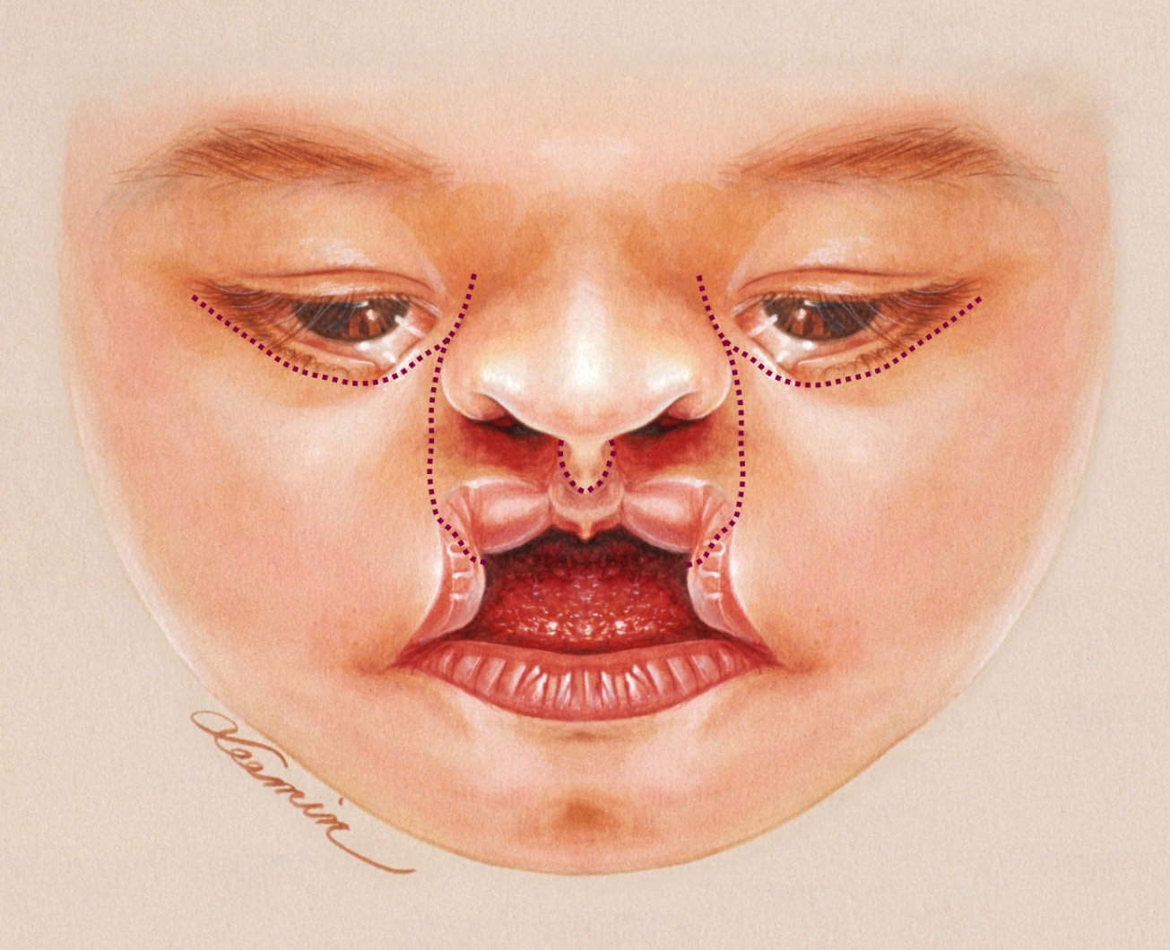
Fig. 1. Incision lines were marked along the margin of the nasal unit medially in a curvilinear fashion upward to the true medial canthus then turning laterally incorporating a triangular shaped medially base upper eyelid flap then coming back medially to the proposed point of the medial canthus. The lateral skin incision is made on the lateral cleft margin up to the medial canthus. The lip landmarks and incision lines were marked as regular unilateral or bilateral cleft lips.

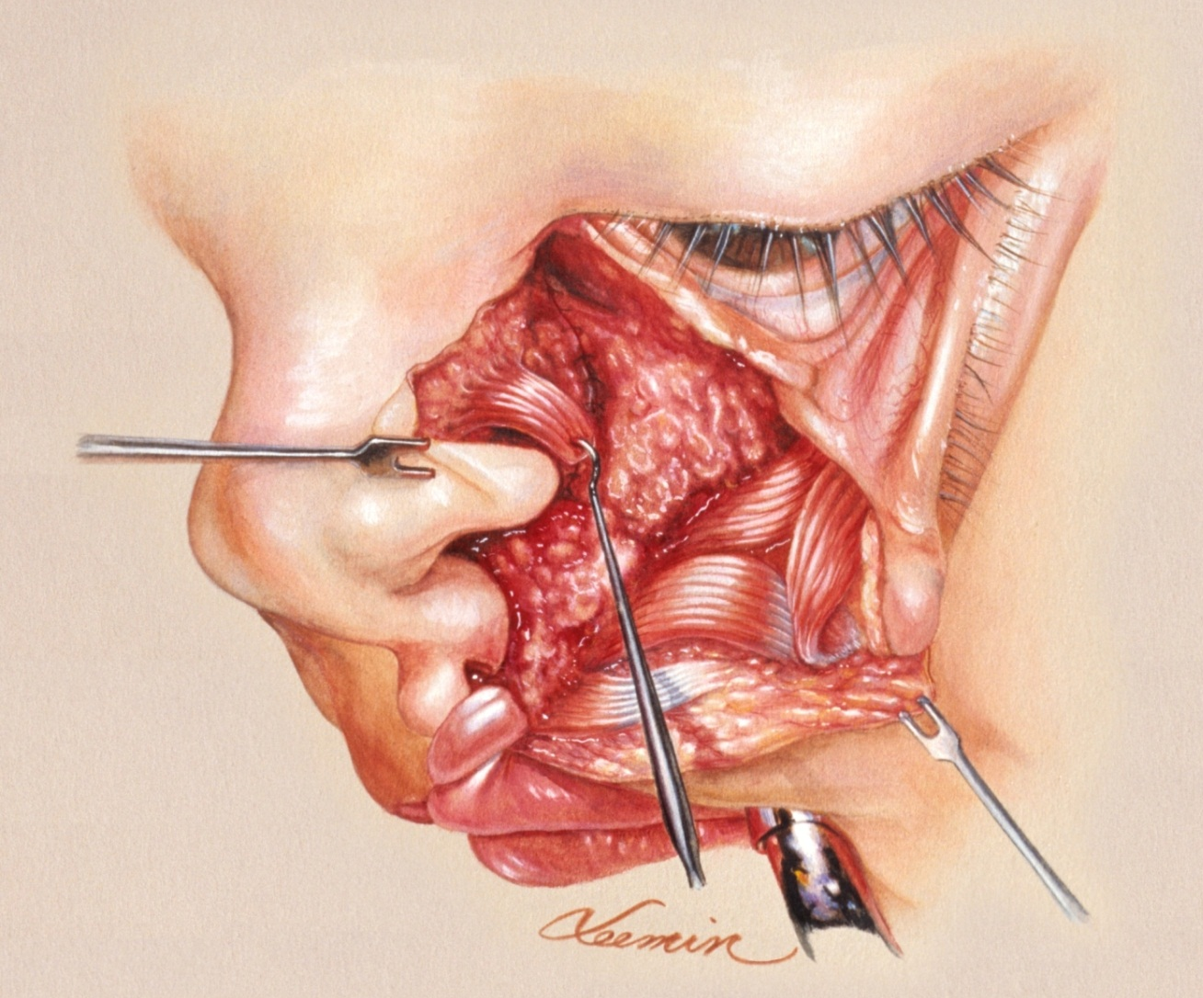
Fig. 2. Once the dissection of laterally based cheek flap has completed, the medially based nasal flap and the alar base is raised off the underlying nasal cartilages and the frontal process of the maxilla to allow downward rotation of the shortened oculo-alar tissue. The nasalis muscle is identified and dissected in a sheet for re-orientation.

Methods: This is a retrospective study of patients (n = 14) who had underwent surgical repair of Tessier No. 3 and No.4 over a 35 years period (1976- 2010) at the craniofacial center in Chang Gung Memorial Hospital. It can be divided into two groups: first group of patients consists of five patients operated by the Z-plasty principles and second group of nine patients operated by the rotation-advancement technique; six of them have Tessier No. 3 clefts and three patients have Tessier No.4 clefts. Seven of those nine patients were primary cases while the other two cases were secondary or tertiary revisions. Patients photographs before and after the procedure were reviewed to assess the outcomes.

Results: Patients in the first group had a less overall satisfactory result in terms of scar quality, color matching or natural facial expression. Overall, a much improved appearance with higher satisfaction rate was demonstrated in the second group of patients. The cases in the second group that were surgically treated with midface rotation advancement technique, though their medial canthus and alar base might not be well repositioned, still had much better result in their scar, color matching and facial expression.

Conclusions: The mid-face rotation advancement technique avoided the significant scarring with poor skin color matching and unnatural facial expressions associated with the interdigitating skin flaps technique. This technique is applicable to either the primary repair or secondary revision of the No.3 and No. 4 craniofacial clefts.

