The Acellular Dermal Replacement Scaffolds Strattice® and Integra®: A Quantitative in vivo Model of Graft Incorporation

Alyssa J. Reiffel, MD; Ying Zheng, PhD; Peter W. Henderson, MD, MBA; Yoann H. Millet, BA; Lawrence J. Bonassar, PhD; Abraham D. Stroock, PhD; Jason A Spector, MD

Abstract

Introduction: Rapid and effective host cell invasion and vascularization is essential for durable incorporation of avascular tissue-replacement scaffolds. In this study, we sought to qualitatively and quantitatively determine which of the two widely applied commercially-available products Strattice® and Integra® (1-5) facilitate more rapid cellular and vascular invasion in a murine model of graft incorporation.

Methods: Four 8mm discs of Integra® and Strattice® were implanted subcutaneously in the dorsa of C57BL/6 mice, harvested after 3, 7, or 14 days, and stained with hematoxylin & eosin, DAPI, and immunohistochemical (IHC) stains for CD31 and α-smooth muscle actin (αSMA). Exponential decay equations describing cellular invasion through each layer were fit to each material/time point. Mean cell density and cell frequency maps were created denoting extent of invasion by location within the scaffold.

Results: Qualitative analyses demonstrated diffuse and extensive cellular infiltration into Integra® by day 3 and increasing over the 2-week period. Invasion of Strattice® was patchy and sparse, even after 14 days. IHC staining for αSMA revealed blood vessel formation within Integra® by day 14 (Figure 1), but no analogous neovascularization in Strattice® (Figure 2). Cell density measurements showed that at all time points, Integra® manifested a greater density and depth of cellular invasion as compared with Strattice®, a finding confirmed by cell frequency mapping.

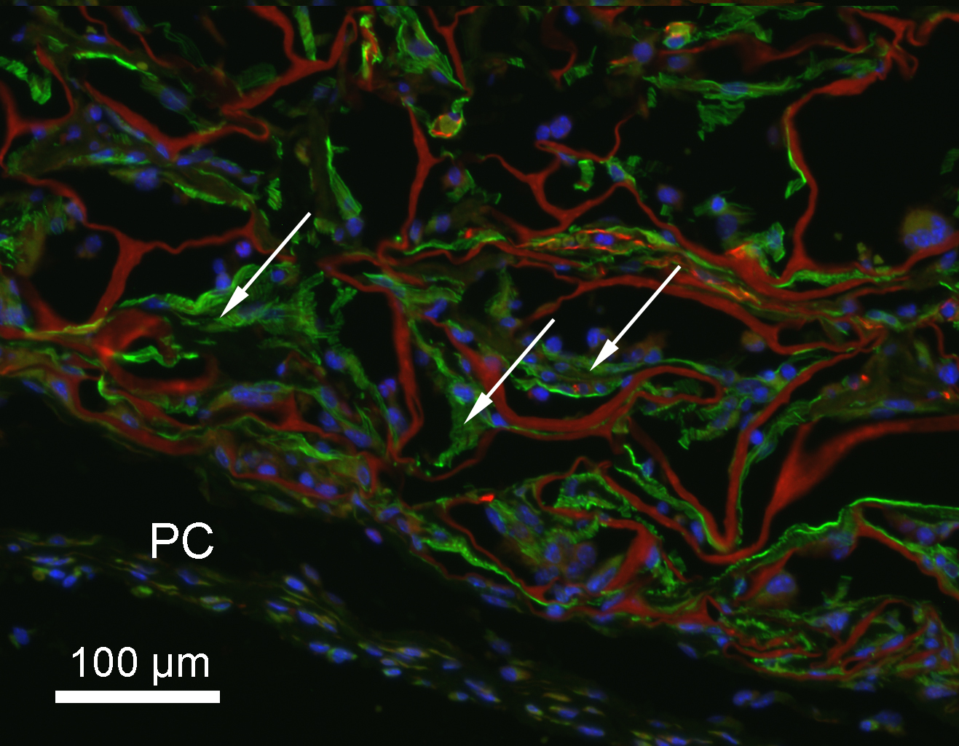

Figure 1: Representative IHC stained section of Integra® explanted after 14 days. α-SMA=green; CD31=red; DAPI=blue; PC=panniculus carnosus.

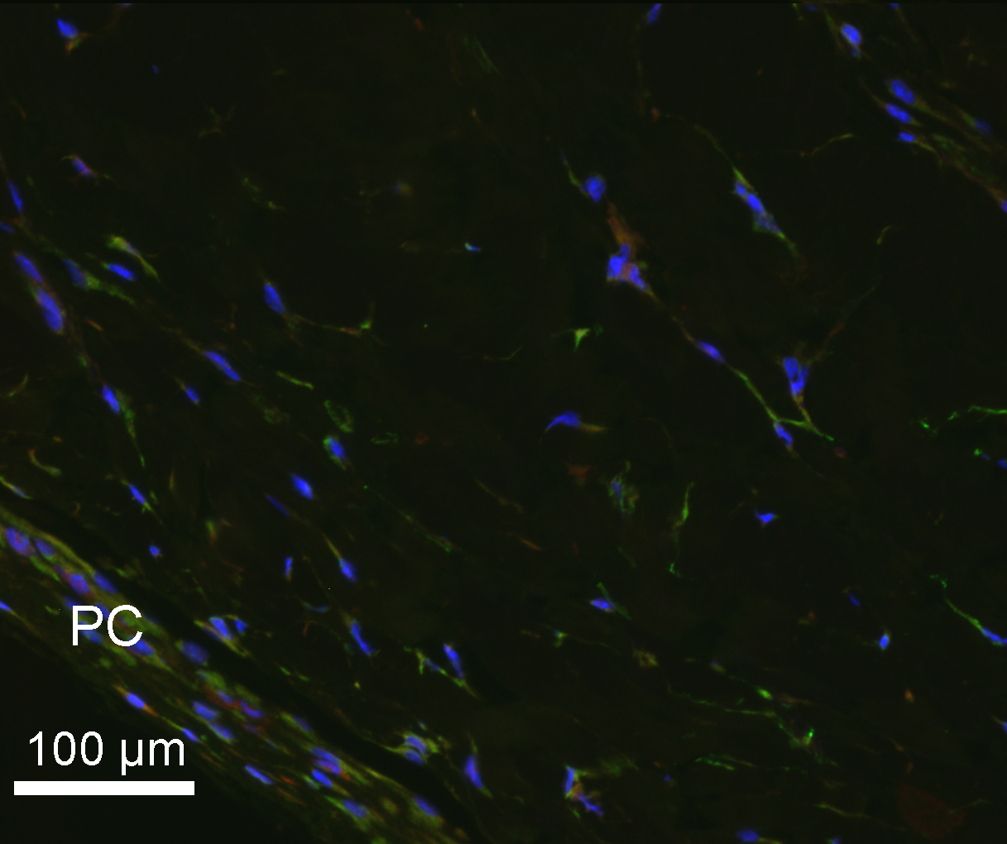

Figure 2: Representative IHC stained section of Strattice® explanted after 14 days. α-SMA=green; CD31=red; DAPI=blue; PC=panniculus carnosus.

Conclusions: These data confirm empiric clinical observations that Integra® is more rapidly invaded than Strattice® when placed in a suitable host bed. A remnant microvasculature template is not sufficient for effective cellular ingrowth into an artificial tissue construct. These findings provide insight into means for improving future dermal replacement products.

References:
1. Burke, J. F., Yannas, I. V., Quinby, W. C., Jr., et al. Successful use of a physiologically acceptable artificial skin in the treatment of extensive burn injury. Ann Surg 194: 413-428, 1981.
2. Yannas, I. V., Burke, J. F., Orgill, D. P., et al. Wound tissue can utilize a polymeric template to synthesize a functional extension of skin. Science 215: 174-176, 1982.
3. Moiemen, N. S., Staiano, J. J., Ojeh, N. O., et al. Reconstructive surgery with a dermal regeneration template: clinical and histologic study. Plast Reconstr Surg 108: 93-103, 2001.
4. Stern, R., McPherson, M., Longaker, M. T. Histologic study of artificial skin used in the treatment of full-thickness thermal injury. J Burn Care Rehabil 11: 7-13, 1990.
5. Reagan, B. J., Madden, M. R., Huo, J., et al. Analysis of cellular and decellular allogeneic dermal grafts for the treatment of full-thickness wounds in a porcine model. J Trauma 43: 458-466, 1997.

Disclosures/Financial Support
A portion of this research was funded by a Glorney-Raisbeck Medical Student Grant in Cardiovascular Research (to Yoann H. Millet), the Morgan Tissue Engineering Foundation, (to Drs. Abraham D. Stroock, Lawrence J. Bonassar and Jason A. Spector) the Empire Clinical Research Investigator Program (to Dr. Peter W. Henderson), and a Ruth L. Kirschstein National Research Service Award (NRSA) Institutional Research Training Grant (T32 HL 083824 05, to Dr. Alyssa J. Reiffel).

None of the authors has a financial interest in any of the products, devices, or drugs mentioned in this manuscript.

