Acellular Adipose Tissue Scaffold for Soft Tissue Reconstruction
Iwen Wu, BS; Zayna Nahas, MD; Gedge Rosson, MD; Jennifer Elisseeff, PhD
Abstract
Background: Soft tissue injury can arise from trauma, tumor resection or congenital defects. Current treatment options using autologous flaps or prosthetic implants have drawbacks that include donor site morbidity and capsular contracture, giving rise to the clinical need for a soft tissue replacement that can be used allogeneically and encourage host tissue regeneration.(1-4) Adipose tissue can potentially provide a biologically instructive scaffold for soft tissue reconstruction. Using mechanical and chemical treatments to decellularize adipose tissue, the extracellular matrix (ECM) can be retained for use as a biocompatible soft tissue filler.
Methods: Decellularization was carried out using mechanical or solvent-based extraction methods for lipid removal, followed by chemical treatments with 3% peracetic acid, 1% Triton-X100, and DNase. To evaluate the instructive capacity of the adipose ECM to facilitate adipogenesis, adipose-derived stem cells (ASCs) were used to compare adipose-derived matrix with human acellular dermis. In vivo biocompatibility was assessed in athymic mice (n=24) and Sprague-Dawley rats (n=12) over 12 weeks. The rats were injected subcutaneously with 200 ul of acellular adipose ECM and athymic mice had ECM injections alone and in conjunction with ASCs.
Results: Adipose tissue was successfully decellularized to produce an acellular matrix that provides both the structural support for reconstruction and instructional cues for host tissue repair, forming a biocompatible soft tissue implant (Figure 1). Adipose tissue formation was detected by two weeks after implantation with no signs of severe immune response to the implanted matrix (Figure 2).
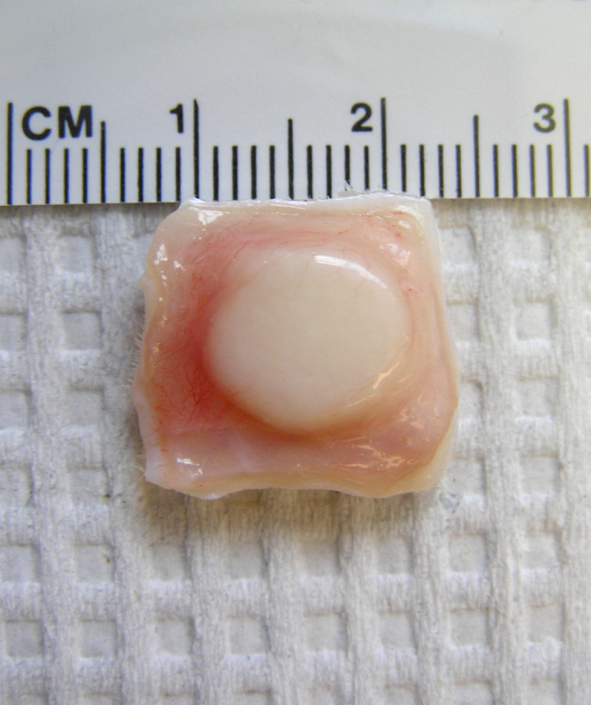
Figure 1. Decellularized adipose ECM after subcutaneous implantation in a rat.

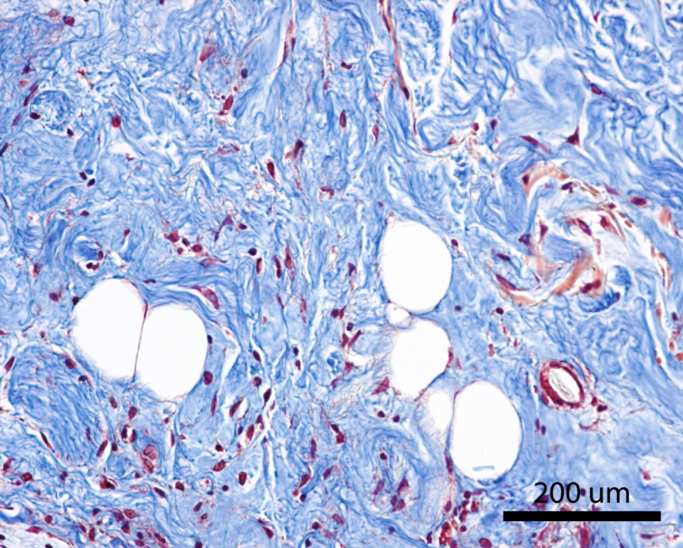
Figure 2. Masson’s trichrome staining showing de novo adipose tissue development in the implant after 2 weeks.

Conclusions: The maintenance of a stable implant volume suggests that adipose-derived ECM can provide the structural and mechanical support necessary to repair defects while creating an instructive environment for soft tissue regeneration.
References
1. Alderman, A. K., Wilkins, E. G., Kim, H. M., Lowery, J. C. Complications in postmastectomy breast reconstruction: two-year results of the Michigan Breast Reconstruction Outcome Study. Plast Reconstr Surg 109: 2265-2274, 2002.
2. Atisha, D., Alderman, A. K. A systematic review of abdominal wall function following abdominal flaps for postmastectomy breast reconstruction. Ann Plast Surg 63: 222-230, 2009.
3. Cordeiro, P. G. Breast reconstruction after surgery for breast cancer. N Engl J Med 359: 1590-1601, 2008.
4. Rosson, G. D., Magarakis, M., Shridharani, S. M., Stapleton, S. M., Jacobs, L. K., Manahan, M. A., Flores, J. I. A review of the surgical management of breast cancer: plastic reconstructive techniques and timing implications. Ann Surg Oncol 17: 1890-1900, 2010.

Disclosure/Financial Support
This work was supported by DOD W81CWH-I1-2-002.
All authors are inventors on IP licensed to Aegeria Soft Tissue.

