Lip Shortening Surgery – Often Overlooked in Facial Reconstruction

John E. Gatti, MD

Abstract

The length of the upper lip increases with age and this is associated with thinning of the lip vermillion and the covering of the upper teeth. A surgeon’s experience with surgery to shorten the upper lip over more than twenty years is presented.

Methods: Lip shortening surgery or a “lip lift” was offered to those patients who exhibited a long and uncomplimentary lip length. The procedure removed a strip of skin at the base of the nose with an irregular incision. Lip asymmetry is addressed by adjusting the amount of skin removed. The incision is closed with two layers of simple sutures.

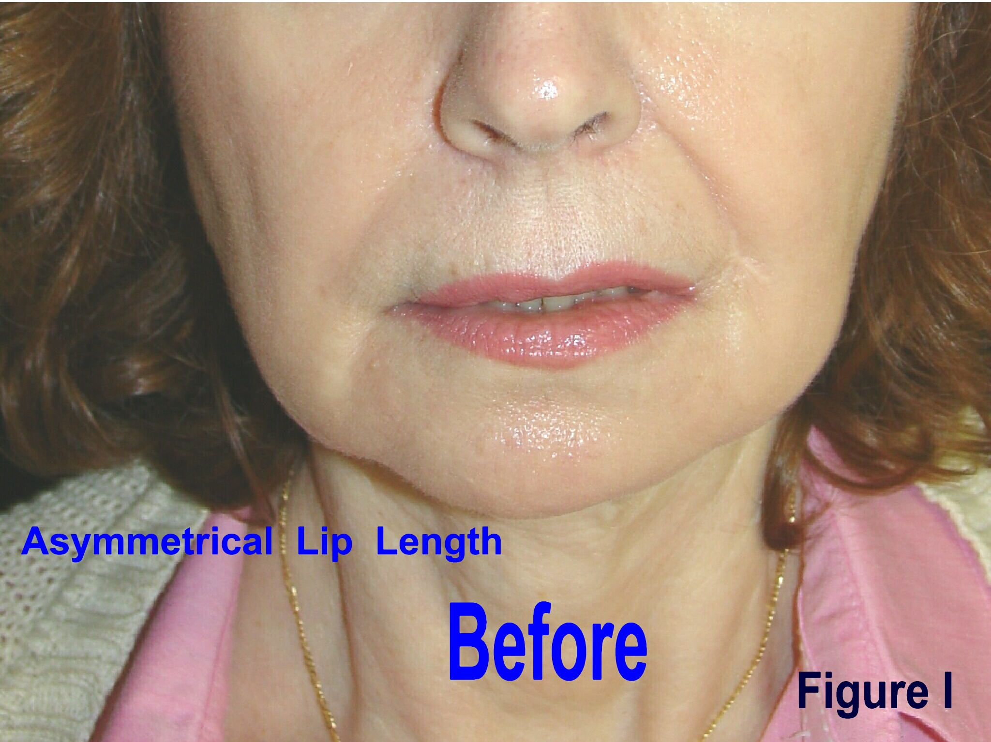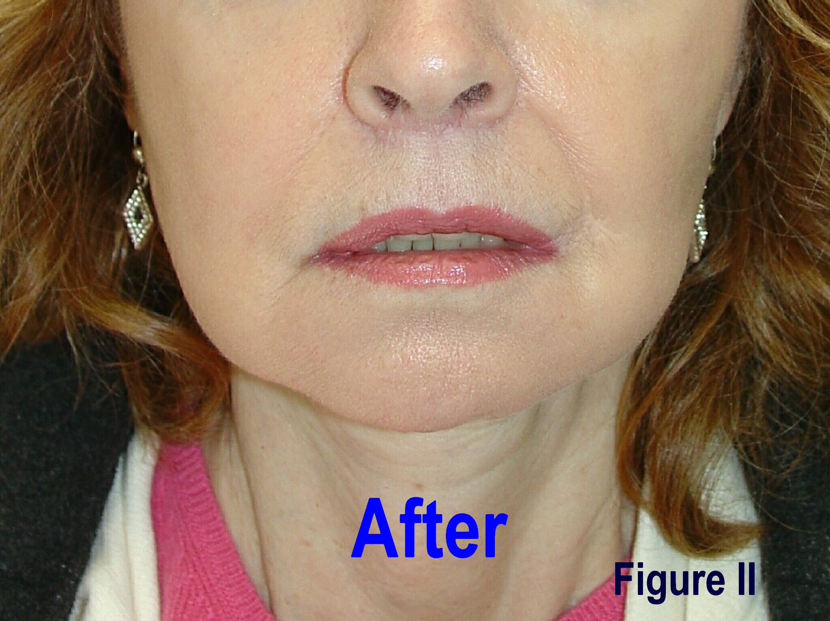

Results: Over a 22 year period 166 lip lifts were performed. A subjective improvement in facial aesthetics was realized with the surgery (Figure I, II). Revisional surgery was necessary in a total of 42 patients (26%) in this group. Persistent scar irregularities were relatively minor and cautery of scar irregularities and visible blood vessels along the incision corrected the problems in 30 (71%) of these 42 patients. Ten patients required direct excision of isolated irregularities with suturing, and, alar distortion in 2 patients required small alar base excisions. Eight patients (5%) requested and received a second lip lift within in one year to improve their result.

Discussion: Lip shortening improves facial aesthetics and should be utilized by surgeons treating the aging face. Lip asymmetry is improved with this direct surgical approach. A high rate of revisional surgery (approximately one-fourth) was found in this series. The highly visible, delicate, central facial landmarks involved in lip shortening surgery magnify small imperfections and correction is often necessary. Surgeons should be willing to explain the complications to their patients and to perform the associated revisions of lip shortening surgery.

