Radiotherapy Prevents Bony Union Through Quantifiable Diminutions In Vascularity and Cellularity In A Murine Model of Irradiated Fracture Healing
Deniz Sarhaddi, BA; Alexis Donneys, MD, MS; Behdod Poushanchi, BS; Catherine N. Tchanque-Fossuo, MD, MS; Sagar S. Deshpande, BS; Daniella M. Weiss, BS; Noah S. Nelson, BS; Peter Felice, MD; Steven R. Buchman, MD
Abstract
Background: Perhaps the most vexing problem confronting head and neck cancer reconstruction is overcoming the impediments of collateral damage imposed by radiation therapy (XRT) on normal surrounding tissue. XRT is detrimental to bone resulting in late pathologic fractures (Fx) that have unacceptably high incidences of non-union. We hypothesize that the pathologic effects of XRT on bone healing are mediated through a mechanism of vascular diminution and direct cellular depletion. Our specific aim was to determine and specifically measure the degree by which XRT impairs healing during fracture repair utilizing histomorphometric and quantitative vascular analysis.
Methods: 24 male Sprague-Dawley Rats were split into 2 groups: Group 1 (Fx, n=12) and Group 2 (XRT/Fx, n=12). Group 1 underwent experimentally produced, unreduced fracture via left unilateral hemi-mandibular osteotomy with external fixator placement. Group 2 received a fractionated human bioequivalent dose of XRT (35Gy/5days) prior to setting the same experimental fracture as Group 1. On post-op day 41, contrast agent was perfused into vessels of all animals prior to mandible harvest. Non-union was defined as the absence of gross bony bridging. Radiomorphometrics for vascularity via microCT and histomorphometric data were analyzed with ANOVA, with statistical significance considered at p<0.05.
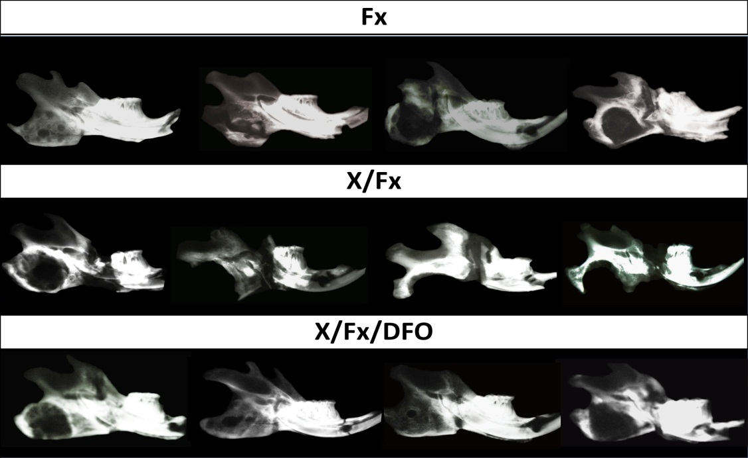
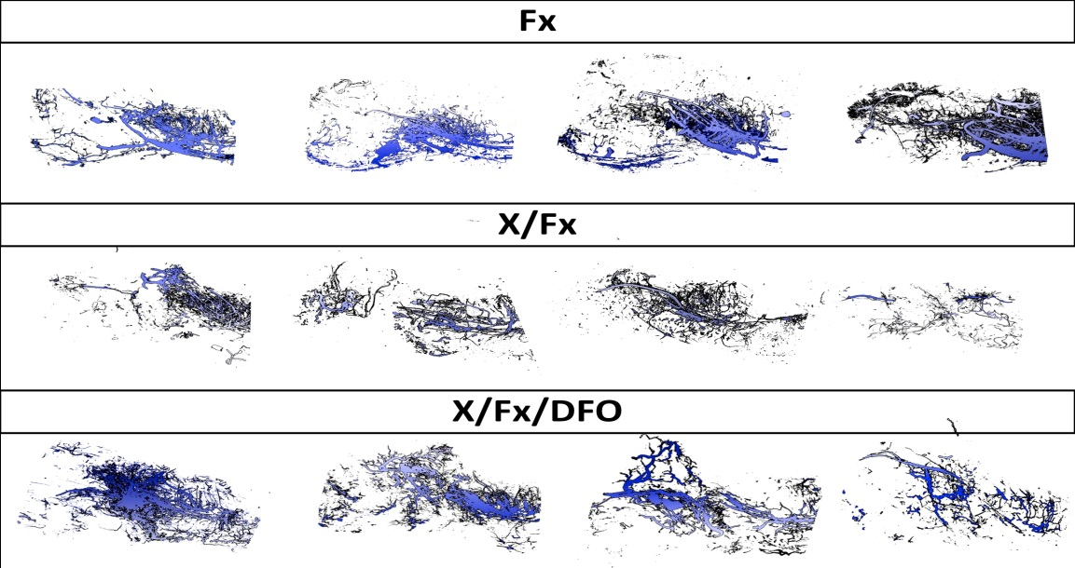
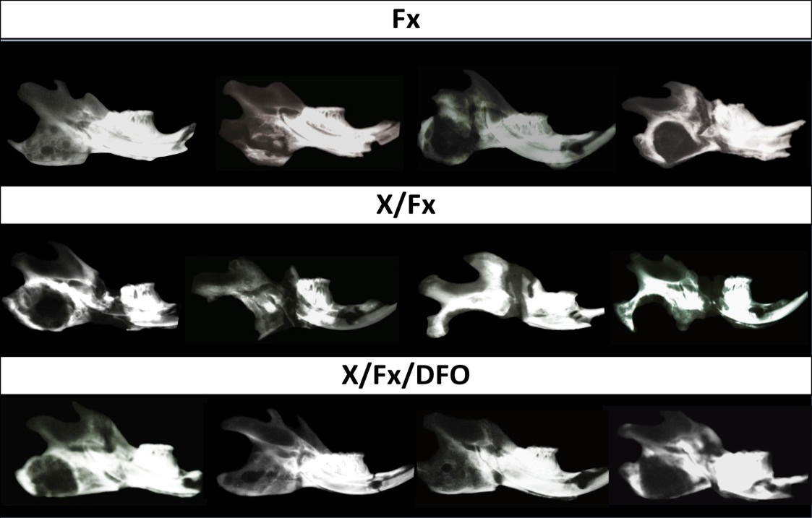
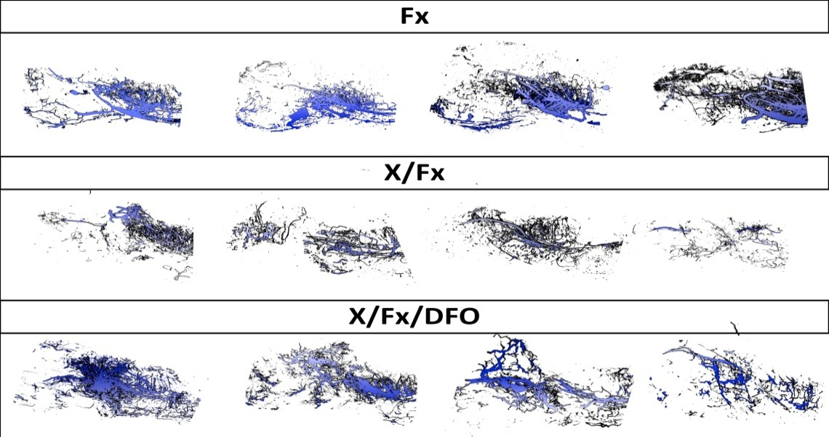
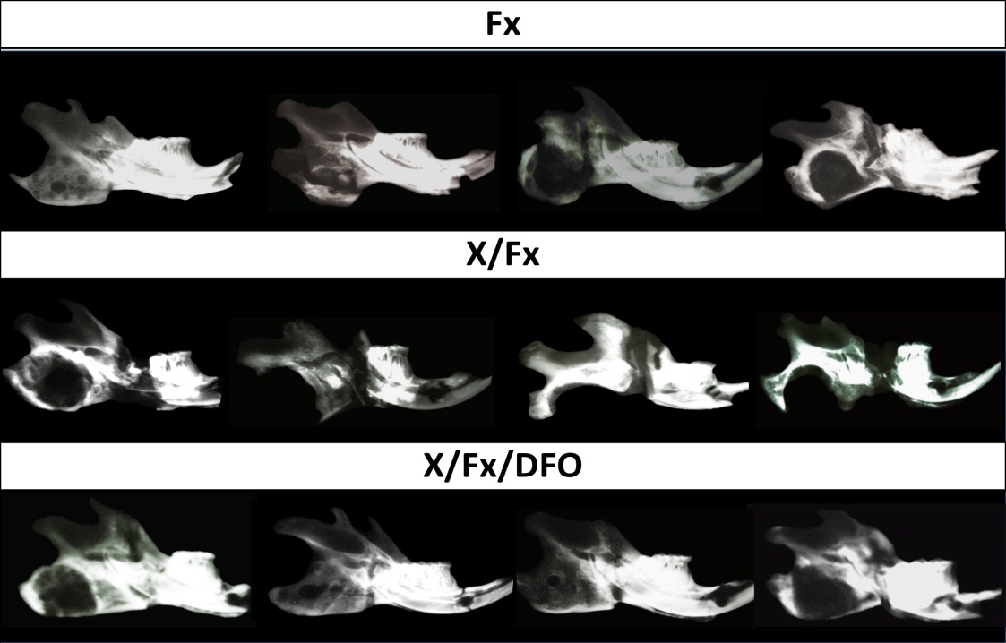
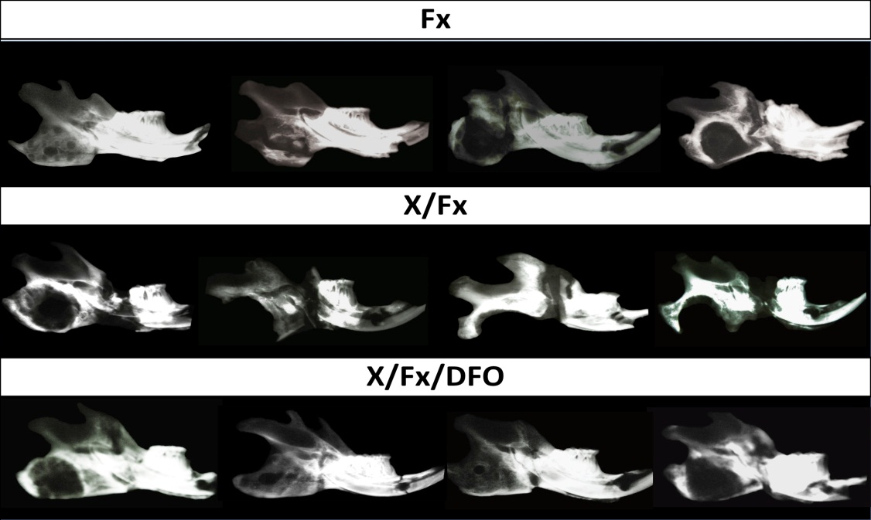
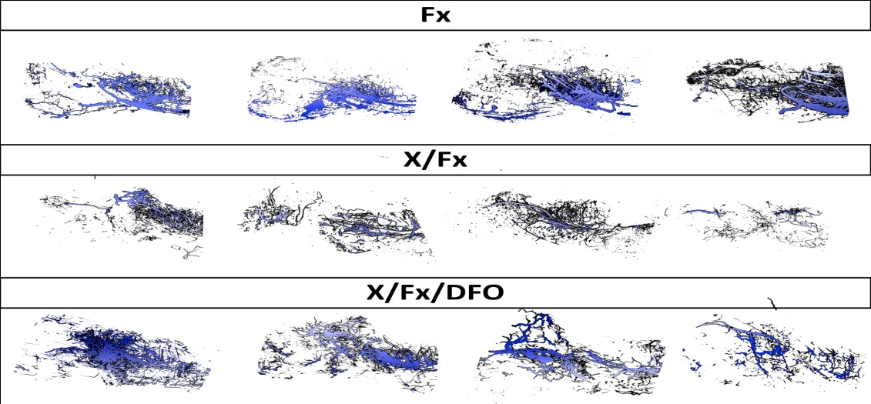
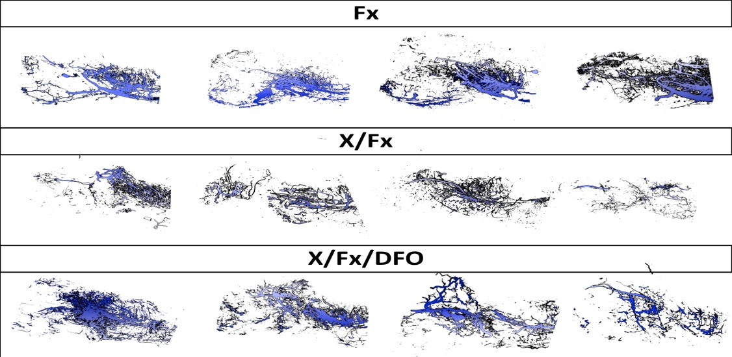
Results: All Fx mandibles demonstrated bony union, while only 25% demonstrated union in the XRT/Fx group (Figure 1). Vascular metrics, including vessel volume, number, thickness and separation, were statistically significantly lower in the XRT/Fx group as compared to the Fx group (Figure 1). Histology also revealed a significant decrease in osteocyte count (p=0.000) and an increase in empty lacunae (p=0.000) in the XRT/Fx group versus the Fx group (Figure 2). Tissue thresholding measures demonstrated a statistically significant decrease in remodeling in the XRT/Fx group, as compared to Fx (p<0.002, Figure 2).
Figure 1. Radiography and µCT angiograph reconstruction. Radiation resulted in a 75% decrease in bony unions, appreciated here with radiography. The diminutive effects of radiation on vascularity are visible with µCT angiograph reconstruction: within the fracture gap, the XRT/Fx group demonstrated a significant decrease in vessel volume, number and thickness, with a corresponding increase in vessel separation, as compared to Fx.
v
v

Fx
XRT/Fx
Conclusions: These results support our contention that cellular and vascular depletion play a key role in the increased rate of non-unions in mandibular fractures occurring after radiotherapy. We have further quantified the degree by which a human bioequivalent dose of radiation depletes these two variables in a model that predictably induces non-union of fractures in an irradiated bed. These quantified depletions can now be used to gauge the success of therapeutic interventions aimed at mitigating impediments to bone healing, to develop a treatment strategy for non-union of fractures after radiotherapy.
Disclosure/Financial Support:
Funding Support provided by NIH RO1 CA 12587-01 (to Dr. Steven R. Buchman).
None of the authors has a financial interest in any of the products, devices, or drugs mentioned in this manuscript.

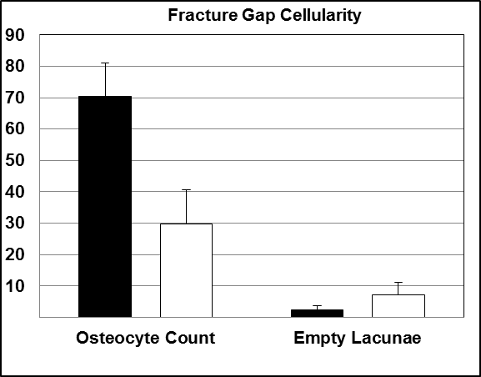
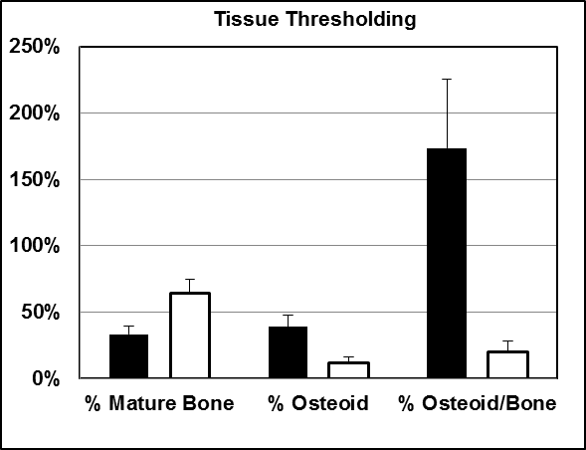
*
*
*
*
*
Figure 2. Histological Analyses. Fracture Gap Cellularity (left). Histological comparison of XRT/Fx vs. Fx reveals a significant decrease in osteocyte count (mean + SD = 30 + 11 vs. 70 + 11; p=0.000) and a corresponding increase in empty lacunae (mean + SD = 7 + 4 vs. 2 + 1; p=0.000) due to XRT. Tissue Thresholding (right). XRT/Fx exhibited a significant increase in % Mature Bone compared to Fx (mean + SD = 64.51 + 10.08 vs. 35.83 + 12.69; p=0.002) and a significant decrease in % Osteoid (mean + SD = 11.57 + 4.36 vs. 37.70 + 15.46, p=0.000) indicative of the decreased remodeling and healing capacity of XRT/Fx. This blunted healing capacity is further illustrated by the decreased ratio of % Osteoid/Bone in XRT/Fx vs. Fx (mean + SD = 19.74 + 8.18 vs. 173.48 + 51.77, p=0.000).
Fx
XRT/Fx
p>0.05

