The Effect of Subcutaneous Mesenchymal Stem Cell Injection On Stasis Zone and Apoptosis In An Experimental Burn Model

Sinan Öksüz, MD; Ersin Ülkür, MD; Oral Öncül, MD; Gamze Torun Köse PhD; Zafer Küçükodacı, MD; Muammer Urhan, MD

Abstract
Background: In an acute burn injury the zone of stasis is initially vital, but may progress to coagulation necrosis. The effect of stem cell treatment at the stasis zone was not investigated before. In this study, salvage of the zone of stasis was aimed by subcutaneous mesenchymal stem cell (MSC) injection.
Methods: MSCs were obtained from the marrow of Sprague Dawley rats (n = 10). Twenty Sprague Dawley rats received thermal injury on the back according to the previously described comb burn model (1). Thirty minutes after the burn injury MSCs were injected subcutaneously to the stasis zone of the experimental group (n = 10). Control group (n = 10) was given the same amount of saline without MSC. Animals in the sham group (n = 6) did not receive any thermal trauma. Seventy-two hours after the burn injury scintigraphic examination was applied to determine average vital tissue at the stasis zone (2,3). The uptake of the radioactive agent was expressed as a percentage of vitality. Thereafter, skin samples were assessed by immunohistochemistry assay for apoptosis count. The blood samples drawn before and seventy-two hours after the burn injury were analysed to determine systemic cytokine levels.

Results: The apoptosis count for the control group was found to be significantly higher than the experimental group at the stasis zone (Figure 1). Vital tissue percentage determined by the scintigraphic examination for the stasis zone of the experimental group was statistically significantly higher than the control group. The cytokine levels did not reveal any statistically significant difference between the groups.
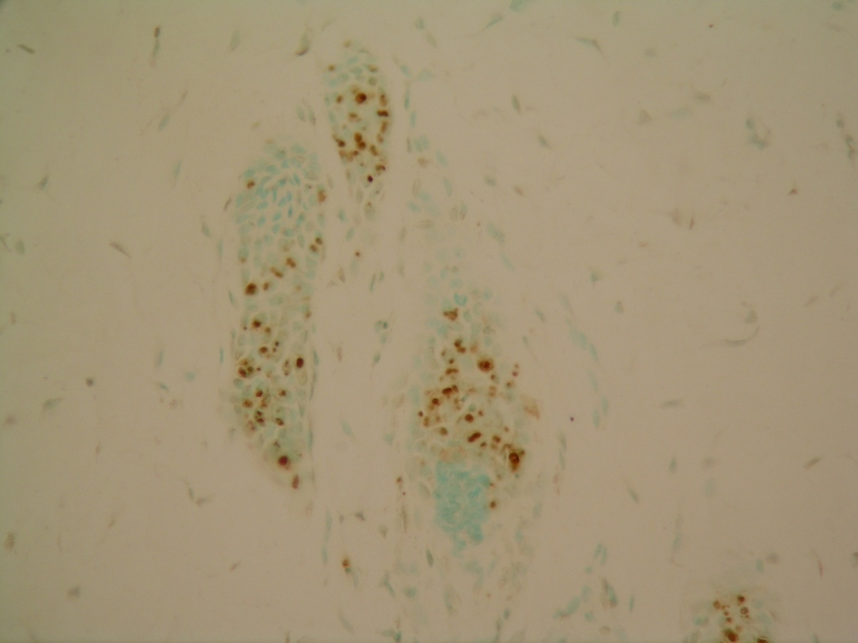

Figure 1. Apoptosis determined at the stasis zone of the control group. (TUNEL, X20)
Conclusion: Apoptosis count and scintigraphic evaluation results of this study confirms that MSC treatment has a statistically significant benefit on the survival of the stasis zone in acute burn.
References
- Regas, F.C., Ehrlich, H.P. Elucidating the vascular response to burns with a new rat model. J Trauma 32: 557-563, 1992.
- Isık, S., Sahin, U., Ilgan, S., Guler, M., Gunalp, B., Selmanpakoglu, N. Saving the zone of stasis in burns with recombinant tissue-type plasminogen activator: an experimental study in rats. Burns 24: 217-223, 1998.
- Zor, F., Ozturk, S., Deveci, M., Karacalioglu, O., Sengezer, M. Saving the zone of stasis: Is glutathione effective? Burns 31: 972-976, 2005.

Disclosure/Financial Support
The authors do not have any conflict of interests or commercial associations or financial interests to disclose.

None of the authors has a financial interest in any of the products, devices, or drugs mentioned in this study.

