Presentation Date: October 28, 2012
Presentation Time: 8:10 AM
Session Title: Cosmetic Abstracts Session 1

Relationship of the Zygomatic Facial Nerve to the Retaining Ligaments of the Face: The SubSMAS Danger Zone

Mohammed Alghoul, MD, Ozan Bitik, MD, Jennifer McBride, PhD, James E. Zins, MD

Background: The transition zone between cheek SMAS and malar SMAS, is considered the most difficult portion of the SMAS to raise due to proximity of zygomatic nerve branches.

Methods: Facial dissection was performed on 12 fresh cadavers (24 hemifaces). Each hemiface was marked with vertical (y) and horizontal (x) coordinates. The zygomatic and masseteric retaining ligaments and the zygomatic and buccal facial branches in the area of dissection were identified and the depth of the nerves in the areas of interest was recorded. 95% confidence regions for the locations of the zygomaticus major (ZM) origin and the main zygomatic retaining ligament (MZRL) and upper masseteric retaining ligament (UMRL) were created.

Results: The distribution, density, and size of the retaining ligaments were variable among every hemiface. The MZRL & UMRL were located in a relatively constant locations at 44.91 mm ± 9.72 mm and 46.35 mm ± 8.34 mm from the tragus. The mean vertical distance between the MZRL and UMRL was 10.95 mm ± 4.07 mm. There was an upper zygomatic branch that invariably passed in between the MZRL and UMRL and was always located deep (mean 4.07 ± 1.29 mm) in the subSMAS plane of dissection and passed under the upper third of the ZM. There was an inferior zygomatic branch that passed immediately inferior to UMRL or penetrated its inferior margin (54 percent of cases) and was located more superficially (mean depth 1.41± 0.95 mm) becoming visible just distal to the ligament, [Figure 1]. 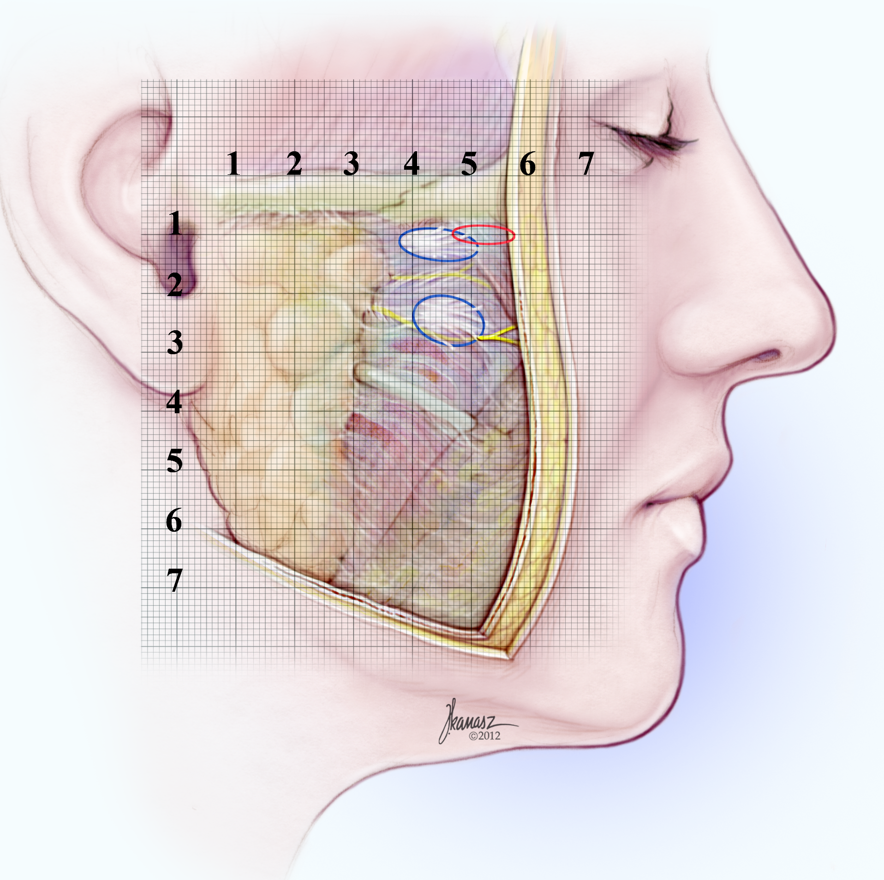

Figure 1. A right hemiface illustration with a millimeter grid showing 95 percent confidence regions for the locations of the origin of the zygomaticus major muscle, main zygomatic retaining ligament (MZRL) and upper masseteric retaining ligaments (UMRL). The upper and lower zygomatic facial nerves are also illustrated with their different depths.

Conclusion: Despite anatomic variation, the MZRL and UMRL can be used as landmarks during dissection since they create a safe passage in between, through which a zygomatic facial branch passes deep. The area of danger is immediately inferomedial to the UMRL where a zygomatic branch becomes superficial and vulnerable.

Disclosure/Financial Support:

None of the authors has a financial interest in any of the products, devices, or drugs mentioned in this manuscript.

