Anatomical Study of the Effects of Five Surgical Maneuvers on Nasal Mucosa Movement
Dennis C. Nguyen, MD; Kamlesh B. Patel, MD; Gary B. Skolnick, BS; Albert S. Woo, MD
Abstract
Introduction: A biomechanical study by Mendonca et al. evaluating the movement of the oral mucosa during cleft palate repair showed that the greatest medial movement occurred with dissection overlying the palatine aponeurosis.¹ As a corollary to the previous work, this study aims to characterize the nasal mucosa during palatoplasty, describing the soft tissue attachments at different zones and quantifying the movement following their release.
Methods: Ten adult cadaver heads were dissected. The palatal nasal mucosa was exposed and divided in the midline. Five consecutive maneuvers were then performed: (1) elevation of nasal mucosal off lateral walls of maxilla, stopping at inferior turbinate; (2) dissection of nasal mucosa from soft palate oral mucosa; (3) separation of nasal mucosa from palatine aponeurosis, including hamulus attachments, (4) release of a newly identified ligamentous attachment tethering mucosa at the pterygopalatine junction; (5) mobilization of vomer flaps. The movements across the midline at the midportion of the hard palate (MP) and posterior nasal spine (PNS) following each maneuver were measured.
Results: The age range of the 10 heads (4 males: 6 females) was between 79-97 years (mean: 84.4). Completion of step 1 obtained a mean release of 3.8 mm and 1.3 mm at the MP and PNS, respectively. By the completion of step 4, a mean cumulative release of 10.3 mm (MP) and 12.9 mm (PNS) was obtained (Fig 1,2). The vomer flaps alone resulted in a mean width of 10.5 mm (MP). The cumulative movement of the lateral nasal mucosa (steps 1-4) and from the vomer flap are equivalent at the MP (p=0.72) (Fig 1). As an isolated maneuver, step 4 yielded the greatest amount of movement at the MP (3.9 mm) and PNS (7.2 mm).
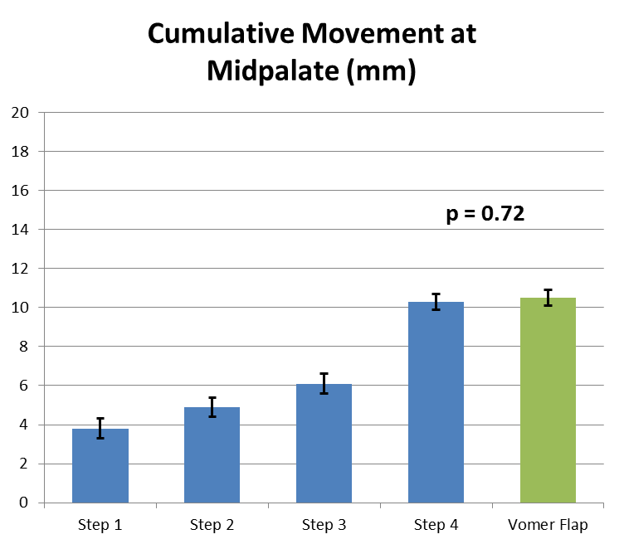
Figure 1. Cumulative movement at the midpalate.

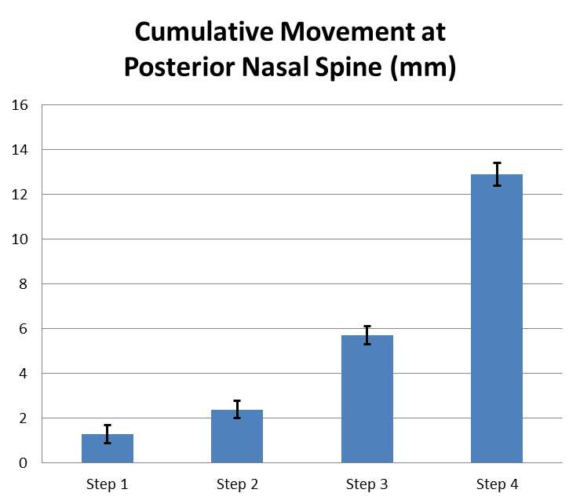
Figure 2. Cumulative movement at the posterior nasal spine.
Conclusion: Oronasal fistulas occur at the MP and the hard-soft palate junction primarily because of repair under tension.² When tension is at the hard palate, the vomer flap is a powerful tool and achieves as much movement as complete release of the lateral nasal mucosa achieved in steps 1-4. At the PNS, our proposed maneuvers progressively add to the movement of the lateral nasal mucosa. Notably, the most powerful maneuver is one which has not previously been described: release of the attachments at the posterior aspect of the medial pterygoid.
References
1. Mendonca DA, Patel KB, Skolnick GB, Woo AS. Anatomical study of the effects of five surgical maneuvers on palate movement. J Plast Reconstr Aesthet Surg 2014. Ahead of print.
2. Sullivan SR, Marrinan EM, LaBrie RA, et al. Palatoplasty outcomes in nonsyndromic patients with cleft palate: a 29-year assessment of one surgeon's experience. J Craniofac Surg 2009; 20 Suppl 1:612-6.
Disclosures/Financial Support
Supported in part by Stryker ® Resident Education Grant. (DCN)
Children’s Surgical Sciences Research Institute, St. Louis Children’s Hospital. (DCN, KBP, GBS, ASW).
None of the authors has a financial interest in any of the products, devices, or drugs mentioned in this manuscript.

