Effect of Vacuum-assisted Closure Performed at the Recipient Site before Fat Grafting

Jung Woo Lee, M.D., Yea Sik Han, M.D., Ph.D., Sin Rak Kim, M.D., Han Kyeol Kim, M.D., Hyun Kim M.D., Ph.D. and Jin Hyung Park, M.D., Ph.D.

Abstract

Purpose: Fat is widely used in soft tissue augmentation. Nevertheless, fat has an unpredictable, high resorption rate¹. Clinically, external expansion with negative pressure is used to increase fat graft survival². In this study, we performed vacuum-assisted closure(VAC) at the recipient site before fat grafting to test for improvements in vascularity and fat graft survival.

Methods: VACs were applied randomly to either the left or right dorsal ear of 20 New Zealand male white rabbits, at a pressure of -125 mmHg. Ears receiving the VAC were assigned to Group 1, and the other ears, the control, were assigned to Group 2. The VAC was removed after one week. The skin flap at each ear was elevated and 1g of fat was grafted above the dorsal perichondrium(Fig. 1). After one week, 10 rabbits were sacrificed, and the fat weight, the vessel density of skin and fat, the amount of glycerol released, which reflects fat viability³ were all measured. The microvessel density was measured with endothelial cell marker CD31, and mature vessel density was measured with smooth muscle actin antibody, both under 200x magnification. Three months after grafting, the remaining 10 rabbits were sacrificed, and the same measurements were taken, exclusive of glycerol release.

Results: Fat weight was not significantly different between groups one week after grafting. Glycerol release in Group 1(183.56±55.1ug/ml/400-mg tissue) was significantly higher than in Group 2(100.32±32.18 ug/ml/400-mg tissue)(P=0.002).
The skin microvessel density measured at one week after grafting, was significantly higher in Group 1(17.3±3.2/HPF) than in Group 2(9.2±2.2/HPF)(P<0.001); the skin mature vessel density was not significantly different between groups. The fat microvessel density was significantly higher in Group 1(4.1±1.2/HPF) than Group 2(2.4±1.0/HPF)(P=0.006); the fat mature vessel density was not significantly different between groups.
The skin microvessel density measured at three months after grafting was significantly higher in Group 1(14.7±3.2/HPF) than in Group 2(9.9±2.0/HPF)(P=0.002).The skin mature vessel density in Group 1(17.7±3.9/HPF) was significantly higher than Group 2 (7.8±1.7/HPF)(P<0.001). The fat microvessel density was not significantly different between groups. The fat mature vessel density of Group 1(2.3±1.0/HPF) was higher than Group 2(0.8±1.0/HPF)(P=0.007). The fat survival rate of Group 1(75.4±3.9%) was higher than Group 2(53.1±4.3%)(P<0.001)(Fig. 2).

Conclusion: VAC prior to fat grafting increased the vascularity of the recipient site, accordingly enhanced, fat graft survival.

References

- Butala P, Hazen A, Szpalski C, et al. Endogenous stem cell therapy enhances fat graft survival. Plast Reconstr Surg. 2012 Aug;130(2):293-306
- Khouri RK, Eisenmann-Klein M, Cardoso E, et al. Brava and autologous fat transfer is a safe and effective breast augmentation alternative: results of a 6-year, 81-patient, prospective multicenter study. Plast Reconstr Surg. 2012 May;129(5):1173-87
- Zhu M, Cohen SR, Hicok KC, et al. Comparison of three different fat graft preparation methods: gravity separation, centrifugation, and simultaneous washing with filtration in a closed system. Plast Reconstr Surg. 2013 Apr;131(4):873-80

Fig. 1. Fat was harvested from the subscapular adipose sac for grafting on the both dorsal ear where VAC was performed ear(Group 1) and control ear(Group2) . Fat was grafted above the dorsal perichondrium.
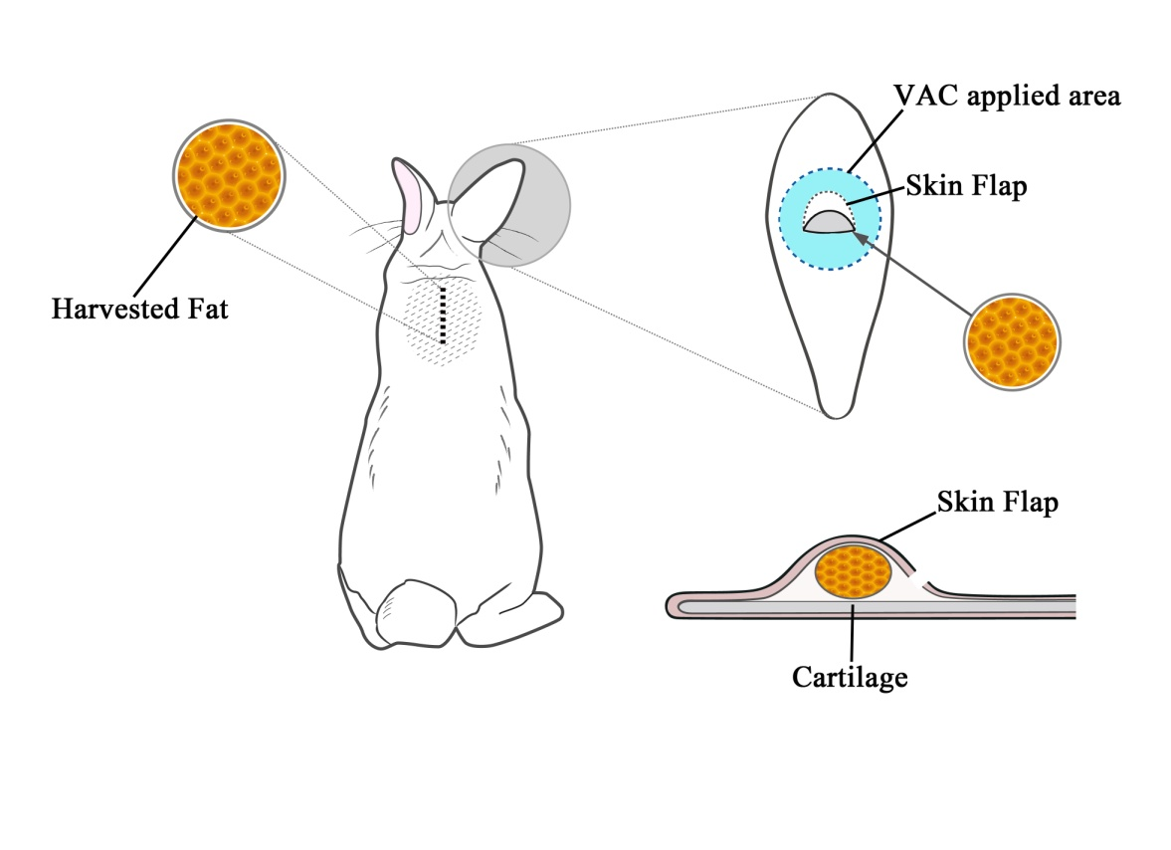

Fig. 2. Weight of grafted fat tissue in Group 1 (the VAC group) and Group 2 (the control group) were compared 1 week and 3 months after grafting.

