The Histologic Impact of Chemotherapy and Radiation on the Remodeling of Acellular Dermal Matrices in Staged, Prosthetic Breast Reconstruction

Ketan Sharma, MD, MPH; Jaime Cavallo, MD, MPHS; Noopur Gangopadhyay, MD; Jason Dudas, MD; Andres Roma, MD; Sara Baalman, MA; Marissa Tenenbaum, MD; Brent Matthews, MD; Corey Deeken, PhD; Terence M Myckatn, MD

Abstract

Background: Acellular dermal matrices (ADMs) typically incorporate with the overlying mastectomy skin flap over time. This process may be necessary to preclude known complications including infection, seroma/hematoma, malposition, dehiscence, skin flap necrosis, and expander/implant loss.^{1,2} Despite widespread ADM use in breast cancer reconstruction, it is not yet understood how chemotherapy and radiation impact this remodeling histologically.

Methods: 86 women with breast cancer (N = 94 breasts) underwent staged implant-exchange reconstruction and received either no additional therapy, neoadjuvant chemotherapy ± radiation, or adjuvant chemotherapy ± radiation. One submuscular control and three ADM biopsies (superior, inferior, and central) were taken from each breast. Biopsies were quantitatively evaluated for cellular infiltration, cell type, fibrous encapsulation, scaffold degradation, extracellular matrix deposition, neovascularization, composite score, Type I and III collagen area and ratio, and time of implant exchange. Two-sided α = 0.05 indicated significance in all tests.

Results: Treatment cohorts were similar with respect to age (p=0.19), BMI (p=0.91), race (p=0.36), diabetes (p=0.82), and smoking (p =0.90). Type I and Type III collagen area decreased with increased time until implant exchange, while collagen ratio remained stable. (Figure 1) Across all treatment types, central ADM biopsies had decreased mean composite remodeling parameters compared to superior and inferior locations (p=0.03).

Comparing submuscular control biopsies, treatment type did not affect remodeling parameters (p=0.28). Regarding ADM biopsies, chemotherapy adversely impacted fibrous encapsulation relative to the untreated group (p=0.03), while chemotherapy with or without radiation adversely impacted Type I collagen area (p=0.02), cellular infiltration (p<0.01), extracellular matrix deposition (p<0.04), scaffold degradation (p<0.01) and neovascularization (p<0.01). Radiation exacerbated the adverse impact of chemotherapy for cellular infiltration, scaffold degradation, and neovascularization (p<0.01). Conversely, neoadjuvant chemotherapy caused a reduction in Type I (p=0.01) and III collagen (p=0.05), extracellular matrix deposition (p=0.03), and scaffold degradation (p=0.02) relative to the untreated group. Similarly, neoadjuvant radiation exacerbated the adverse effect of neoadjuvant chemotherapy for Type I collagen, ECM deposition, scaffold degradation, and neovascularization (p<0.01). (Table 1)

Conclusions: Neoadjuvant and adjuvant chemotherapy impair ADM remodeling, while radiation exacerbates this effect. This study provides a specific histologic basis for the potential pathophysiology of how impaired remodeling may contribute to known ADM complications, and can ultimately be used to develop a stratified risk-prediction model based on patient clinicopathologic characteristics and oncologic treatment paradigm.

Figure 1.

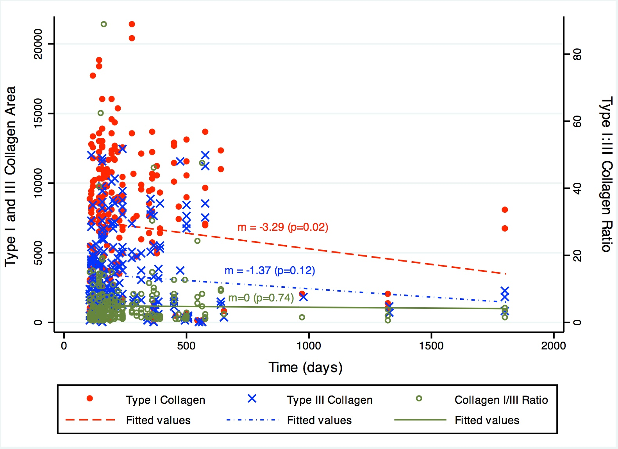

Table 1.

 | None | Neoadjuvant Chemotherapy Alone | Neoadjuvant Chemotherapy + Radiation | Chemotherapy Alone | Chemotherapy + Radiation | P- Value
Time¹ | 159 (128-186) | 168 (147-370) | 208 (203-387) | 208 (177-233) | 505 (344-571) | < 0.01
Cell Type | 2.39 | 2.43 | 2.68 | 2.30 | 2.42 | 0.04
Cellular Infiltration | 2.91 | 3 | 2.8 | 2.85 | 2.5 | < 0.01
ECM Deposition | 2.84 | 3 | 2.52 | 2.65 | 2.28 | < 0.01
Scaffold Degradation | 2.51 | 2.84 | 2.22 | 2.35 | 1.68 | < 0.01
Fibrous Encapsulation | 3 | 3 | 3 | 2.95 | 2.91 | 0.25
Neovascularization | 2.76 | 2.89 | 2.44 | 2.61 | 2.05 | < 0.01
Mean Composite | 2.74 | 2.86 | 2.61 | 2.62 | 2.30 | < 0.01
Collagen I² | 8525 (4684-11499) | 6930 (1276-8721) | 9747 (7602-11532) | 7196 (1224-10015) | 5813 (336-10502) | < 0.01
Collagen III² | 2205 (1240-4481) | 1189 (663-3419) | 3657 (1880-6624) | 2607 (1304-4109) | 1531 (180-6708) | 0.15
Ratio | 2.10 (1.08-6.65) | 2.96 (1.16-11.17) | 2.44 (1.51-4.06) | 2.39 (1.23-4.99) | 1.80 (1.06-3.32) | 0.96
¹ Time until implant exchange, in days
² Area of collagen observed via microscopy, in μm²

