Outpatient Circumferential Abdominoplasty in the Non Post-bariatric Surgery Patient

Marissa E. Baca, MD; Keith C. Neaman, MD; John D. Renucci, MD

Abstract

Background: Circumferential abdominoplasty is a body contouring procedure that provides 360° improvement in body shape and contour. However, it has traditionally been associated with a number of drawbacks¹⁻⁵. Our aim is to quantify and compare these factors when performed in the outpatient setting. Furthermore, investigation of non-bariatric patient satisfaction with circumferential abdominoplasty is perhaps the more important factor in determining integration of the procedure for this particular patient population into a practice.

Methods: A retrospective review of 59 consecutive patients who underwent a circumferential abdominoplasty, performed by a single surgeon in an outpatient setting from 2006 to 2013, was investigated. Patient demographics, comorbidities and operative details were recorded. Major and minor complications, corresponding interventions and postoperative details were followed. Patients were invited to participate in a satisfaction survey at a follow up appointment.

Results: Of the 59 patients undergoing circumferential abdominoplasty, 89.8% were female with an average age of 44. The average BMI was 27. One patient was a smoker. Approximately half of the patients, 50.8%, experienced a complication; the majority were minor (Table 1). A small percentage, 13.6%, required a revision. Increased amounts of tissue and lipoaspirate removed correlated with increased complications, p=0.000 and p=0.016 respectively. Patients experiencing a complication were more likely to undergo a revision, p=0.029, as were patients with increased BMI, p=0.030, and those having additional procedures performed, p=0.010. The patient survey had a 33.9% response rate. 100% of patients stated that their expectations were met, with an average overall satisfaction rating of 9.4 on a 1 – 10 scale (Figure 1). 45% of patients stated that they experienced problems, but 90% of patients stated that they would undergo the procedure again.

COMPLICATIONS | % (N)
Total patients experiencing complications | 50.8% (30)
Total complications | 45*
Life threatening complications | 0% (0)
Deep venous thrombosis | 0% (0)
Pulmonary embolism | 0% (0)
Major complications | 35.6% (16)
Unacceptable scar requiring revision | 17.8% (8)
Wound dehiscence/skin breakdown requiring operative closure | 8.9% (4)
Abscess requiring incision & drainage | 4.4% (2)
Seroma requiring aspiration | 2.2% (1)
Hematoma requiring operative drainage | 2.2% (1)
Minor Complications | 64.4% (29)
Suture granuloma | 22.2% (10)
Cellulitis requiring oral antibiotics | 17.8% (8)
Wound dehiscence/skin breakdown requiring local wound care | 15.6% (7)
Unacceptable scar not requiring revision | 4.4% (2)
Swelling of mons pubis | 4.4% (2)
*9 patients experienced multiple complications

Table 1. Detailed complication rates among patients

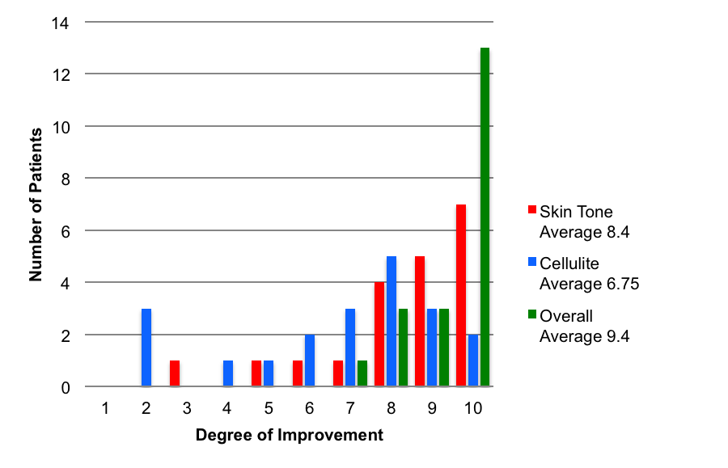
Figure 1. Patient ratings for degree of improvement post circumferential abdominoplasty

Conclusions: Circumferential abdominoplasty can be safely performed in the outpatient setting in the non post-bariatric patient. There is a high associated complication rate of 50.8%, however the majority of complications are minor, and all are non-life threatening. More importantly, patient survey data demonstrates that patients acknowledge complications at approximately the same rate as medical reports, 45% v. 50.8%. Still, the patients report high rates of satisfaction despite those complications. Patient satisfaction is arguably the most important determination of a successful cosmetic operation. Therefore, integration of outpatient circumferential abdominoplasty is a reasonable option for non post-bariatric patients seeking cosmetic body contouring.

References
- Rohrich RJ, Gosman AA, Conrad MH, Coleman J. Simplifying circumferential body contouring: The central body life evolution. Plast Reconstr Surg. 2006;118:525-535.
- Aly AS, Cram AE, Chao M, Pang J, McKeon M. Belt lipectomy for circumferential truncal excess: The University of Iowa experience. Plast Reconstr Surg. 2003;111:398-413.
- Nemerofsky RB, Oliak DA, Capella JF. Body lift: An account of 200 consecutive cases in the massive weight loss patient. Plast Reconstr Surg. 2006;117:414-430.
- Jones BM, Toft NJ. Bodylifting: Indications, technique, and complications. J Plast Reconstr Aesthet Surg. 2008;61:730-735.
- Vico PG, DeVooght A, Nokerman B. Circumferential body contouring in bariatric and non-bariatric patient. J Plast Reconstr Aesthet Surg. 2010;63:814-819.

Disclosure/Financial Support
None of the authors has a financial interest in any of the products, devices, or drugs mentioned in this manuscript.

