Price Transparency in the Online Age

Jonathan Kaplan MD, MPH

Abstract

Background: Plastic surgeons have traditionally hesitated to provide pricing information online due to concerns: 1.) Patients might price shop instead of focusing on surgeon relationship, 2.) Patients might not understand prices are estimates subject to adjustment based on their body habitus, and 3.) Competitors could be comparing prices. There are also benefits to using online price transparency as a tool for lead generation: A.) Patients receive pricing information they seek, B.) Plastic surgeons receive contact information for follow up, and C.) Patients schedule consults only after having realistic price expectations. This case study follows a private practice for one year after it disclosed 104 procedure prices.

Methods: A procedure pricing ‘widget’ containing a list of offered services was embedded in the author’s private practice website. Prospective patients browsed procedures of interest, adding them to personal “wishlists.” After supplying their name, email address and phone number, patients received emails containing a breakdown of estimated costs including surgeon’s fee, OR/anesthesia fees, implants and other ancillary fees. The physician received similar emails containing patient contact information.

Results: Over the course of the physician’s 1st year in a new practice in San Francisco, 208 prospective patients submitted a total of 412 ‘wishlists’. Figure 1 shows that of the 208 prospects, 37 (17.8%) came in for consultations. Of the 37 that came in for consultation, 23 (62.2%) booked procedures. The average price per booked procedure was $4,018.16 (total gross of $92,417.57). Figure 2 compares this ‘price-aware’ group with patients who were not aware of pricing information prior to consultation. Only 44% of ‘not-price-aware’ patients booked procedures, compared to 62.2% of ‘price-aware’ patients. Therefore, price-aware patients were 41% more likely to book a procedure than non-price-aware patients – greater than the 21% cited in a previous survey.¹

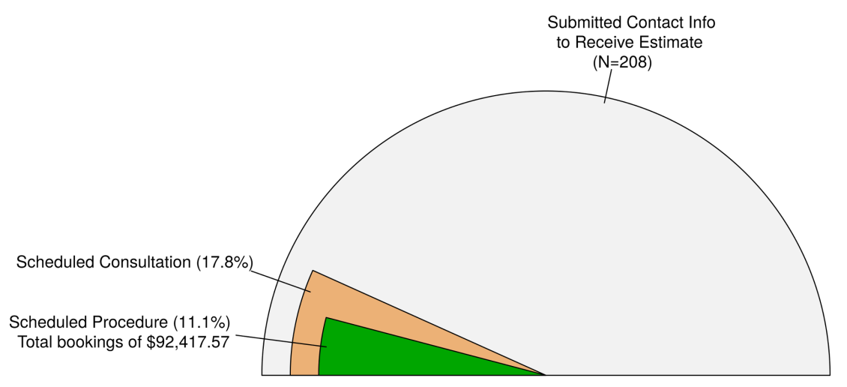
Figure 1. Outcomes and financial impact of disclosing price information to prospective patients over 1 year period.
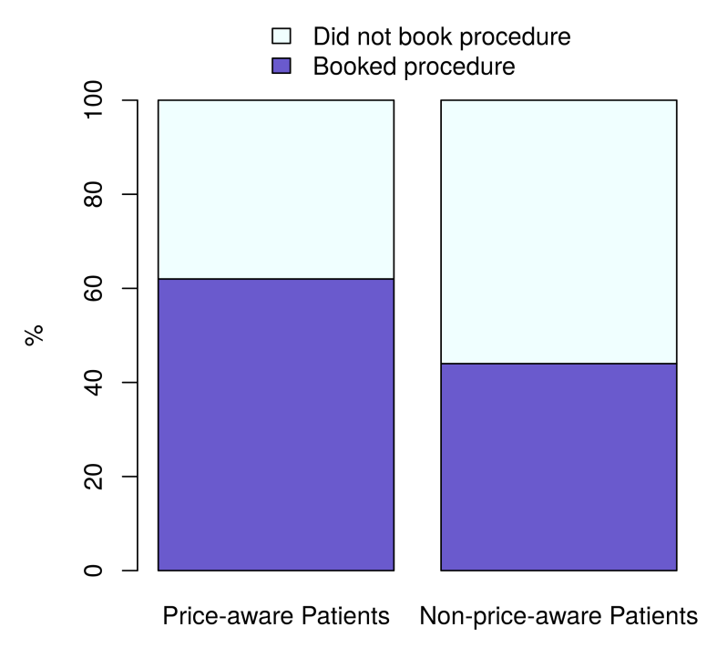

Figure 2. Procedure booking versus pre-consultation price awareness.

Conclusions: By using this interactive pricing platform instead of a static webpage, the consumer learns the costs of various procedures while the doctor captures patient contact information. By using this tool as a lead generator, a plastic surgeon consults with only the most serious of patients. This platform can also be used for patients with HDHPs that are paying out-of-pocket for medically necessary services.

References
1. http://www.therealratingsgroup.com/5-surprising-things-we-learned-about-plastic-surgery-patients-in-2013/ Accessed on May 27th, 2014.

Disclosure/Financial Support
Jonathan Kaplan is a practicing board certified plastic surgeon and is the Founder/CEO of BuildMyBod®, a web-based platform with iPhone/iPad app capabilities that delivers price transparency in healthcare.

