Human Epineural Sheath Conduit Augmented with Human Mesenchymal Stem Cells as a New Biologic Construct Supporting Peripheral Nerve Regeneration: A Preliminary Report

Maria Siemionow, MD, PhD, DSc, Grzegorz Kwiecien, MD, Maria Madajka, PhD, Safak Uygur, MD, Joanna Cwykiel, MS, Adam Bobkiewicz, MD, Arnold Caplan, PhD

Abstract

Background: Peripheral nerve injury (PNI) repair is a challenging task, resulting usually in unsatisfactory outcomes. (1,2) Rat epineural sheath conduit supported with rat bone marrow-derived stromal cells demonstrated neuroregenerative potential by providing neuroprotection, neovascularisation, and secretion of neurotrophic factors.(3-5) To bring this approach to clinical applications, we developed a new biologic construct for nerve regeneration - human epineural conduit (hEC) consisting of human epineural sheath (hES) filled with human mesenchymal stem cells (hMSC). The aim of this study was to assess the feasibility of hEC on the PNI repair in the nude rat model.
Methods: Sciatic nerve defects (20mm) were created in 24 nude male rats. Animals were divided into four experimental groups: Group 1 - no repair; Group 2 - autograft; Group 3 - hES filled with saline; and Group 4 - hEC (supported with 3-4 x 10^6 hMSC). hES was created by fascicles removal using pull-out technique (Figure 1). Bone marrow-derived hMSC were injected into the empty hES. Outcome assessment included: sensory pinprick (PP) and motor toe-spread (TS) tests at 1, 3, 6, 12 weeks. Somatosensory evoked potentials (SSEP), gastrocnemius muscle index (GMI), histomorphometry, immunostaining for GFAP, NGF, S-100, HLA I / II, VEGF, and laminin B2 were performed 12 weeks post-surgery.
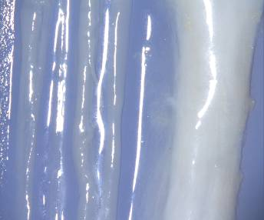
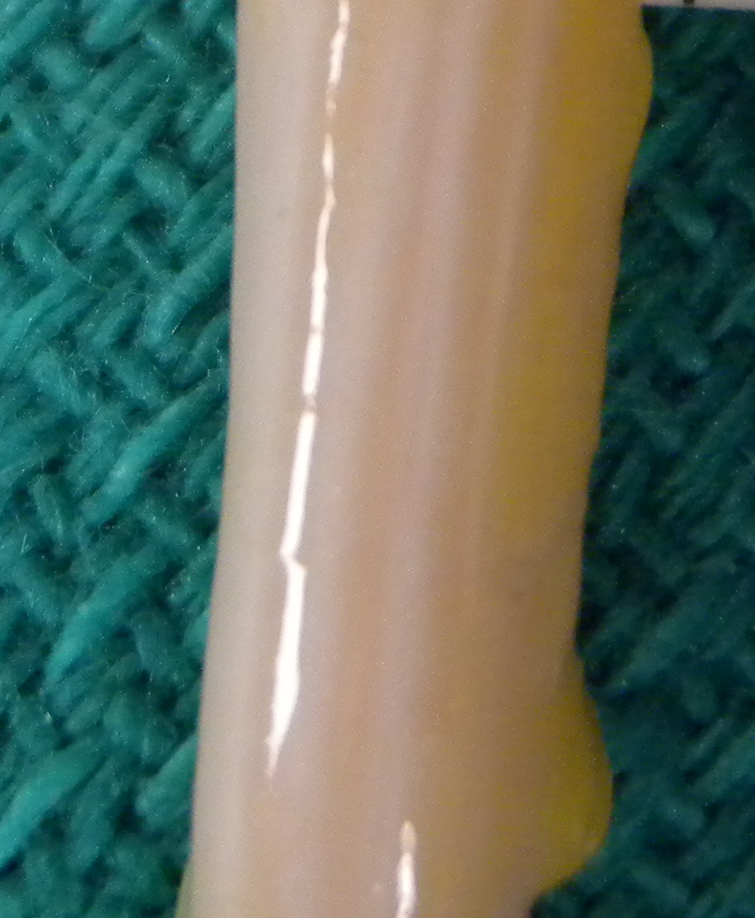
A
B
C
Figure 1. Preparation of human epineural sheath (hEC) conduit. A- Normal human cadaver median nerve, B- Fascicles removed from human cadaver median nerve, C – pre-fabricated human median nerve epineural sheath conduit. (human epineural conduit - hEC) created by surgical removal (counter pressure technique) of nerve fascicles from human median nerve under operating (40X) microscope.

Results: Cultured hMSC expressed CD105, CD73 and CD90. Proangiogenic factor VEGF and neurogenic factor laminin B were strongly expressed on the surface of hES (Figure 2). No leakage of cells was observed at the time of injection during conduit implantation. hEC maintained its shape and integrity at 12 weeks following repair. No local inflammation or scarring was observed at the end of the follow up. Clinical evaluation and SSEP analysis confirmed sciatic nerve recovery in groups 3 and 4 with outcomes comparable to nerve autograft repair. Immunostaining showed presence of the hMSC in the conduit at 12 weeks post-implantation. Quantitative nerve and muscle histological analysis is currently in progress.
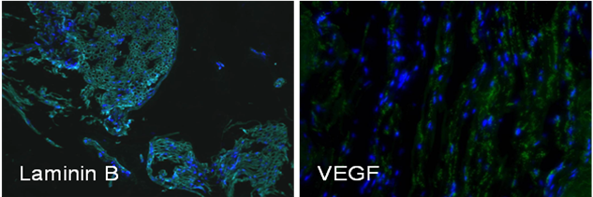
Figure 2. Laminin B and VEGF expression (green marker FITC) on the surface of human epineural sheath. Blue color (DAPI) stains nuclei. Magnification 200x.

Conclusion: This study confirmed the feasibility of the application of hEC for restoration of PNI. The functional outcomes following the use of hEC were comparable to the golden standard of autograft repair. hEC is a promising new technology for regeneration of long gap nerve defects which combines the effect of neurotropic properties of hES and immunomodulating properties of hMSC.

References:
1. Ray WZ, Mackinnon SE. Management of nerve gaps: autografts, allografts, nerve transfers, and end-to-side neurorrhaphy. Exp Neurol 2010;223(1):77-85.
2. Siemionow M, Uygur S, Ozturk C, Siemionow K. Techniques and materials for enhancement of peripheral nerve regeneration: a literature review. Microsurgery. 2013 May;33(4):318-28.
3. Lukaszuk M, Kwiecień G, Madajka M, Uygur S, Drews M, Siemionow M. Repair of the peripheral nerve gap with epineural sheath conduit to prevent muscle denervation atrophy in the diabetic rat model. Pol Przegl Chir. 2013 Jul 1;85(7):387-94.
4. Siemionow M, Demir Y, Mukherjee AL. Repair of peripheral nerve defects with epineural sheath grafts. Ann Plast Surg. 2010 Dec;65(6):546-54.
5. Siemionow M, Duggan W, Brzezicki G, Klimczak A, Grykien C, Gatherwright J, Nair D. Peripheral nerve defect repair with epineural tubes supported with bone marrow stromal cells: a preliminary report. Ann Plast Surg. 2011 Jul;67(1):73-84.

Disclosure/Financial Support:
This study was supported by a Established Investigator Award from the Musculoskeletal Transplant Foundation (to Dr. Maria Siemionow).

None of the authors has a financial interest in any of the products mentioned in this manuscript.

