Heads-up 3D Microscopy: An Ergonomic and Educational Approach to Microsurgery

Bernardino M. Mendez, MD; Michael V. Chiodo, BA; Neil Dalal, MD; Jason Levine, MD; Lohith Bose, MD; Darl Vandevender, MD; Parit A. Patel, MD

Background: Microsurgery performed with traditional binocular eyepieces can lead surgeons to use neck and back postures that cause discomfort and musculoskeletal fatigue.¹ As a result of poor posture, surgeons are more prone to work-related neck and back injuries and potentially shorter operative careers.²⁻³ A new technology from TrueVision projects the microscope optical image onto a three-dimensional (3D), high resolution flat-screen display. This allows microsurgeons to operate while sitting or standing in a neutral, heads-up position, thereby reducing biomechanical loads on neck and back joints.¹ This heads-up 3D technology also enhances the viewing members' learning experience and the microsurgeon's ability to interact with the student. The purpose of this study is to evaluate the feasibility of performing heads-up 3D microscopy as a more ergonomic and educational alternative to traditional microsurgery.

Methods: A pilot study was created where rat femoral artery anastomoses were performed by eight microsurgeons using 3D heads-up microscopy (Image 1). Sprague-Dawley rats were used with an average weight of 350-grams and femoral artery diameter ranging from 0.8-1.0 millimeters. The TrueVision camera apparatus was attached to a standard surgical microscope which projected a 3D high-definition image displayed onto a 1080p flat-screen monitor. Three-dimensional goggles were used to visualize the image. A questionnaire was used to evaluate comfort, image quality and technical difficulty and to compare these measures with each microsurgeon's experience with traditional microsurgery.

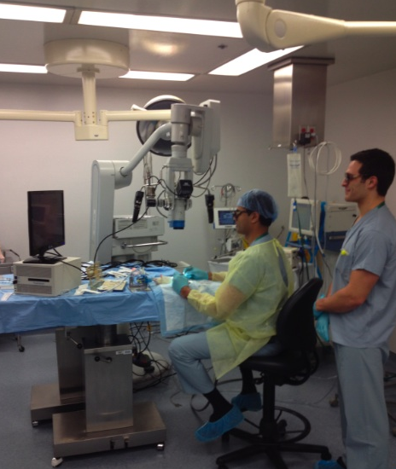

Image 1. Microsurgeon performing rat femoral artery anastomosis using heads-up 3D microscopy.
Results: Rat femoral artery anastomoses were successfully carried out by all eight microsurgeons with operative times ranging from 40-75 minutes. Seventy-five percent of subjects rated neck and back comfort throughout the heads-up procedure to be superior to traditional microsurgery, while the remaining 25% rated it equivalent. Seventy-five percent found image resolution, field of view and technical feasibility to be superior or equivalent compared to traditional microsurgery, while 63% evaluated depth perception to be superior or equivalent. One-hundred percent of subjects found heads-up microscopy to be a more valuable educational experience.

Conclusions: 3D heads-up microscopy is feasible and may allow for a more ergonomic approach to microsurgery without compromising image quality or technical ease. Its use has become prevalent in the fields of ophthalmology and otolaryngology and there may be a role for its use in Plastic and Reconstructive Surgery.

References:
- Yu D, Sackllah M, Woolley C, et al. Quantitative posture analysis of 2D, 3D, and optical microscope visualization methods for microsurgery tasks. Work; 41 Suppl 1, 1944-7; 2012.
- Wallace RB 3rd. The 45-degree tilt: improvement in surgical ergonomics. J Cataract Refract Abstract Surg; 25(2), 174-6; 2011.
- Bhadri PR, Rowley AP, Khurana RN, et al. Evaluation of a stereoscopic camera-based three-dimensional viewing workstation for ophthalmic surgery. Am J Ophthalmol; 143(5), 891-2; 2007.

Disclosure/Financial Support
This project was supported in part by the Research and Graduate Program at Loyola University Medical Center, Stritch School of Medicine in Maywood, IL.

None of the authors have a financial interest in any of the products, devices, or drugs mentioned in this manuscript.

