Venous Thromboembolism in Body Contouring: An Analysis of 17,774 Patients From the National Surgical Quality Improvement (NSQIP) Databases
Ari M Wes BA, John P. Fischer MD, Jonas A. Nelson MD, Joseph M. Serletti MD, Stephen J. Kovach MD, and Liza C. Wu MD

Purpose: To examine the incidence and predictors of venous thromboembolism (VTE) following body contouring procedures.

Methods: We reviewed the American College of Surgeons National Surgical Quality Improvement Program (ACS-NSQIP) database from 2005 to 2012 for all identifiable body contouring cases. A bootstrap analysis and multivariable logistic regression analyses (MVR) were used to determine independent predictors of VTE. Odds ratios from the MVR were then used to define risk magnitudes for each significant predictor, and each patient’s risk score was totaled.

Results: Seventeen thousand seven hundred and seventy four patients underwent body contouring during the study period. Average BMI of patients undergoing body contouring was 31.4 kg/m2, while 2,137 individuals were morbidly obese (BMI ≥ 40 kg/m2). The most common areas of intervention were the breast and abdominal regions (N=11,881, 66.8%; N=5,501, 30.9% respectively). 16,306 (91.7%) patients underwent an isolated contouring procedure, while 1,293 (7.3%) underwent 2 procedures, and 175 (1.0%) underwent 3.
VTE occurred in 99 (0.56%) individuals. Multivariate logistic regression revealed that age greater than 45 years (45-60 years: OR 1.54, P=0.1; >60 years: OR 3.1, P<0.001), undergoing abdominal contouring (OR 3.33, P<0.001), obesity (30≤BMI<35: OR 3.30, P<0.001; 35≤BMI<40: OR 4.26, P<0.001; BMI≥40: OR 3.09, P=0.001;), and being admitted as an inpatient (OR 3.01, P<0.001) were associated with an increased odds of VTE. Each of the aforementioned variables were assigned rounded risk scores (Table 1), with patients’ total scores being categorized as low (0-4), medium (5-7), or high risk (8-9). The low risk cohort exhibited a VTE incidence of 0.15%, while the medium risk cohort experienced an incidence of 1.12%, and the high risk group a VTE incidence of 3.03% (Figure 1).

Conclusion: This study identifies predictors of VTE and defines a simple risk scoring model using a large, prospective dataset. These findings show that in the presence of certain risk factors incidence of VTE increases dramatically; in these cases VTE prophylaxis my be warranted.

Figure 1. Risk Scoring Model
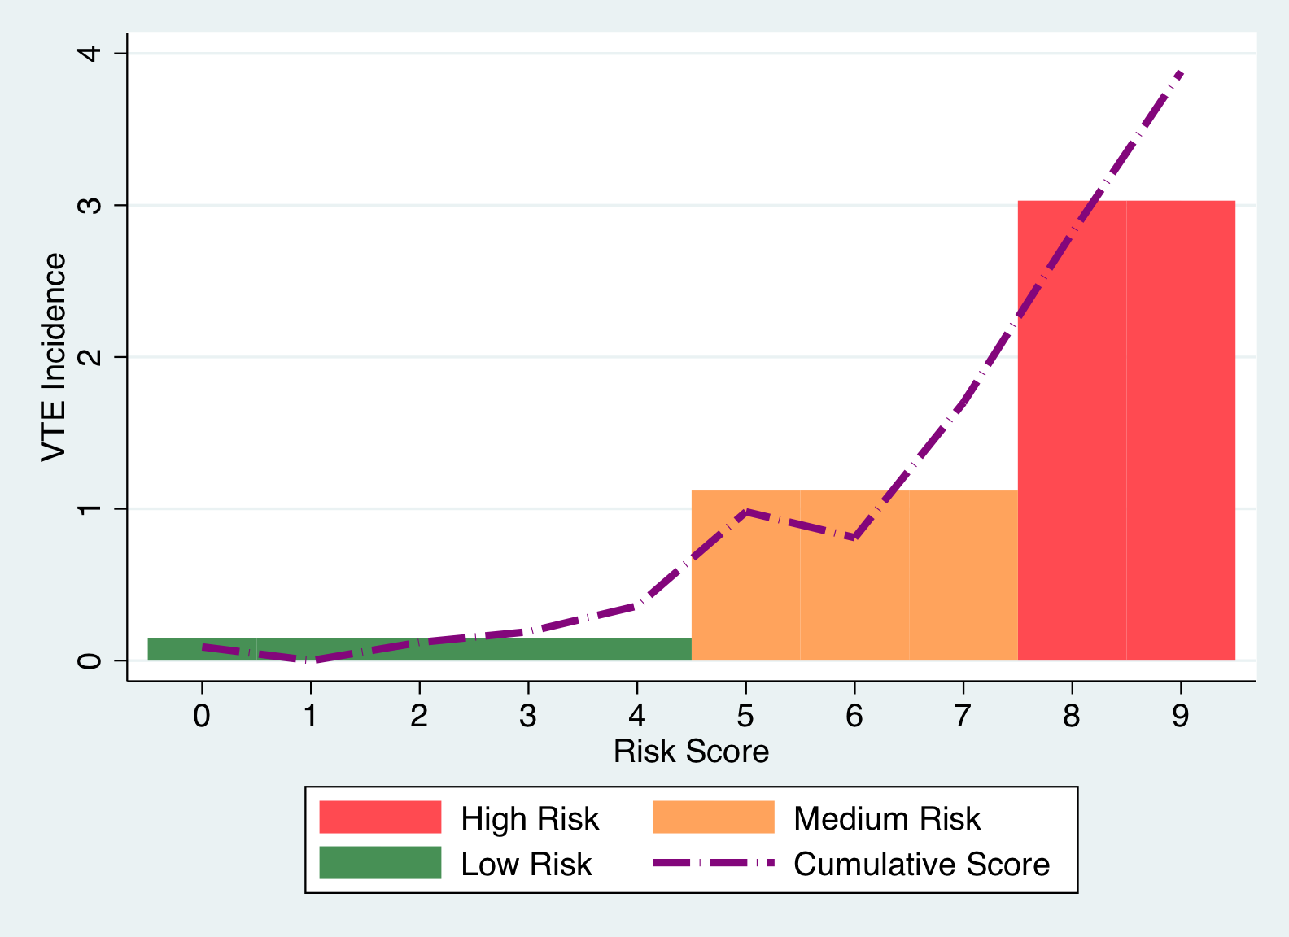

Table 1. Risk factor weights.
Risk Factor | Risk Points
Age: 45-60 Years | 1
Age: >60 Years | 2
Abdominal Contouring | 2
In-Patient | 2
30≤BMI<35 | 2
35≤BMI<40 | 3
BMI ≥ 40 | 3

