Total Breast Reconstruction with Autologous Fat Transfer: Review of a Seven-Year Multicenter Experience

Roger K. Khouri, MD; Gino Rigotti, MD; Roger K. Khouri Jr., BS; Silvia C. Rotemberg, MD; Eufemiano Cardoso, MD; Thomas M. Biggs, MD

Abstract

Background: Autologous Fat transfer (AFT) is now widely accepted as an adjunct to traditional methods of breast reconstruction. However, AFT’s ability to reconstruct an entire breast is not yet firmly established. We hereby present our seven-year, multicenter experience with total breast reconstruction using solely AFT and external expansion.

Methods: We performed 1,877 AFT procedures on 616 breasts in 488 women (44% radiated) to reconstruct 99 lumpectomies, 87 immediate, and 430 delayed total breast reconstructions. Effective graft retention requires the fat to be delivered as micro-ribbons to enhance surface area-to-volume ratio and oxygen delivery, the interstitial fluid pressure (IFP) to remain below 9 mmHg to prevent reduced perfusion, and the recipient site to have sufficient vascularity.^{1,2} To optimize these variables, after 2-4 weeks of Brava treatment, which increased pre-expansion volume by 100-300%, we diffusely injected the breasts with 100-400 ml (225 ml, average) of micro-droplets of 15G sedimented, manually harvested lipoaspirate.³ For patients with restrictive scarring, the Percutaneous Aponeurotomy & Lipo-Filling (PALF) technique was used.⁴ The procedure was repeated every 8-14 weeks as needed till completion of the reconstruction. Follow up ranges from six months to seven years (mean, 2.5 years). 427 women completed the reconstruction, while 12.5% dropped out (2.5% medical, 10% personal reasons).

Results: Final breast reconstructed volume was 375 ml (150–900). Completing the reconstruction required 2.0, 2.1, 2.8, 4.2, and 4.9 procedures/breast for lumpectomy, nonradiated immediate, nonradiated delayed, radiated immediate, and radiated delayed mastectomies, respectively. 97% were satisfied with the volume, shape, and feel of their breasts as they recovered near-normal sensation over the entire mound. 37% of the radiated and 12% of the nonradiated reconstructions had palpable masses, none of which required open biopsy. Complications included 5 (0.8%) pneumothoraces, 15 (2.4%) abscesses/ulcerations in the radiated, and 3 (0.5%) abscesses/ulcerations in the nonradiated breasts. The immediate nonradiated had the best results, while the immediate radiated had the highest complications. One mastectomy (0.2%) and two lumpectomies (2.0%) had local recurrence. As has been reported in other large studies on fat grafting the breast,⁵ we found no increased rate of cancer recurrence (Figures 1,2).
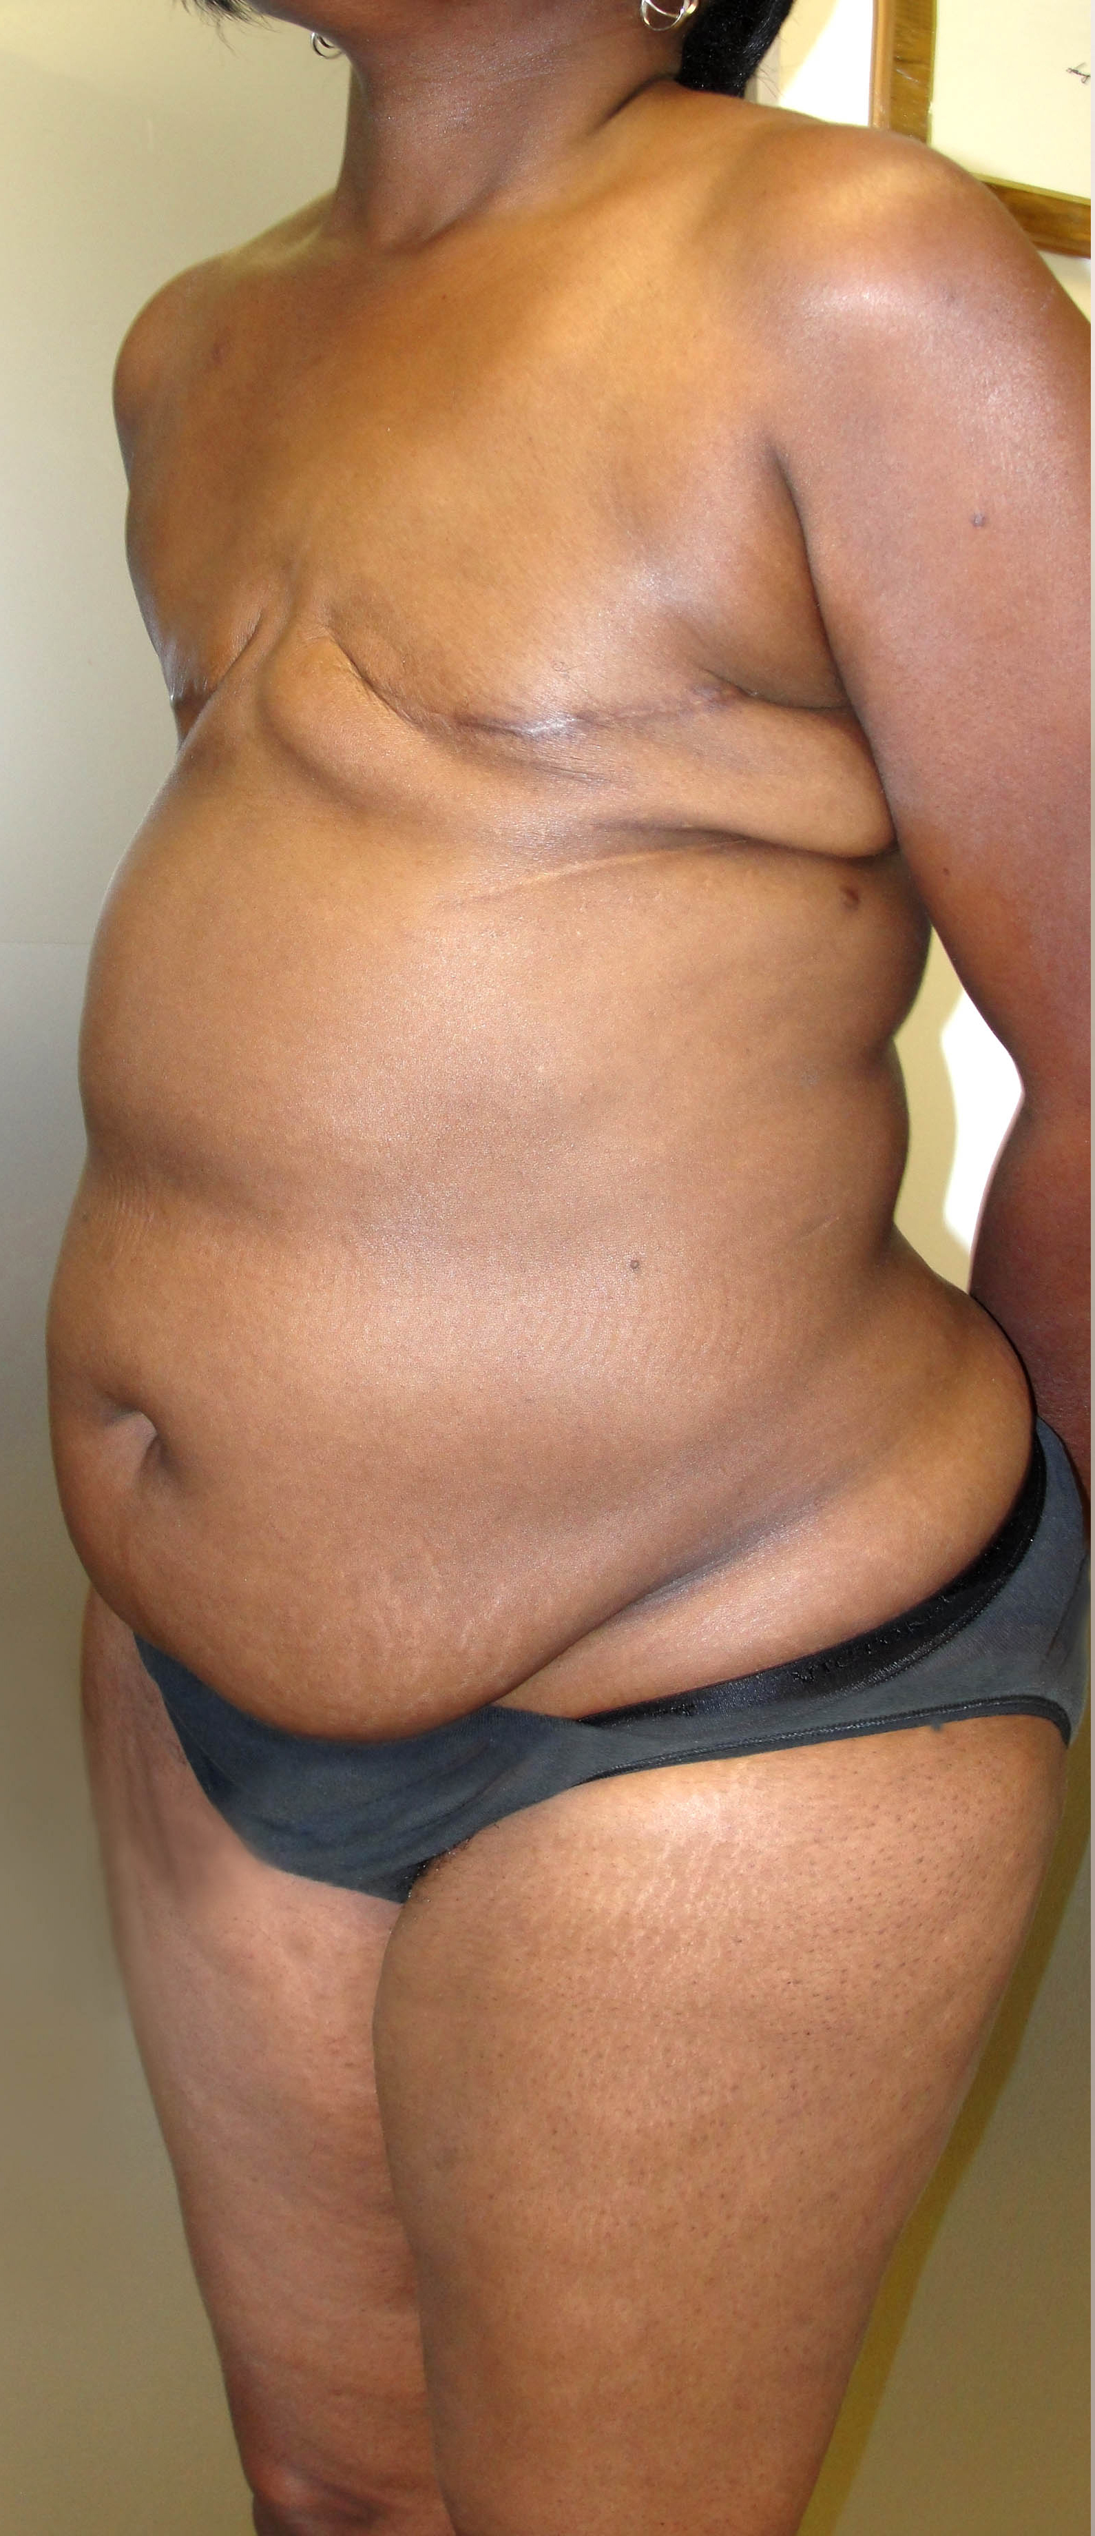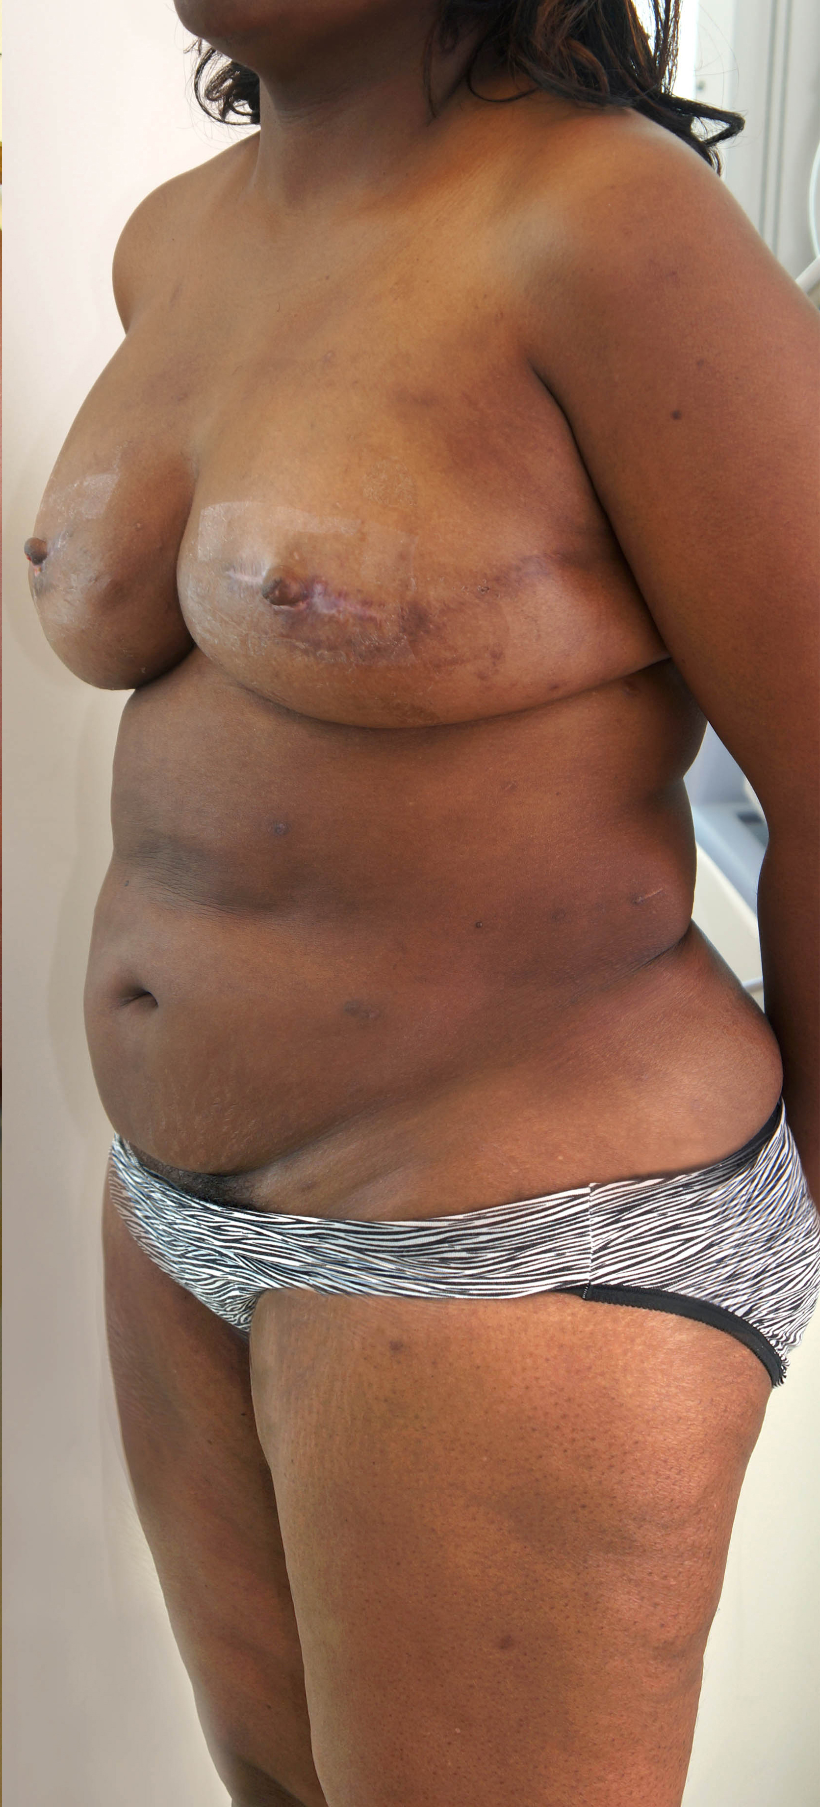
Figure 1: 42-year-old woman two years after a bilateral mastectomy (Left)
Figure 2: After three Brava + AFT procedures and a nipple reconstruction, she regenerated her >600 ml breasts and improved her body contour without any incisions (Right)

Conclusions: AFT + Brava is a minimally invasive, safe, and effective alternative for breast reconstruction. The procedure is outpatient, involves no incision, has minimal complications, and a very high level of patient satisfaction.

References:
1. Khouri RK Jr., Khouri RR, Lujan-Hernandez JR, Khouri KR, Lancerotto L, Orgill DP.
Diffusion & perfusion: The keys to fat grafting. Plast Reconstr Surg Glob Open. 2014;in
press.
2. Khouri RK, Rigotti G, Cardoso E, Khouri RK Jr, Biggs TM. Megavolume autologous fat
transfer: part I. Theory & principles. Plast Reconstr Surg. 2014;133(3):550-7.

3. Khouri RK, Rigotti G, Cardoso E, Khouri RK Jr, Biggs TM. Megavolume autologous fat
transfer: part II. Practice & techniques. Plast Reconstr Surg. 2014;133(6):1369-77.

4. Khouri RK, Smit JM, Cardoso E, et al. Percutaneous Aponeurotomy and Lipo-Filling: A
regenerative alternative to flap reconstruction? Plast Reconstr Surg. 2013;132(5):1280
90.

5. Seth AK, Hirsch EM, Kim JY, Fine NA. Long-term outcomes following fat grafting in
prosthetic breast reconstruction: a comparative analysis. Plast Reconstr Surg.
2012;130(5):984-90.

Disclosure/Financial Support
Roger K. Khouri, M.D. has an equity interest in the company, BRAVA®, LLC, the manufacturer of the BRAVA® device. He also has an equity interest in Lipocosm®, the manufacturer and distributor of the LipografterTM, consisting of the K-VAC SyringeTM and AT-ValveTM. None of the other authors have any conflicts of interest to disclose.

