The Use of “Negative Pressure Drainage System” for Caring Split-Thickness Skin Graft Recipient Sites: A Randomized Controlled Trial
Fu-yin Hsiao, MD; Tien-Hsiang Wang, MD; Hsu Ma, MD, PhD
Abstract
Background: Traditional method as saline soak for care of recipient wounds of split-thickness skin graft produces discomfort and inconvenience to the patients due to the necessary of frequent dressing changing and pain during the procedures. Therefore, we developed a negative pressure drainage system to coverage these wounds to improve these problems. To compare the efficacy and safety of negative pressure drainage system with controls (indirect saline soaks) in the coverage of recipient site wounds of split-thickness skin graft.

Materials and methods: Randomized, comparator-controlled trial in patients underwent split-thickness skin graft conducted in Taipei Veterans General Hospital between Aug. 2012 and Dec. 2013. Twenty-eight patients age 21 to 80 years were randomly assigned in the intervention group (n=14) of negative pressure drainage system (Fig. 1) or to a control group (n=14) of traditional method. Patients who had immunologic disease, end-stage renal disease, coagulopathy, or history of radiation were excluded. The conditions of graft take and pain and discomfort were compared every day during the first 7 days after operation and 2 weeks and 3 months follow up.
Figure 1 Demonstration of the negative pressure drainage system over a split-thickness skin grafted wound.
Results: Twenty-eight participants were analyzed. Fourteen patients were in the negative pressure drainage system group and other 14 were in the control group. All wounds healed smoothly on the postoperative 7th day. No wound infection was noted, including one patient who had diabetes mellitus. All patients responded to follow-up for at least 3 months and no hypertrophy scar formation was noted. The pain level was obtained during the dressing change and was significant between the groups, with the negative pressure drainage system being less painful (P = .0001) (Fig. 2)
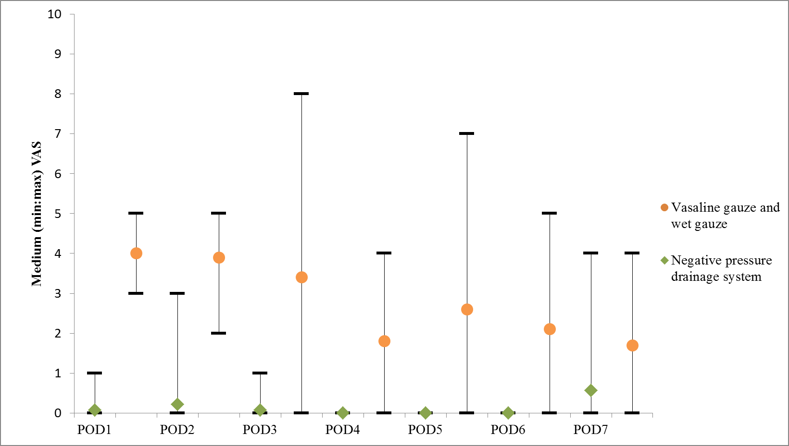
Figure 2 Pain measured using the visual analog scale (VAS) system.
Conclusion: From clinical experiences, we know that this new method is practical and cost-effective for covering
References
Li TS, Choong MY, Wu HF, et al Simplified negative-pressure wound therapy system for skin graft wounds. Plast Reconstr Surg 129(2):399e-401e
Disclosure/Financial Support
Supported in part by Taipei Veterans General Hospital (V102C-189)
None of the authors has a financial interest in any of the products, devices, or drugs mentioned in this manuscript.

