The Effect of Perineurotomy on Nerve Regeneration in Diabetic Rats
Cihan Sahin, MD, Huseyin Karagoz, MD, Fuat Yuksel, MD, Yalcin Kulahci, MD, Dilek Akakin, MD, Nukhet Dagbasi, MD, Celalettin Sever, MD, Ersin Ulkur, MD

Abstract
Background: One of the main causes of diabetic neuropathy is endoneurial edema, which increases the internal pressure of the perineurium, which has a tight structure (1). The treatment used to reduce internal pressure is perineurotomy, in which a surgical incision is made into the perineurium.
Methods: Forty male Sprague-Dawley rats were used in the study. They were classified into four groups. Streptozotocin-induced diabetes was created in groups III and IV. The sciatic nerve was transected and repaired epineurally in all groups. Perineurotomy was performed additionally in group II and IV to the sciatic, peroneal, tibial, and sural nerves from the most proximal side to their most distal ends. The sciatic function indices were calculated for functional assessment. Light and electron microscopic evaluations were performed for morphometric assessment. In addition, the myelinated and degenerated fibers were counted in all groups.
Results: The sciatic function indices of the diabetic perineurotomy group were found to be significantly higher than those of the other groups (p < 0.05)(Figure 1). Based on the number of myelinated fibers, there was a statistically insignificant difference between group I and group II. But the difference between group III and group IV was significant (p < 0.05), with a much larger fiber count for group IV compared with group III (Figure 2).
Light microscope observation revealed normal characteristics of myelinated fibers in the control and perineurotomy group. Diabetic groups showed significantly more axonal degeneration than the healthy groups (p < 0.05). The number of degenerated fiber counts increased significantly (p < 0.05) in diabetic control group compared with diabetic perineurotomy group.
The control and perineurotomy groups revealed regular axon morphology with normal appearing neurofilaments in electron micrographs. Myelin debris and several elongated processes separating the myelin sheaths were prominent in the diabetic nerves. Also, the presence of vacuolizations was apparent. The myelin sheath does not represent a regular contour. In the diabetic perineurotomy group, the myelin sheath appears with regular morphology in slightly vacuolated axons.
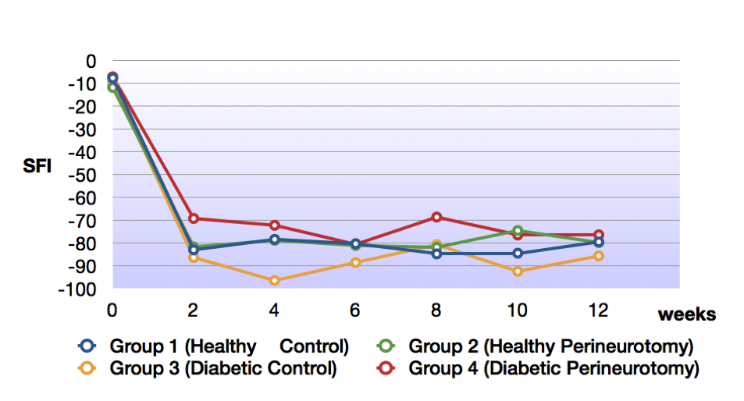
Figure 1. Walking track analysis

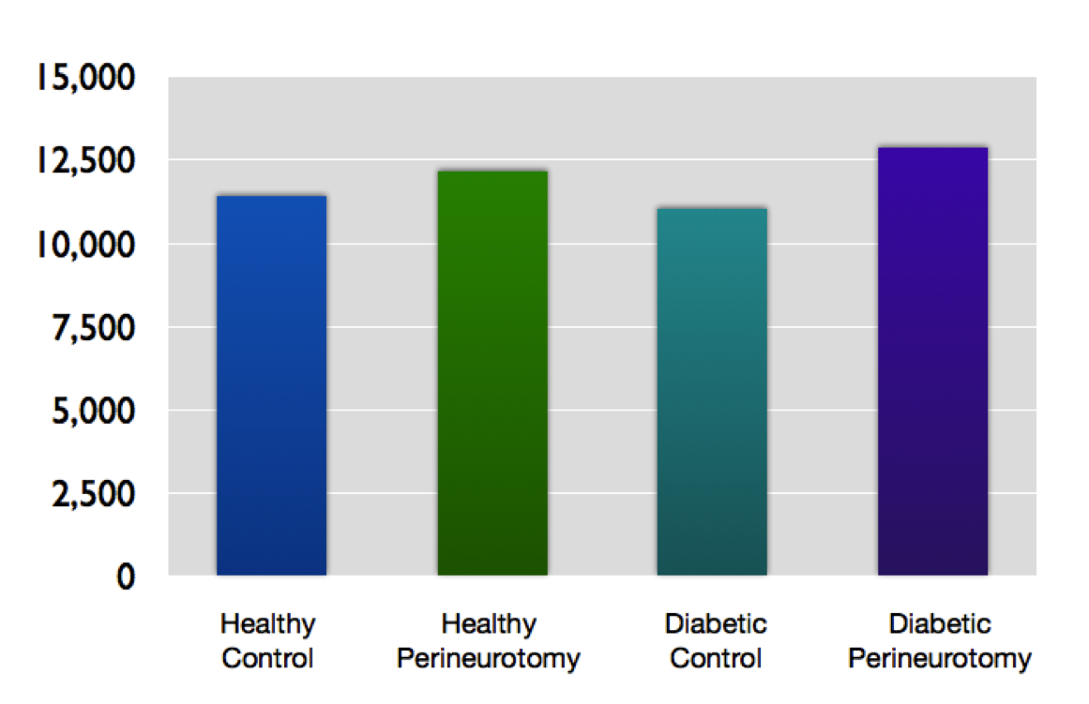
Figure 2. Myelinated fiber count
Conclusion: We can conclude that perineurotomy increases the regeneration of nerves in diabetic rats and has beneficial effects on the overall function of the lower extremities. Further experimental evidence and clinical trials are needed for perineurotomy to be used as a reliable tool in diabetic nerve repairs.

References
1. Kale B, Yuksel F, Celikoz B, Sirvancı S, Ergu ̈n O, Arbak S. Effect of various nerve decompression procedures on the function of distal limbs in streptozocin-induced diabetic rats: Further optimism in diabetic neuropathy. Plast Reconstr Surg. 2003;111:2265–2272.

Disclosure/Financial Support None of the authors has a financial interest in any of the products, devices, or drugs mentioned in this manuscript.

