Is It Possible To Increase Flap Viability By Hydrostatic Dilation? An Experimental Study In The Rat Abdominal Fasciocutaneous Flap Model
Cihan Sahin, MD, Bilge K Aysal, MD, Ozge Ergun, MD
BAckground: There are limits to survivability of a pedicle-based or free tissue transfer. When these limits are exceed flap complications such as poor healing and flap necrosis can result (1). The best known and experienced way of increasing flap perfusion (or survival area) is the delay procedure. However delay procedures have some disadvantages such as two operations and a waiting time. For this reason there have been many studies which aims to increase flap survivable area and improve perfusion (2). In this study the authors purposed to investigate the effect of hydrostatic dilation (HD) on a fasciocutaneous flap model as an alternative method to surgical delay.

Methods: Eighteen female Wistar rats were randomly assigned to one of three abdominal fasciocutaneous flap groups (6 rats in each group): the control group, the delay group, and the hydrostatic dilation group. The surgical delay procedure was performed by division of left-sided superficial inferior epigastric (SIE) vessels. Hydrostatic dilation was performed to the left-sided SIE artery and vein with a mean pressure of 300 mm Hg, while elevating the flap on the right sided SIE pedicle (Figure 1). The groups were compared by means of microangiography and survival ratio of abdominal flaps 7 days after elevation.

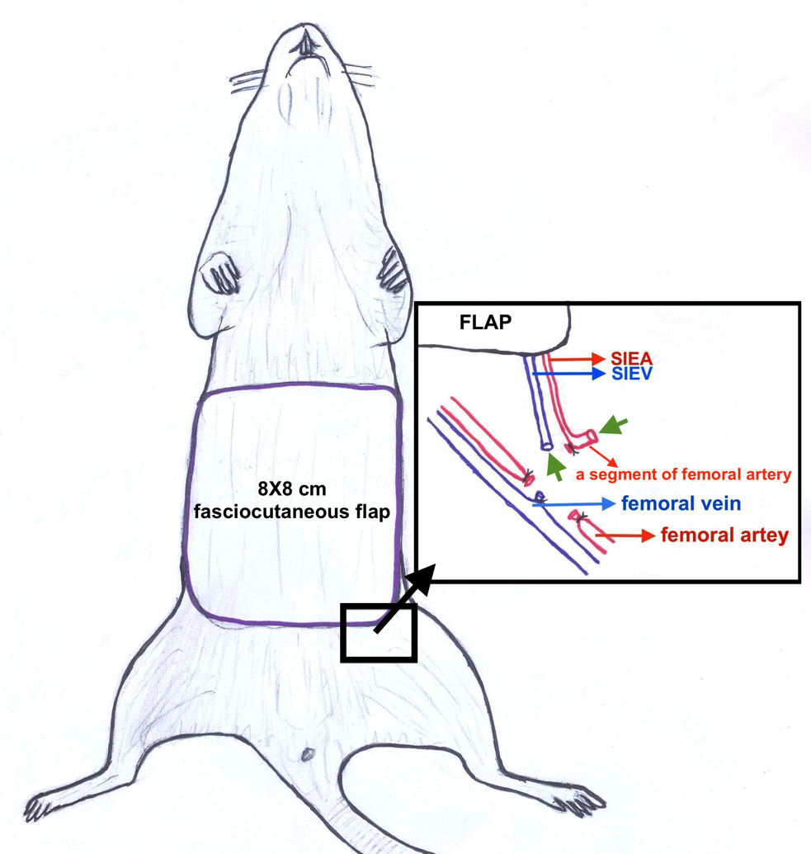
Figure 1. Schematic drawing of the left pedicle, where the hydrostatic dilation procedure was applied. Green arrowheads show the vessels to which hydrostatic dilation was applied.

Results: The flap necrosis rates for groups were control group: 44.75±4.31%; delay group: 33.32±7.11%; and HD group: 32.51±5.03%. There was a significant difference between the control group and the HD and delay groups (p < 0.05). There was no difference between the delay and hydrostatic dilation groups about surface area necrosis. Looking at the microangiographies overall, the increased vascularity in delay and HD groups were remarkable.

Conclusion: HD is a new method of enhancing flap viability. We believe that it can be used in clinical cases instead of surgical delay after further experimental evidence and clinical trials. HD procedure was not superior to the surgical delay procedure, however it has many advantages over the surgical delay: it is noninvasive, application is easy, does not need second operation, less time consuming and more cost-effective.

References
- Glotzbach JP, Levi B, Wong VW, Longaker MT, Gurtner GC. The basic science of vascular biology: implications for the practicing surgeon. Plast Reconstr Surg. 2010 Nov;126(5):1528-38.
- Karacaoglu E, Yuksel F, Turan SO, Zienowicz RJ. Chemical delay: an alternative to surgical delay experimental study. Ann Plast Surg. 2002 Jul;49(1):73-80; discussion 82-1.

Disclosure/Financial Support None of the authors has a financial interest in any of the products, devices, or drugs mentioned in this manuscript.

