Implementation of a Successful Pressure Ulcer Prevention (PUP) Program in a Tertiary Care Hospital.
Umar Choudry, MD; Mary Murphy, RN, Patrick Boland MS1.
Abstract
Introduction: In 2008, CMS (Medicare and Medicaid) decided to stop all reimbursement for stage III and IV HAPU. The Minneapolis VAMC created the Interdisciplinary Pressure Ulcer Prevention Committee (IPUPC) to evaluate, recommend, and implement changes in the hospital to reduce HAPU.
Methods and Materials: The IPUPC used the National Pressure Ulcer Advisory Panel (NPUAP) Clinical Practice Guidelines as reference. We initiated the ‘Analysis’ Phase in 2009, studying the current procedures in place at the time. We then performed the ‘Design’ Phase, delineating the changes and improvements to the system based on the above guidelines. The ‘Implementation’ Phase of these changes went into effect in 2010. The ‘Maintenance’ Phase has continued ever since with quarterly data collection and analysis.
Results: The IPUPC met monthly and after the ‘Analysis’ Phase, we decided to ‘Implement’ the following changes:
- A hard-stop to document at the time of admission the presence or absence of a pressure sore
- A concerted effort to educate all the providers of the hospital about PUP.
- We created ‘Skin Champions’ on every floor (nurses who were ‘experts’ at PUP) as go-to specialists.
- On admission and then at daily rounds, every patient ‘flagged’ at risk for a potential HPAU had a specific ‘PUP’ order set placed into their chart:
    - Consultation of a wound nurse
    - Consultation of a dietician
    - Turning protocol
    - Skin protection protocol
    - Stool/urine control protocol
    - Pressure relief protocol for at risk areas e.g. ankles, occiput, pressure points from tubing/casts etc.
    - Patient and Family education protocol
- HAPU identified on daily rounds would initiate an ‘Incident Report’ that would have to be followed up by the appropriate nurse manager.
- Implementation of quarterly data collection rounds: Every 3 months the WOC nurses and Skin Champions would examine EVERY patient on EVERY floor for HAPU (Prevalence-Incidence (PI) Studies).
Once the above steps were initiated, at the monthly IPUPC meetings every HAPU would be discussed in detail and a RCA (Root Cause Analysis) performed. This became part of our ‘Maintenance’ Phase. Through these RCA and quarterly PI studies, we made improvements and changes in the protocols for PUP. The above steps resulted in a 78.4% drop in total HAPU in 3 years, with an 82% drop in Stage I and II HPAU, and 50% drop in Stage III and IV HAPU (Figure 1).
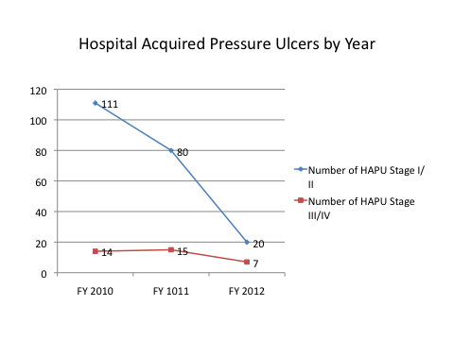
Figure 1: The figure shows the decrease in HAPU through FY 2010 – FY 2012.
Conclusions: A multi-disciplinary team implemented ‘Analysis’, ‘Design’, ‘Implementation’, and ‘Maintenance’ Phases to successfully drop HAPU by about 80% in 3 years. This approach can be used by other tertiary care centers for PUP.
References
- Minnesota Hospital Association Safe Skin Model. Website: https://www.mnhospitals.org/pressure-ulcers . Last accessed June 3, 2014.
- National Pressure Ulcer Advisory Panel Quick reference Guide to Pressure Ulcer Prevention. Website: http://www.npuap.org/wp-content/uploads/2012/02/Final_Quick_Prevention_for_web_2010.pdf. Last accessed June 3, 2014.

Disclosure/Financial Support

No financial support was provided to conduct the research.

None of the authors has a financial interest in any of the products, devices, or drugs mentioned in this manuscript.

