In Vitro Characteristics of Porcine Tendon Hydrogel for Tendon Regeneration
Chris Crowe, BS, Grace Chiou, MD, Rory McGoldrick, MBBS, Kenneth Hui, BA, Emily Hollenbeck, BS, Hung Pham, BS, James Chang, MD
Purpose:
Previous work has characterized the development of a human tendon hydrogel capable of improving mechanical strength following tendon injury (1). Animal tendon hydrogel has not yet been described, but would prove beneficial due to the cost and ethical concerns associated with the use of human cadaveric tendon. This study details the manufacture and assesses the biocompatibility of porcine tendon hydrogel seeded with human adipoderived stem cells (ASCs).
Methods and Materials:
Porcine tendon was dissected from surrounding connective and muscle tissue and decellularized via 0.2% SDS and 0.2% SDS/EDTA wash solutions before lyophilization. Tendon was milled and reconstituted by previously described methods (2). Decellularization was confirmed by H & E staining, SYTO Green 11 nucleic acid dye, and DNeasy assay. The protein composition of milled tendon matrix before and after digestion was identified by mass spectrometry. Rheological properties were determined using an ARG2 rheometer. Biocompatibility was assessed by live/dead assay. The proliferation of human ASCs seeded in porcine and human hydrogel was measured by MTS assay. All experimental conditions were performed in triplicate.
Results:
Histology of H & E and SYTO Green stained tendon showed no cells or nucleic acid, respectively, following SDS and EDTA washes. Using DNeasy assay, only 132 ng DNA per mg of tendon persisted after washes – a value similar to decellularized human tendon (3). Mass spectrometry showed that collagen composes 32.3% and 35.8% of milled porcine tendon before and after pepsin digestion, respectively (Figure 1). Rheology demonstrated that porcine hydrogel maintains a fluid consistency over a range of temperatures, unlike human hydrogel, which tends to solidify. Live/Dead staining revealed that human ASCs survive in hydrogel ten days after seeding and retain spindle-like morphology. Cell proliferation was measured in 2% human hydrogel and 1% porcine hydrogel at 3 (O.D. 0.68 and 0.58, respectively; p = 0.051) and 5-day (O.D. 1.17 and 0.92, respectively; p = 0.05) time points (Figure 2).
Conclusion:
Following reconstitution and digestion, porcine hydrogel was capable of growing human ASCs for at least ten days. The minimal difference in proliferative capacity suggests that porcine tendon hydrogel may be an effective and viable alternative to human hydrogel for the enhancement of tendon healing.

References:
- Kim M, Farnebo S, Woon C, Pham J, Chang J. Tendon Hydrogel Improves Healing in a Rat Achilles Tendon Injury Model, Plastic & Reconstructive Surgery, in press.
- Farnebo S, Woon CYL, Schmitt T, Jourbert LM, Kim M, Pham H, Chang J. Design and characterization of an injectable tendon hydrogel: a scaffold for guided tissue regeneration in the musculoskeletal system. Tissue Eng Part A. 2013. Epub 2013/12/17.
- Pridgen BC, Woon CY, Kim M, Thorfinn J, Lindsey D, Pham H, Chang J. Flexor tendon tissue engineering: acellularization of human flexor tendons with preservation of biomechanical properties and biocompatibility. Tissue Eng Part C Methods. 2011;17(8):810-28.

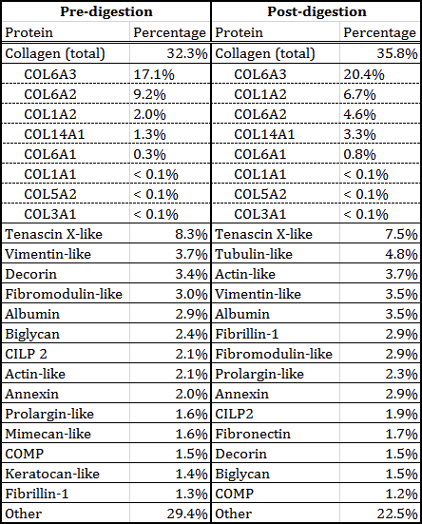
Figure 1. Mass spectrometry of porcine tendon hydrogel before and after digestion.

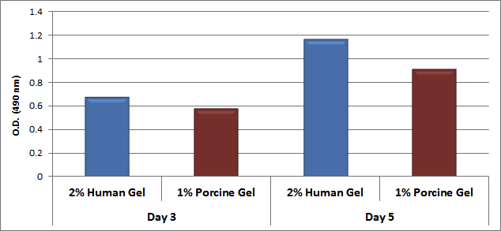
Figure 2. Proliferation of human ASCs in human and porcine tendon hydrogel.

