Enhanced Nerve Regeneration by Minimizing Intraneural Scarring using a Semi-Permeable Nanofiber Wrap.
Karim A. Sarhane, MD, MSc; Zuhaib Ibrahim, MD; Chris Cashman, MD/PhD candidate; Russel Martin, MS candidate, Kellin Krick, PhD candidate; Sami H Tuffaha, MD; Justin M Broyles, MD; Baohan Pan, MD, PhD; Nijaguna Prasad, PhD; Sepehr Tehrani, MD candidate; Mohammed Alrakan, MD; Christopher Wallner, MD; Damon S. Cooney, MD, PhD; Ruifa Mi, MD, PhD; Ahmet Höke, MD, PhD; WP Andrew Lee, MD; Hai-Quan Mao, PhD; Gerald Brandacher, MD
Abstract
Background: Despite great advances in microsurgery, functional outcomes following nerve repair remain suboptimal. Scar formation at the repair site is recognized as a major impediment to regenerating axons. In this regard, an inert barrier around the coaptation site that prevents inflammatory cells infiltration while still allowing the diffusion of nutrients and nerve growth factors holds great potential in promoting nerve regeneration and functional return. In this study, we examined the efficacy of a novel semi-permeable nanofiber construct, prepared from FDA approved biomaterials, to be used as a wrap around the repair site to promote nerve regeneration and functional recovery.

Methods: Nerve wraps comprised of nonwoven electrospun poly (ε-caprolactone) nanofibers with pores smaller than 10 µm were synthesized (Fig. 1a). They were wrapped around the repair site in a sciatic transection/repair model in Thy-1 GFP rats. At 5 weeks, their neuro-protective and neuro-regenerative potentials were assessed. At 16 weeks, functional recovery was evaluated.

Results: At 5 weeks, the nanofiber wraps resulted in significantly decreased collagen deposition and inflammation/macrophage invasion at the repair site (Fig. 1b). The total number of myelinated axons was significantly increased (Fig. 1d), and there was a trend towards a higher number of regenerated dorsal root ganglion sensory neurons. Mechanistically, these outcomes were correlated to an up-regulation of the anti-inflammatory cytokine (IL-10) and down-regulation of the pro-inflammatory cytokine (TNF-α) (Fig. 1e). In addition, at 16 weeks, the nerve wrap group showed enhanced functional recovery as demonstrated by electrophysiology (Fig. 1f), gait analysis, neuromuscular junction re-innervation (Fig. 1g), and gastrocnemius muscle weight and histology.

Conclusions: Our results demonstrate favorable outcomes of a novel semi-permeable and clinically translatable nanofiber nerve wrap in protecting the coaptation site and enhancing axonal regeneration through scar-free nerve repair, resulting in optimal functional recovery.

Disclosure/Financial Support
None

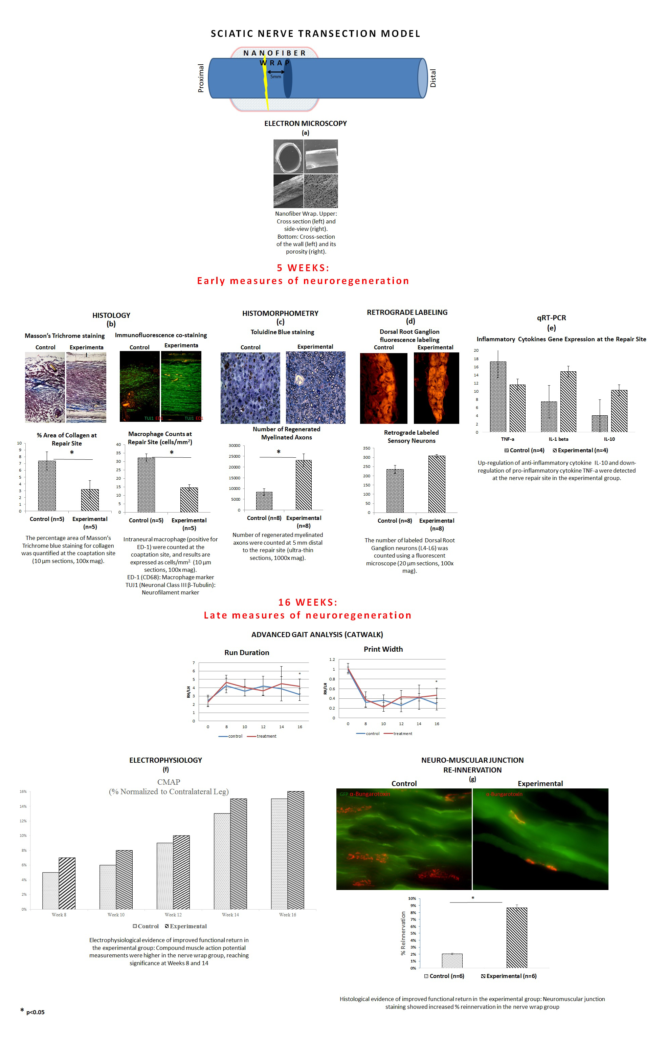
Figure 1. Analysis of Early and Late Measures of Nerve Regeneration Using the Nanofiber Nerve Wrap.

