Publication Bias and the Under-Reporting of Complications in the Literature; Have We Dug Our Own Pay-for-Performance Grave?

Michael R. DeLong, MD; Duncan B. Hughes, MD; Jared A. Blau, BS, MEd; Scott T. Hollenbeck, MD

Background: With the evolution of healthcare delivery and the transition to outcomes-based reimbursement it is critical to establish an accurate and achievable baseline level of performance for future comparison. We hypothesize that historical reports are subject to publication bias and may under-report complication rates for common plastic surgery procedures. To test this, we compared breast free flap reconstruction complication rates using the National Surgical Quality Improvement Database (NSQIP) with rates reported currently in the literature.
Methods: Prior studies with data obtained from the NSQIP database were identified and included to determine NSQIP complication rates. To determine the reported literature complication rates, historical references were included from several separate institutions with a study population of greater than 100 patients. Due to the limited complication categories available in the NSQIP dataset, only wound infection and free flap failure were enumerated. The complication rates between NSQIP and literature groups were compared with Chi Square testing.
Results: A total of 609 free flap breast reconstructions were identified from the NSQIP dataset, with a reported flap failure rate of 5.7% and wound infection rate of 5.9%. Upon reviewing the current literature, 9 studies were included (Table 1) with an average reported flap failure rate of 1.7% (68/4040, p < 0.0001) and wound infection rate of 5.8% (156/2712, p > 0.05).

Conclusions: The current literature on surgical complications is potentially susceptible to publication bias and may under report certain complications (free flap failure, Figure 1). While the NSQIP dataset may more accurately report immediate complications, it does not capture sub-acute and long-term complications. Additionally, the inconsistent coding, minimal detail, and paucity of plastic surgery specific complication types limit the utility of the NSQIP dataset. With the transition of reimbursement paradigms it is imperative to develop methods to determine complication rates that accurately reflect true frequency, as surgeons will be held to these standards in the future.

Disclosure/Financial Support:
The study was not funded. The authors report no financial conflicts of interest.

Table 1. Complication Reporting for Breast Reconstruction Free Flaps
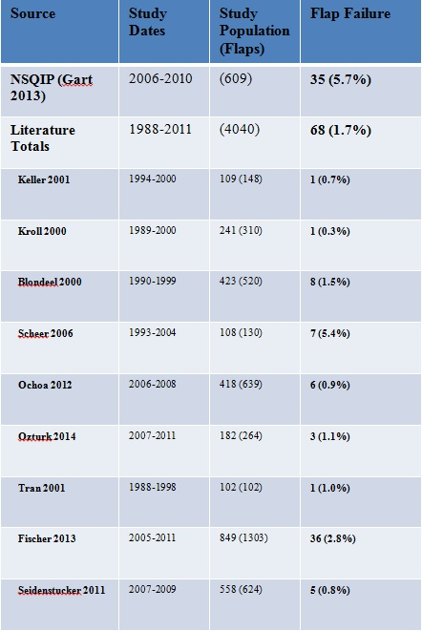

Figure 1. Current Reported Free Flap Failure Rate Compared to NSQIP

