Measuring Outcomes that Matter to Cosmetic Patients: Development and Validation of the FACE-Q Satisfaction with Lips and Lip Lines Scales
Jonathan A. Schwitzer, Anne F. Klassen, Stefan J. Cano, and Andrea L. Pusic
Abstract
Purpose: Over 13 million minimally invasive cosmetic procedures were performed in the United States in 2012, a 137% increase from 2000¹. Accurate and reliable measurement of patient-reported outcomes is crucial to ongoing practice improvement and clinical research in this area of facial aesthetics. The FACE-Q is a new patient-reported outcome instrument (PRO) comprised of a series of independently functioning scales and adverse effects checklists designed to measure outcomes important to facial aesthetic patients (surgical and nonsurgical). Here we describe the development and validation of FACE-Q Satisfaction with Lips and Lip Lines scales.
Methods: The FACE-Q was developed according to international guidelines for PRO instrument development. Through qualitative methods we identified concepts important to facial aesthetic patients, which were used to inform upon the following items and scales: Satisfaction with Lips, Satisfaction with Lines around Lips. These scales were field tested in 12 plastic surgery and dermatology practices across North America from 2010-2013, as well in an international clinical trial studying a minimally invasive lip treatment. Rasch Measurement Theory (RMT) and traditional psychometric methods were used to evaluate scale reliability and validity. Clinical change was assessed using pre- and post-treatment Rasch transformed scores for the lip scales as well as for the previously validated Satisfaction with Facial Appearance scale,² comparing paired t-tests and calculating Kazis effect sizes and standardized response means.
Results: 398 patients completed the FACE-Q scales. Mean age was 44.7 years (range 18-76, SD 14.6 years); 36 (9.0%) patients were male. RMT methods resulted in the validation of the Satisfaction with Lips and Lip Lines scales, which were found to be psychometrically sound and clinically meaningful with excellent reliability and validity. Rasch transformed scores (range 0-100) were found to change significantly pre- to post-treatment, including in Satisfaction with Lips (34.9 pre v 74.5 day 30 post-treatment, p<0.001), Lip Lines (45.3 pre v 79.4 day 30 post-treatment, p<0.001) , and Facial Appearance (40.6 pre v 57.0 day 90 post-treatment, p<0.001) (Figure 1).

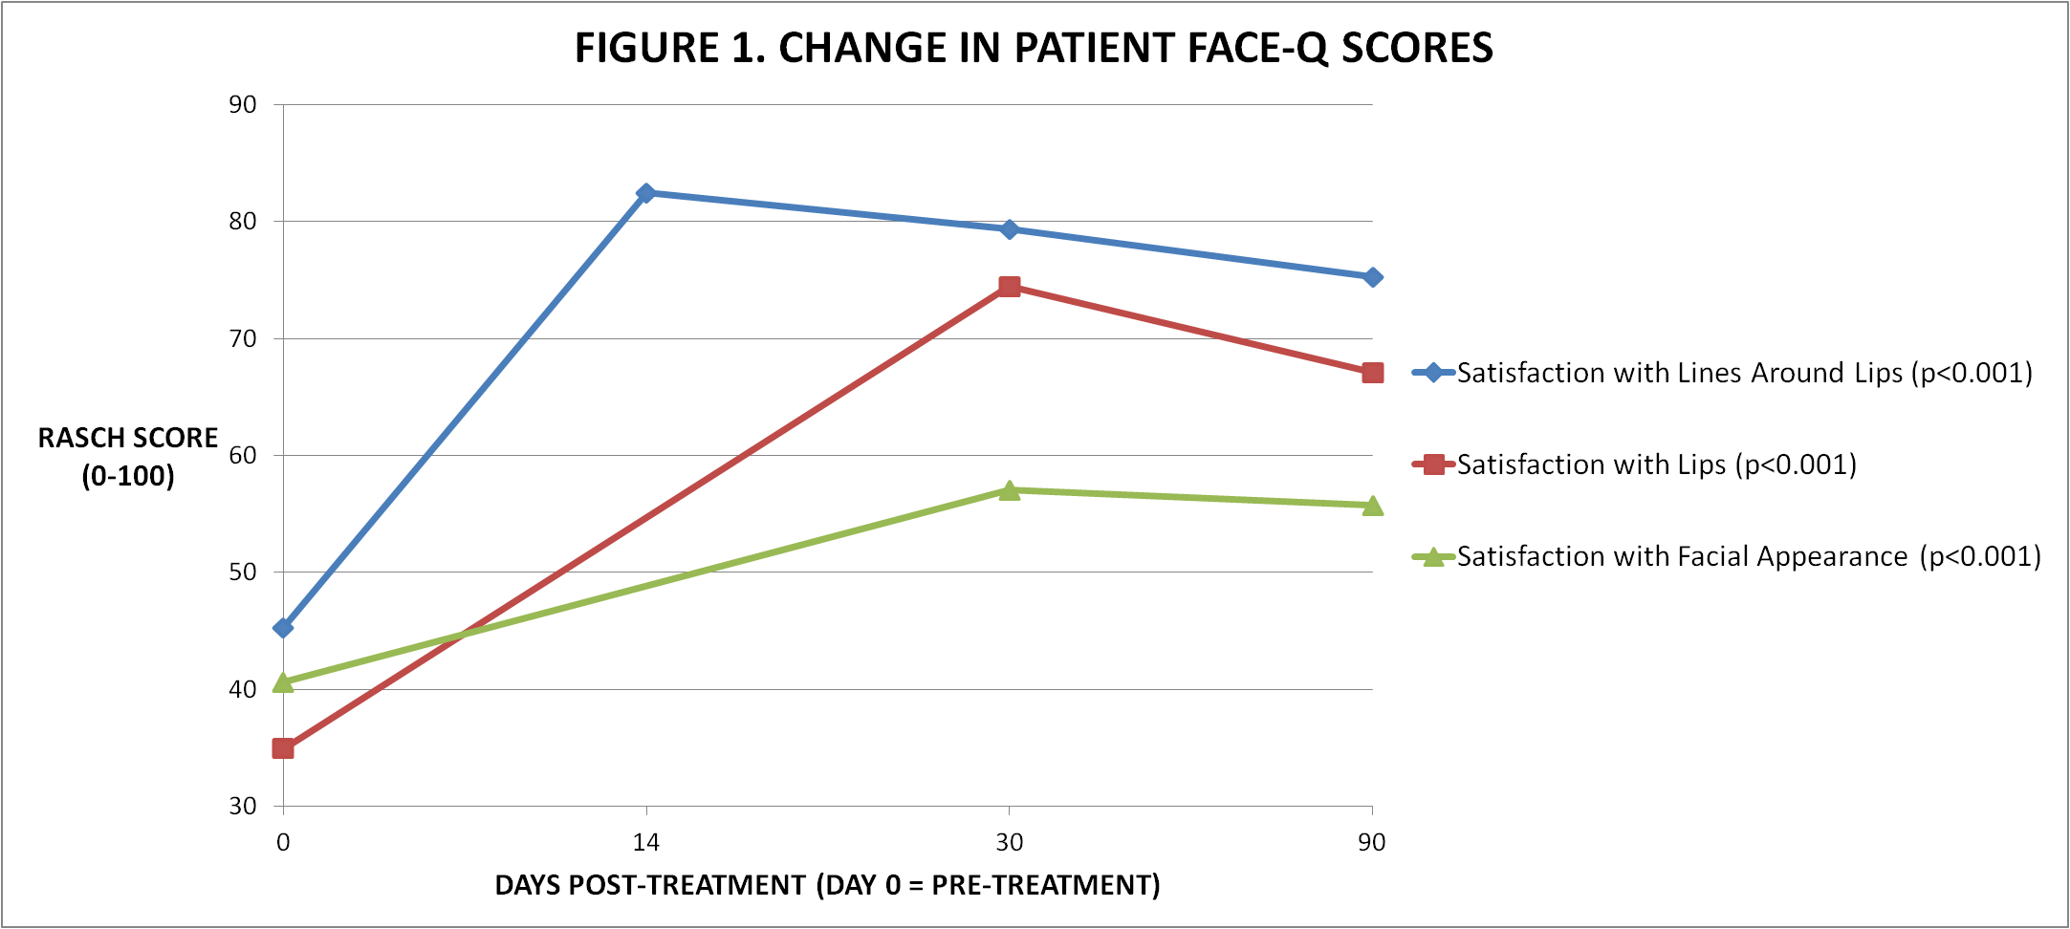
Conclusions: As the number of cosmetic procedures continues to grow, the process must be guided by high-level evidence. The FACE-Q was developed as a comprehensive outcome measurement tool for patients undergoing facial aesthetic procedures, enabling accurate quality of life measurement assessments that will further evidence-based practice.
References:
1. “2012 Plastic Surgery Statistics Report: 2012 Cosmetic Plastic Surgery Statistics, Cosmetic Procedure Trends.” American Society of Plastic Surgeons. February 19, 2014. http://www.plasticsurgery.org/Documents/news-resources/statistics/2012-Plastic-Surgery-Statistics/full-plastic-surgery-statistics-report.pdf
2. Pusic AL, Klassen AK, Scott A, et al. Development and Psychometric Evaluation of the FACE-Q Satisfaction with Appearance Scale. Clin Plast Surg. 2013 Apr;40(2):249-60.
Disclosures:
The FACE-Q is owned by Memorial Sloan-Kettering Cancer Center. Drs. Cano, Klassen, and Pusic are co-developers of the FACE-Q and as such receive a share of licensing revenues based on the inventor sharing policies of Memorial Sloan-Kettering Cancer Center.

