Prospective, Multi-Center, Pivotal Trial Evaluating the Safety and Effectiveness of Micro-focused Ultrasound with Visualization (MFU-V) for Improvement in Lines and Wrinkles of the Décolleté

Steven H. Dayan, MD; Sabrina G. Fabi, MD; Mitchel P. Goldman, MD; Suzanne L. Kilmer, MD; Michael H. Gold, MD

Abstract

Objective: Photodamage of the surrounding skin of the neck and chest area (décolletage) is often highlighted as patients continue to invest in rejuvenating their facial skin. This prospective, multi-center, single treatment study evaluated aesthetic improvement in lines and wrinkles of the décolleté with MFU-V.

Methods: 125 female subjects meeting inclusion and exclusion criteria were enrolled and completed one treatment on the chest using three transducers: 4 – 4.5mm (1.2J), 7 - 3.0mm (0.45J), and 10-1.5mm (0.20J). Pain was assessed using a validated scale (0-10) during the treatment. Standardized photographs were taken prior to treatment, immediately after treatment, and at each follow-up visit (day 90 and 180).

Efficacy will be determined by blinded masked assessments at 180 days post treatment compared to baseline. Physician Global Aesthetic Improvement Scale (PGAIS) scores and Patient Satisfaction Questionnaire (PSQ) responses will be tabulated at days 90 and 180 post-treatment.

Results: Treated subjects (n=125) presented with a mean age of 56.7 years old (37.5 – 70.4), mean BMI of 24.7 (18.3 – 38.3) and Fitzpatrick skin types I-IV (I-0.8%, II – 48.0%, III – 41.6% and IV -9.6%). The mean pain score at each depth was 6.2 at 4.5mm, 5.9 at 3.0mm, and 4.8 at 1.5mm. Masked Assessment results show improvement in 66.4% of subjects at 180 days using the Last Value Carried Forward method. CGAIS scores show 75.0% of subjects improved at 90 days and 66.4% at 180 days. At the 90-day visit, 83.6% of subjects noted an improvement and 65.5% were satisfied. Day 180 results show a similar trend with 82.7% of subjects noting improvement and 62.7% satisfied. Agreement was noted across all measures at both Day 90 and 180 time points, suggesting that improvements observed following treatment are clinically significant. Most notable is alignment in subject reported improvement and masked clinician assessment of improvement. Device safety was demonstrated, no serious adverse events reported. Of the adverse events, all were mild except two (1.9%) that were moderate, one of which was not device related. All events resolved. A typical result can be seen below (figures 1 and 2).

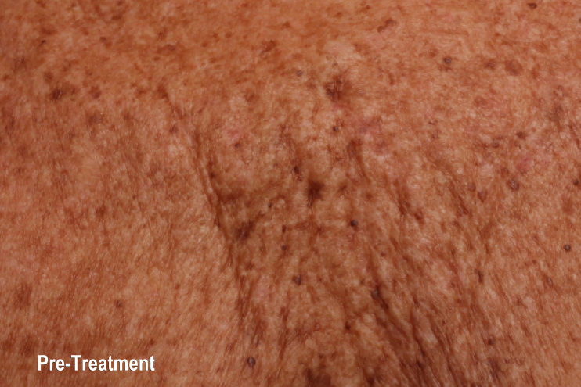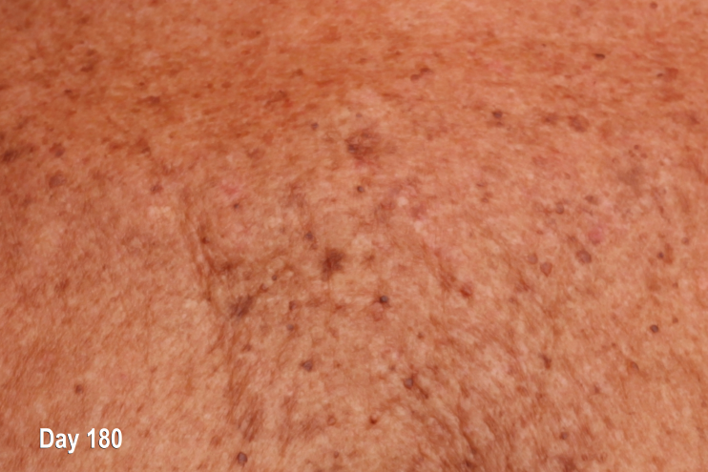
Figure 1. Pre-treatment, Before MFU-V Treatment Figure 2. 180 Days Post 1 MFU-V Treatment

Conclusion: These results demonstrate significant reduction of wrinkles and lines, as well as tightening and toning of the Décolleté at three and six months after a single treatment using MFU-V. Comfort was managed with oral pre-treatment medications.

