What Makes a Plastic Surgery Residency Attractive: An Applicant’s Perspective
David A. Atashroo, M.D.; Krishna Vyas, B.S., M.H.S.; Elizabeth R. Zielins, M.D.; Zeshaan Maan, MBBS, MS, MRCS; Graham G. Walmsley, M.D.; Michael P. Lynch, M.D.; Daniel L. Davenport, Ph.D.; Michael T. Longaker, M.D., MBA; Henry C. Vasconez M.D.
Abstract
Background: Plastic Surgery is among the most competitive specialties, and although some of the attributes of successful applicants have been described, little is known about the characteristics of programs that are most attractive to successful applicants (1-5). This study aimed to understand program characteristics that are most influential to students when ranking plastic surgery programs and to identify changes that programs may make to improve and to attract the best students.
Methods: An anonymous, 21-question, multiple choice and open response online survey of newly matched plastic surgery residents for the integrated and combined match in the 2011-2012 and 2012-2013 academic years was conducted. Subjects were queried regarding their personal qualifications, application experiences, and motivations for residency program selection.
Results: A total of 92 out of 245 matched plastic surgery residents responded for a participation rate of 38%. (Table 1) Applicants with Step I scores greater than 245 received significantly more interviews (*p=.001) (Figure 1) and ranked faculty mentorship programs and resident benefits as significantly less important (*p<.05), but geographic location as significantly more important (*p=.005). Applicants who had published more than two manuscripts received significantly more interviews (*p=.001) (Figure 1) and ranked the presence of a strong research infrastructure and program reputation as significantly more important (*p<.05). Forty-two percent of applicants completed an away rotation at the program which they matched, and these applicants were significantly more likely to match at their number one ranked program (*p=.001).
Table 1: Demographics of newly matched plastic surgery applicants who responded to the survey.
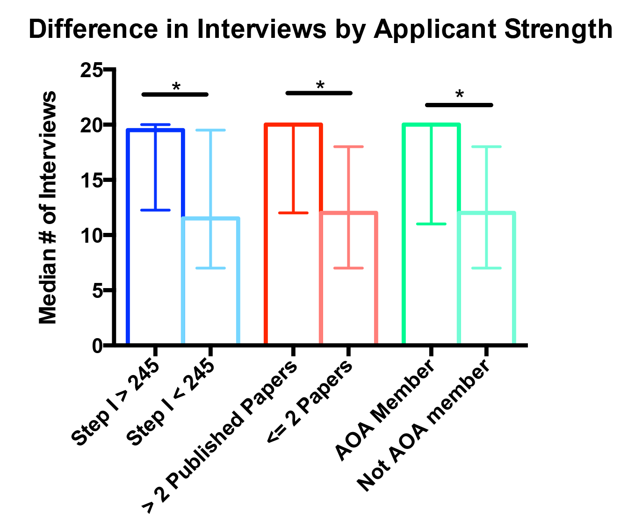
Figure 1: Comparison of number of interviews receives to standard metrics of applicant strength.
Conclusions: Plastic surgery applicants have differing preferences regarding the ideal training program, but some attributes resonate similarly among applicants. These trends can guide programs for improvement. Notably, research infrastructure and support should be encouraged and enhanced. Resident relationships should be fostered within and outside the medical center. Away rotations should receive strong encouragement at all levels, and a commitment to fostering residents to work and train in environments that promotes their well-being and happiness should be a guiding principle.
References
1. Program, N. R. M. Advanced data tables for 2006 main residency match. Association of American Medical Colleges, 2006:4-7.
2. Wood, J. S., David, L. R. Outcome analysis of factors impacting the plastic surgery match. Annals of plastic surgery 2010;64:770-774.
3. Rogers, C. R., Gutowski, K. A., Munoz-Del Rio, A., et al. Integrated plastic surgery residency applicant survey: characteristics of successful applicants and feedback about the interview process. Plastic and reconstructive surgery 2009;123:1607-1617.
4. LaGrasso, J. R., Kennedy, D. A., Hoehn, J. G., Ashruf, S., Przybyla, A. M. Selection criteria for the integrated model of plastic surgery residency. Plastic and reconstructive surgery 2008;121:121e-125e.
5. DeCroff, C. M., Mahabir, R. C., Zamboni, W. A. The impact of alpha omega alpha membership on successfully matching to residency. Plastic and reconstructive surgery 2010;126:113e-115e.

Disclosures/Financial Support
None of the authors has any financial interest in any of the products, devices, or drugs mentioned in this manuscript.

