Adipose Derived Stromal Cells Obtained by Ultrasound Assisted Liposuction Versus Suction Assisted Liposuction: A Comparison of Their Regenerative Capacity

David Atashroo, MD; Dominik Duscher, MD; Zeshaan N. Maan, MBBS, MSc, MRCS; Elizabeth R Zielins, MD; Kevin Paik, BS; Alexander Whittam, BS; Michelle Lin, BS; Adrian McArdle, MB, BCh, BAO(NUI), MRCSI; Christopher Duldulao, BS; Graham G Walmsley, BA; Michael S Hu, MD, MPH, MS; Ruth Tevlin, MB BAO BCh (NUI), MRCSI, Derrick C. Wan, MD; Geoffrey C. Gurtner, MD, FACS; Michael T Longaker, MD, MBA

Abstract

Introduction:
Ultrasound assisted liposuction (UAL) is gaining popularity in plastic surgery for permitting easier fat harvest while minimizing trauma and blood loss (1). However, little has been studied concerning the quality of adipose derived stromal cells (ADSCs) obtained with this method. As the role of ADSCs in cell based therapies is growing dramatically, we studied the regenerative abilities of ADSCs harvested by traditional suction assisted liposuction (SAL) versus UAL.

Methods:
Paired lipoaspirate samples obtained via SAL and UAL from healthy patients were analyzed for their ADSCs yield via Fluorescent Assisted Cell Sorting (FACS) using an established progenitor surface marker profile (CD34⁺CD31⁻CD45⁻). Cells sorted by this profile were then compared for their proliferation capacity using an MTT assay and were grown in culture for differentiation toward adipogenic and osteogenic lineages. Gene expression profiles were compared with qPCR. Cell staining was used to compare adipogenic and osteogenic markers. Tissue regenerative abilities were compared employing an established murine wound-healing model by adding 250k ADSCs obtained via SAL or UAL seeded on a hydrogel scaffold to the wounds controlled with hydrogel alone.

Results:
There was no significant differences in ADSC yield, viability or proliferation between UAL and SAL (*p<.05) (Figure 1). Equal adipogenic differentiation capability was demonstrated on Oil Red O staining and by the lack of any significantly different expression of PPAR-gamma or LPL at Day 7 of differentiation (*p>.05). Similarly, Alkaline Phosphatase and Alizarin Red staining demonstrated similar osteogenic differentiation capability that coincided with the non-significantly different expression of osteogenic markers Runx-2, Osteopontin and Osteocalcin (*p>.05). There was a significantly accelerated rate of wound healing comparing each of the cell assisted groups versus hydrogel alone (*p<.05) and no significant difference between SAL and UAL groups (*p>.05) (Figure 2).
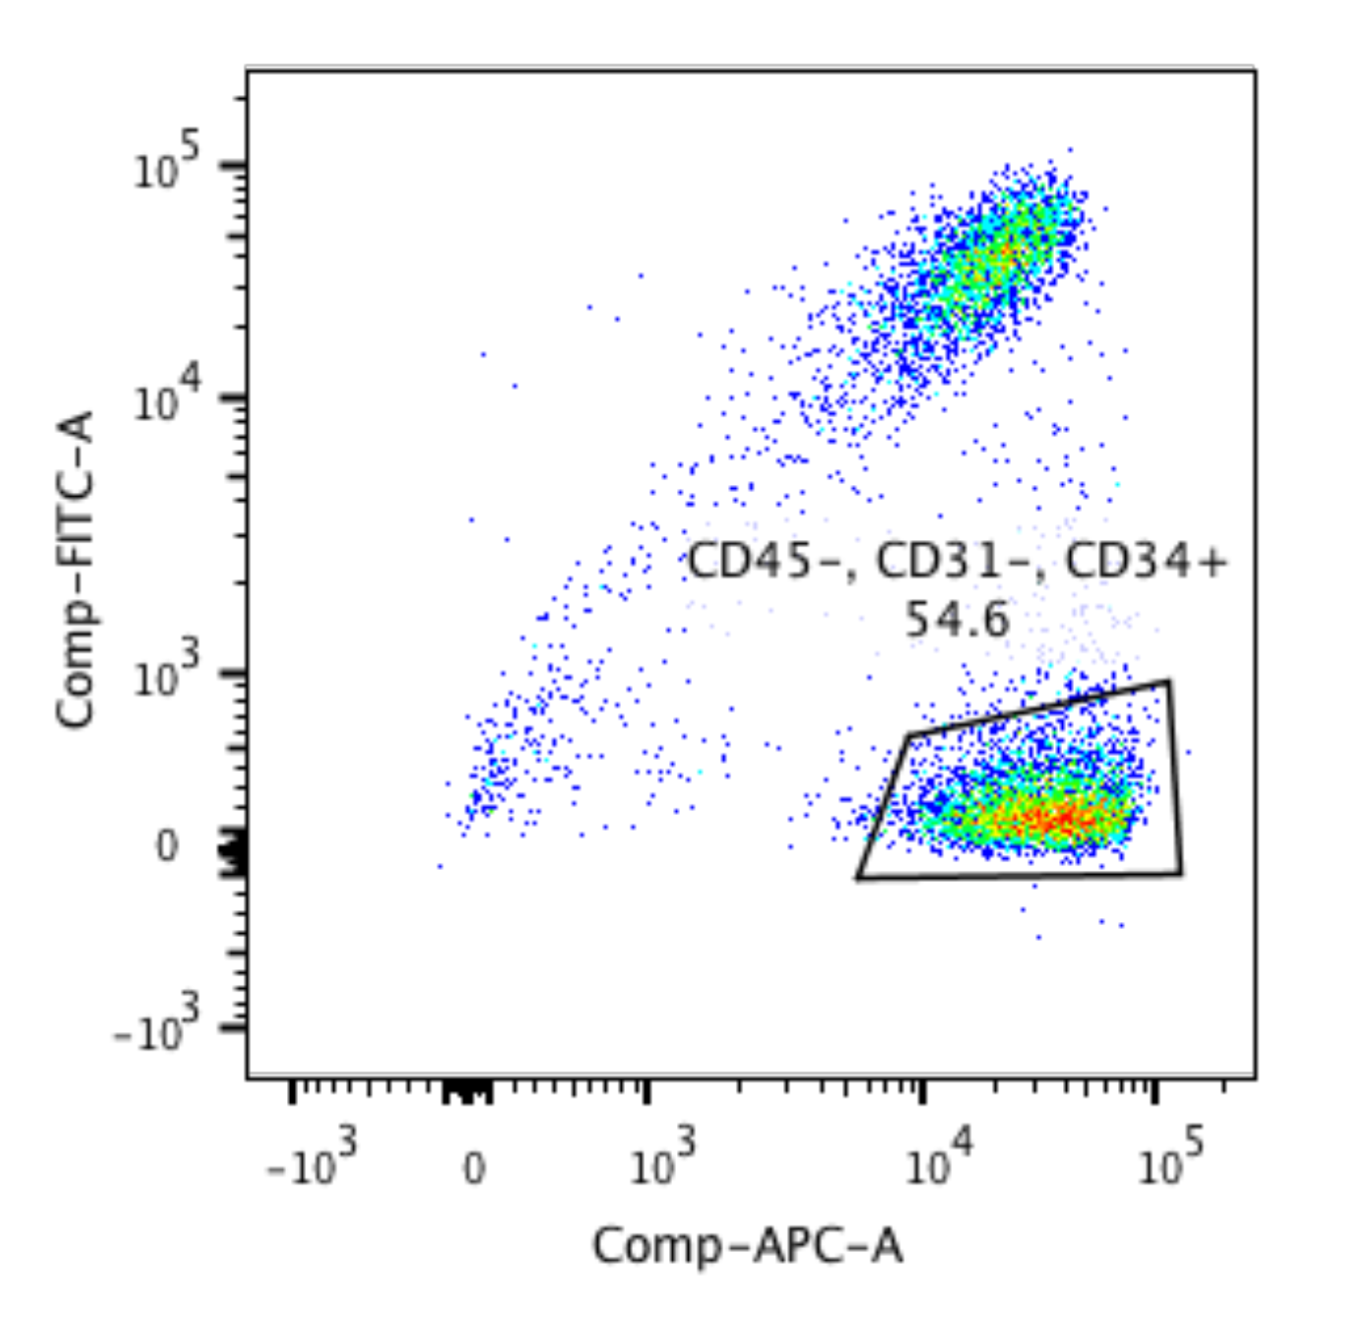

Figure 1: Representative FACS data of ADSC subpopulation.

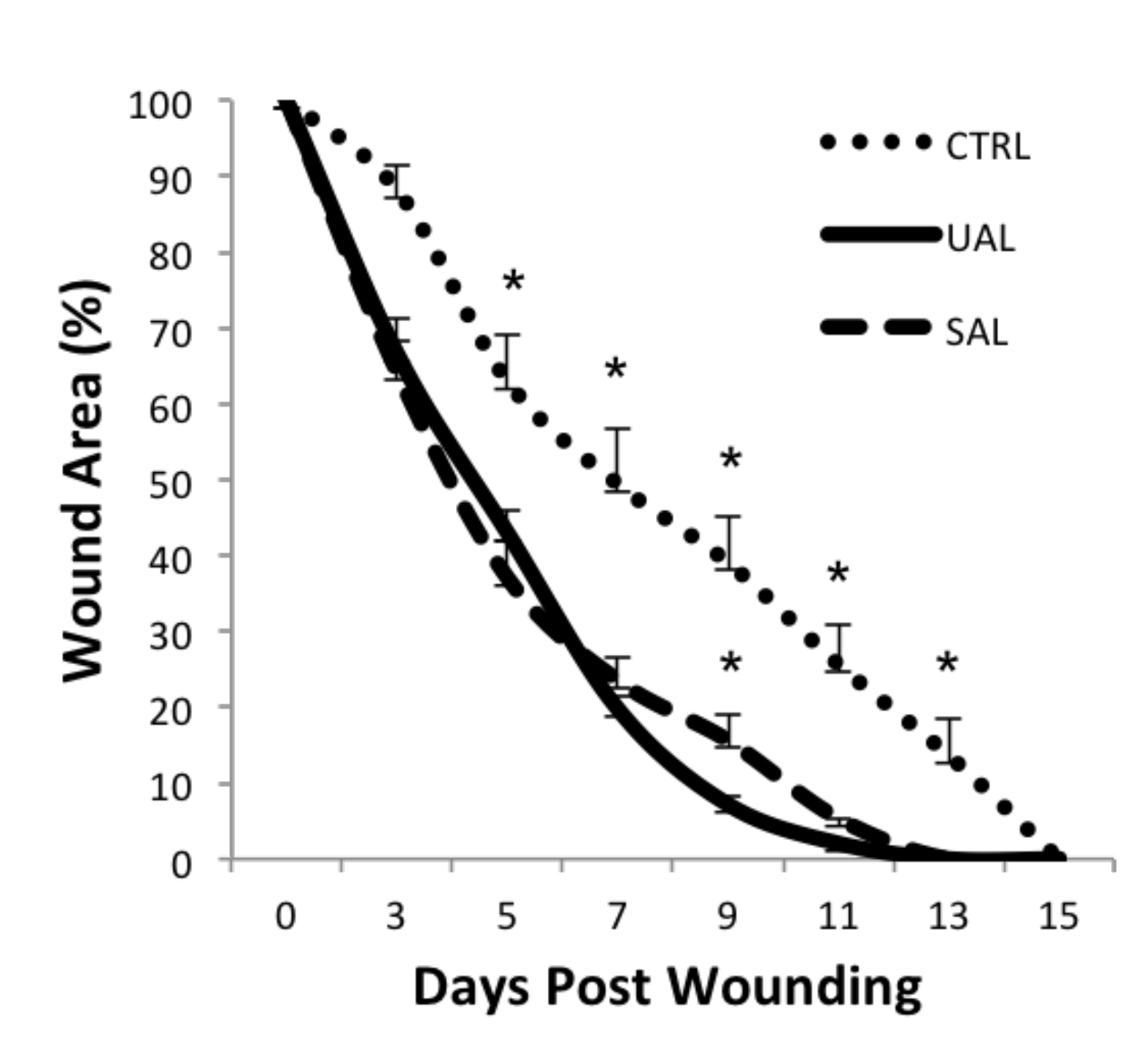
Figure 2: In Vivo wound healing data

Conclusions:
UAL represents an equivalently viable way to obtain functional ADSCs for cell-based therapies as compared to traditional SAL.

References
1. Heymans, O., Castus, P., Grandjean, F. X. & Van Zele, D. Liposuction: review of the techniques, innovations and applications. Acta chirurgica Belgica 106, 647-653 (2006).

Disclosures/Financial Support
None of the authors has any financial interest in any of the products, devices, or drugs mentioned in this manuscript.

