Body Contouring Plastic Surgery Decreases Long-Term Body Mass Index Regain Following Laparoscopic Adjustable Gastric Banding, A Matched Retrospective Cohort Study.

Tali Friedman, MD, MHA, Itay Wiser, MD, PHD, Eliezer Avinoah, MD, Oren Ziv, MD, Tomer Ziv, PHD, Lior Heller, MD

Abstract

Background: Laparoscopic adjustable gastric banding (LAGB) bariatric surgery is the safest yet least effective reported method for massive weight loss . Thirty to 50 percent of patients undergoing LAGB will regain back part or most of their lost weight within 2-4 years . Recent evidence suggest that patients who underwent body contouring plastic surgery (BCPS) following bariatric Roux-en-Y technique demonstrate improved long-term weight control compared with those who did not . Our study objective was to evaluate the effect of BCPS following LAGB on long-term BMI control.

Methods: A retrospective cohort of patients aged 18-50 years, who underwent LAGB surgery between 1997 and 2007. Long-term weight regain was evaluated and compared between group of patients who underwent subsequent plastic surgery (LBCPS) and a group of LAGB alone (LAGBO). Groups were matched for age, gender, and initial body mass index (BMI). A multivariate Cox regression was used to evaluate the risk for long-term BMI regain.

Results: LBCPS (N=18) had lower endpoint BMI and BMI regain percentage compared with LAGBO (N=54) (24.64±3.76 kg/m² vs. 31.0±7.2 kg/m², p<0.001; 12.7±13.6% vs. 34.3±30.9%. p<0.001, respectively). No differences were observed in time from LAGB to minimal weight, and total follow-up time between both groups (2.3±1.5 vs. 2.7±1.8 years, p=0.39; 7.3±2.9 vs. 8.0±2.7 years, p=0.32, respectively). BCPS had an independent strong protective effect for endpoint BMI regain over 25% (see figure 1) and BMI≥30kg/m² (HR=0.19 , p=0.025; HR=0.13, p=0.046, respectively).

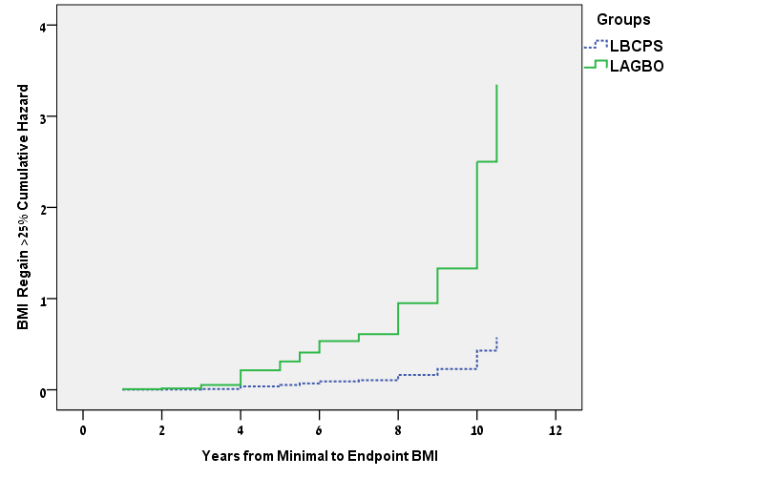
Figure 1 - Hazard Function for BMI Regain >25% in LBCPS and LAGBO groups

Conclusion: When compared with patients who did not undergo BCPS following LAGB, patients who underwent body contouring plastic surgery following LAGB had improved long-term BMI control.

Disclosure/Financial Support
This study was self-supported, and had no external source of funding.
None of the authors has a financial interest in any of the products, devices, or drugs mentioned in this manuscript.

References
1. Pontiroli AE, Morabito A. Long-term prevention of mortality in morbid obesity through bariatric surgery. a systematic review and meta-analysis of trials performed with gastric banding and gastric bypass. Annals of surgery. 2011;253(3):484-7.
2. Nguyen NT, Slone JA, Nguyen XM, Hartman JS, Hoyt DB. A prospective randomized trial of laparoscopic gastric bypass versus laparoscopic adjustable gastric banding for the treatment of morbid obesity: outcomes, quality of life, and costs. Annals of surgery. 2009;250(4):631-41.
3. Balague N, Combescure C, Huber O, Pittet-Cuenod B, Modarressi A. Plastic surgery improves long-term weight control after bariatric surgery. Plastic and reconstructive surgery. 2013;132(4):826-33.

