Approach to the Severe Hidradenitis Suppurativa Patient: A 20-Year Review

Nicholas Howland, MD; Erick Sanchez, MD; Matthew Bunker, BS; Kyle Kaltwasser, BS; John Bauer, MD; Linda Phillips, MD
Abstract
Purpose: Hidradenitis suppurativa is a chronic inflammatory skin disease that affects regions rich in apocrine sweat glands. The disease is typically nonresponsive to a range of medical therapy, and the mainstay of treatment remains surgical excision. There is a lack of standard treatment guidelines in approaching these patients. We present herein our own experience with this disease, including preoperative, operative, and postoperative management. We also present a new treatment algorithm for approach to the patient with severe hidradenitis suppurativa (HS).
Methods: A retrospective IRB-approved chart review of all patients diagnosed with hidradenitis at this institution from 1992-2012 was performed. Data gathered included pertinent risk factors (e.g. smoking, BMI, cancer history, etc.), culture data, medical intervention, surgical intervention, complications, and basic demographic information. All patients were classified based on lesion location (axilla, groin, perineal/perianal, breast, other) and operative intervention. Statistical analysis of the data was performed using SAS. A p-value of <0.05 was considered significant.
Results: A total of 683 patients were identified. Of these, 329 underwent surgical intervention for treatment of severe HS. The majority of surgical patients were treated with local excision and primary closure (n= 191). 98 patients required placement of STSG for coverage, and 40 patients required a local tissue flap. Patients were categorized according to defect closure: Type I-primary closure, Type II-primary closure +/- graft, Type III-graft +/- flap. Smoking status was not significant across all types of intervention (p=0.68). Of note, weight and BMI were independent risk factors for patients undergoing flap closure (p=0.03 and p=0.003, respectively). Total recurrence rate was 23%.
Conclusions: Hidradenitis suppurativa remains a difficult-to-treat cutaneous disease that profoundly affects diagnosed patients. While there is a variety of medical management available, surgical excision remains the mainstay of therapy. It is noted that this study is biased toward patients who have failed treatment by dermatology or their primary care physician. This institution treats a large number of these patients, both medically and surgically. A simple, stepwise approach (Figure 1) to the management of these patients provides for better patient satisfaction and less recurrence in this chronic disease.
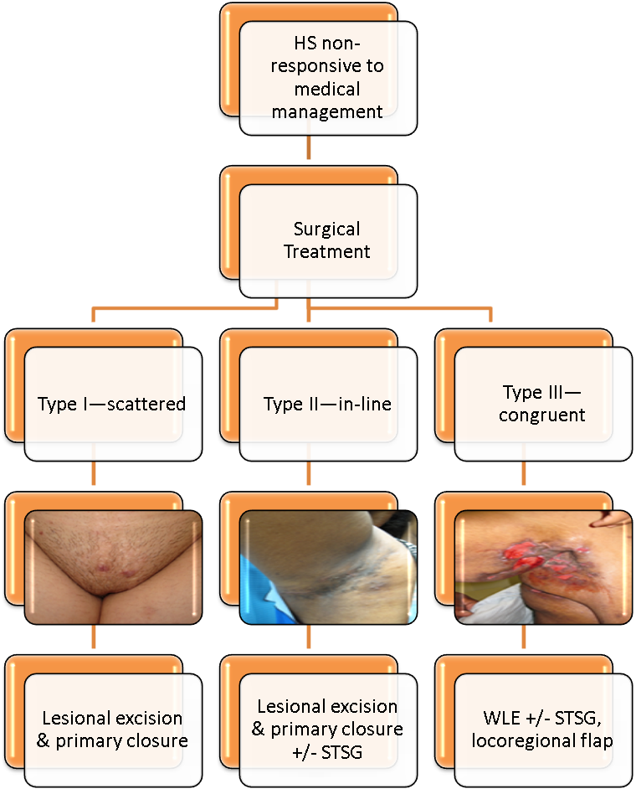

References
- Jemec, G. Hidradenitis Suppurativa. NEJM 366(2):158-164; 2012.
- Kurzen H, Kurokawa I, Jemec G, et al. What causes hidradenitis suppurativa? Exp Dermatol 17:455-472; 2008.

