Anatomical Study Quantifying Maneuvers to Increase Nasal Tip Rotation
Neil S. Sachanandani MD, Dennis C. Nguyen MD, Gary Skolnick BS, Albert S. Woo MD, Kamlesh B. Patel MD
Background: An algorithm has recently been described for control of nasal tip rotation with incremental maneuvers¹. It proposed the following sequence of rhinoplasty maneuvers: (1) tip suturing, (2) cephalic trim, (3) lowering of the anterior septal angle, (4) caudal septal resection, (5) shortening of the upper lateral cartilages to increase tip rotation. The purpose of our study is to quantify the amount of increase in nasal tip rotation in the first two maneuvers of the proposed algorithm, as they are the most common techniques used.
Methods: Nine fresh cadaveric noses were dissected with loupe magnification via an open rhinoplasty approach. We performed tip suturing with placement of a floating columellar strut graft followed by cephalic trim. Tip suturing included placement of an interdomal suture, medial crural suture, and medial crural septal suture. True lateral photographs were obtained for image analysis of the specimens and measurements of the nasolabial angle (NLA) were recorded. The change in the nasolabial angle was calculated to measure the effect on nasal tip rotation (Figs. 1 and 2).
Results: There was an increase of 15.1± 2.9 (mean ± standard error of the mean) degrees in the nasolabial angle across our group of specimens using this set of maneuvers. Placement of tip sutures and a columellar strut had a greater effect on increasing tip rotation than a cephalic trim (12.4 versus 2.7 degrees, p = 0.021).

Conclusion: Sequential rhinoplasty maneuvers are clinically known to alter nasal tip rotation and have a progressive effect of increasing rotation. Nasal tip suturing with concomitant placement of a columellar strut was shown to have a more profound effect on nasal tip rotation than the cephalic trim.
References
- Tabbal GN, Lee MR, Rohrich RJ. Altering Tip Rotation in Rhinoplasty: An Algorithmic Approach. Oral Presentation at the Texas Society of Plastic Surgeons Meeting and American Society of Plastic Surgeons Meeting. 2013.
Disclosures
None of the authors have a financial interest relevant to this manuscript.

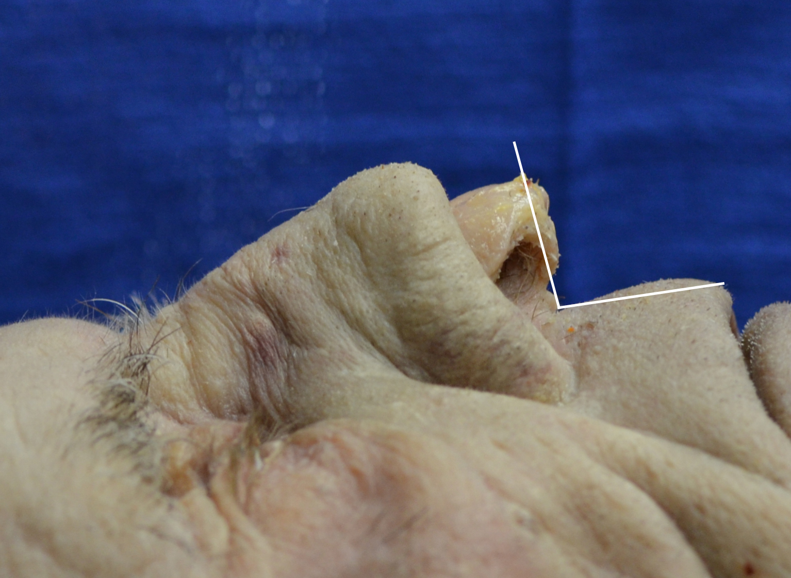
Figure 1. Nasolabial angle, Baseline measurement, 97 degrees.

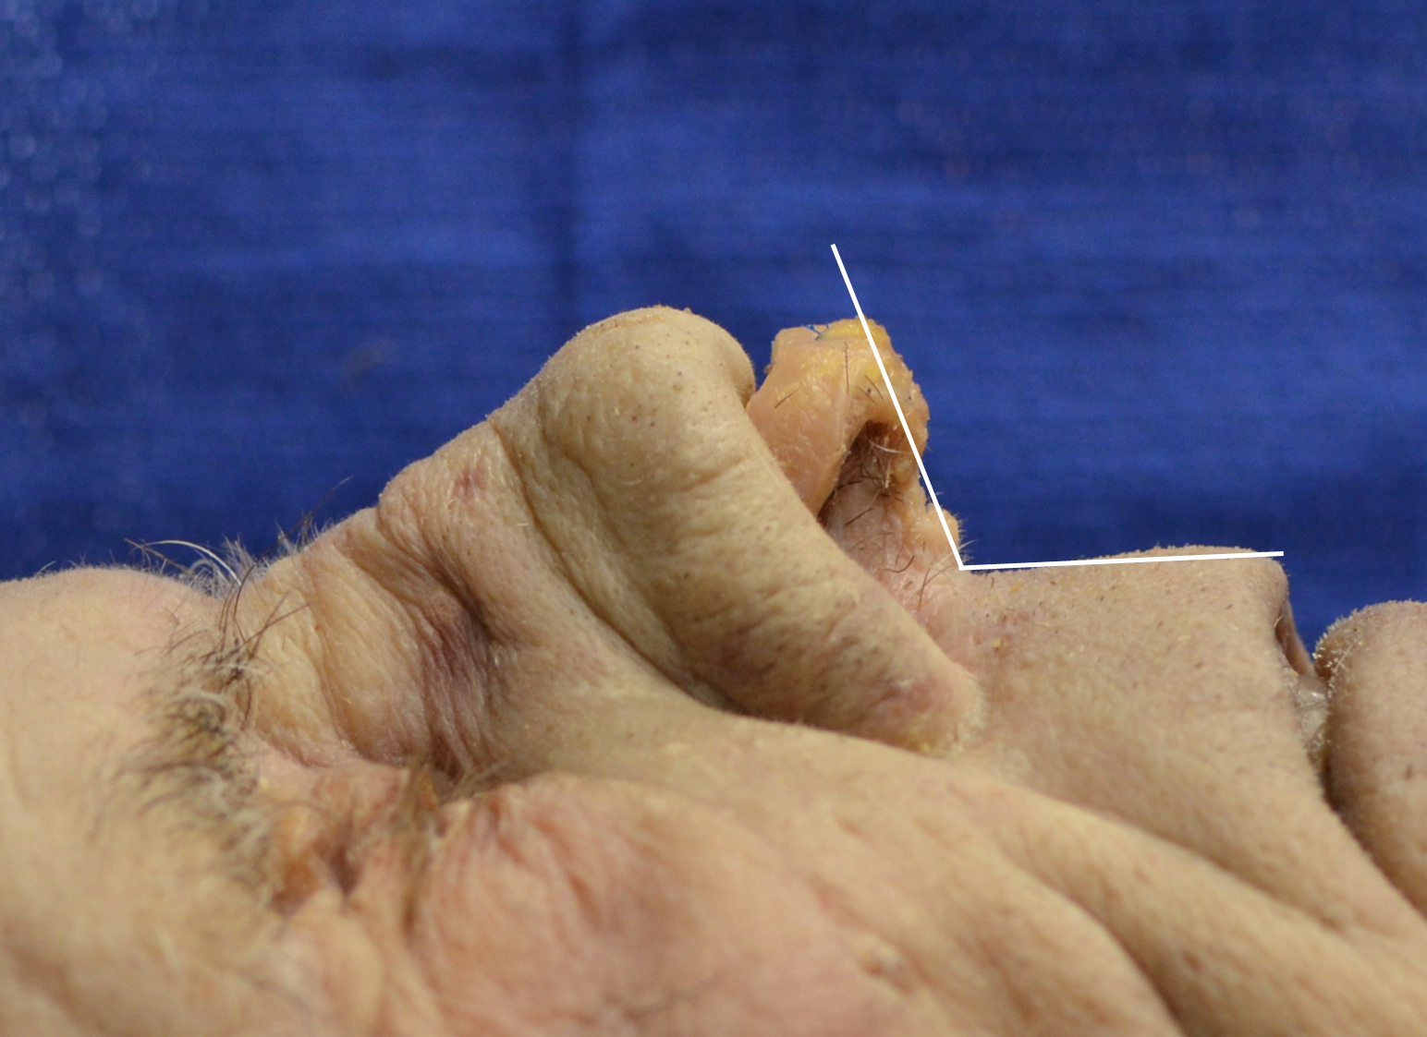
Figure 2. After placement of tip sutures, columellar strut and cephalic trim, Nasolabial angle measurement 108.7 degrees.

