A Technique for Recreation of the Nasolabial skin fold and Alar skin crease following Naso-labial Flap Reconstruction of the Nose

Waqqas N. Jalil, MD; Edward W. Buchel, MD, BSc; Thomas EJ. Hayakawa, MD;

Abstract

Background: Reconstruction of the nose presents a unique set of problems because of its inherent skin texture and complex contours. These factors are never more critical than on the lower third of the nose. A common reconstruction for lower third nasal defects is the nasolabial flap. Unfortunately, outcomes are often suboptimal due to a loss of important facial aesthetic landmarks such as the nasolabial fold (NLF) or the alar skin fold (ASF). There are few options available to recreate these landmarks. Several proposed in the past include excision of the flap and full-thickness-skin-grafting, periosteal sutures to help recreate the fold, and lastly trying to preserve an intervening skin bridge representing the NLF (not always possible in skin cancer/lesion excision). We propose a reproducible 3-flap technique for late recreation of the NLF and ASF following nasolabial flap reconstruction.

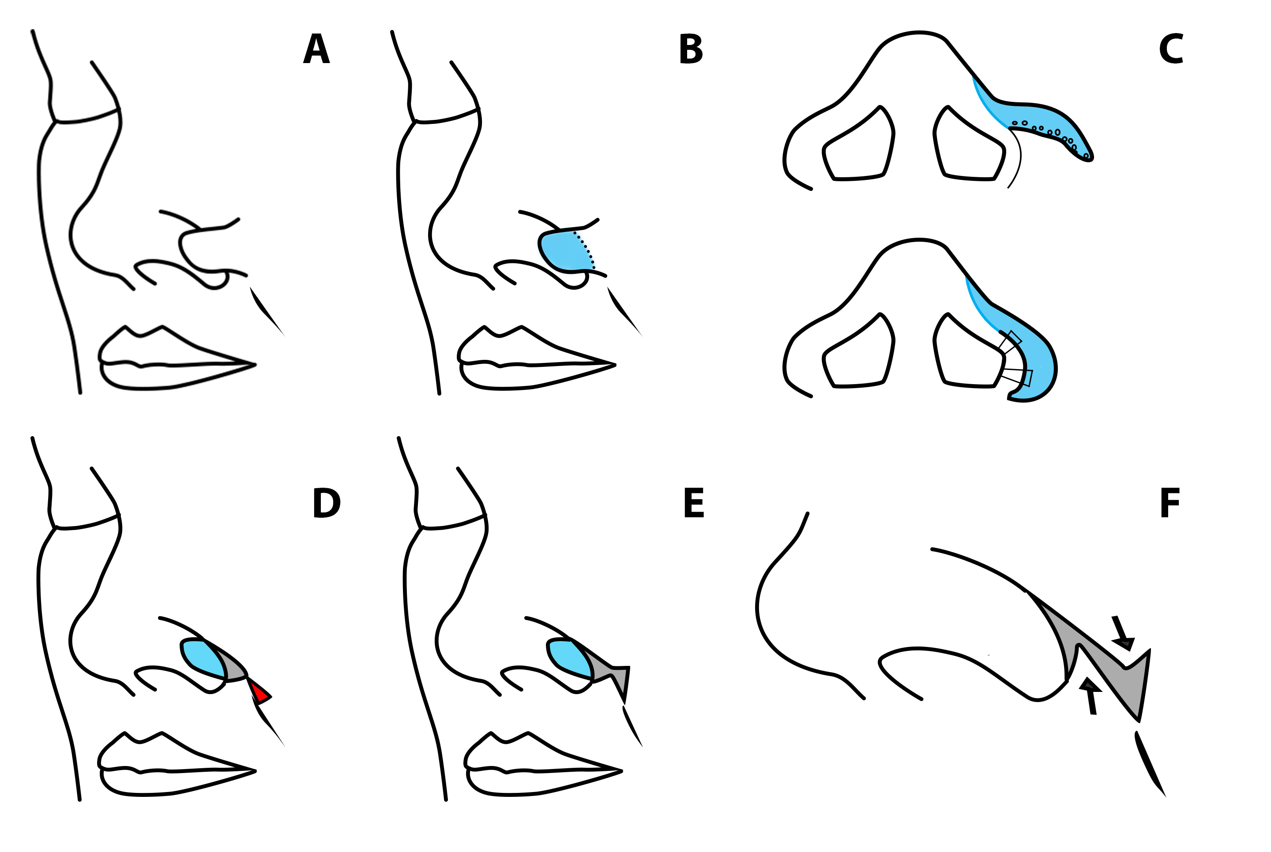
Methods: Three consecutive patients underwent a 3-flap technique. The first flap utilizes the unaesthetic “web” that bridges the ala onto the cheek to recreate the lower lateral ala. This flap is nasally based and its perfusion crosses the old inset incisions. This does not affect viability provided that it is not undermined too close to these incisions. The next two small flaps close the resulting triangular defect on the cheek by employing the technique of “opposing triangles” (See Figure 1)
Figure 1. Steps to Surgical Procedure. A, Pre-operative appearance of a nasolabial flap reconstruction B, Blue shading outlines approximate limits of first flap C, First flap is thinned and then through and through sutures are placed to sharply define the alar convexity D, Grey triangle represents resulting defect and red triangle outlines skin to be excised E, Resulting “opposing triangles” F, The inferior triangular flap is advanced superiorly and the superior flap moves inferiorly preventing any deforming lateral forces on the new ala
Results: All patients achieved restoration of ASF and NLF. Representative photo. (See Figure 2).

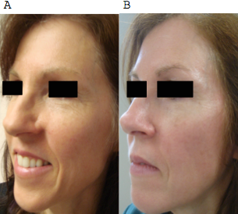

Figure 2. Patient A, Pre-Operative photo B, Post-Operative following 3 flap correction
Conclusions: We propose a surgical technique that allows reliable recreation of important facial aesthetic transition landmarks such as the ASF and NLF that may be lost as a result of nasolabial flap reconstruction of the nose

Disclosure/Financial Support: None
References
- Schmidt BL, Dierks EJ. The nasolabial flap. Oral and maxillofacial surgery clinics of North America. 2003;15(4):487-95, v.
- Thornton JF, Weathers WM. Nasolabial flap for nasal tip reconstruction. Plast Reconstr Surg. 2008;122(3):775-81.
- Zitelli JA. The nasolabial flap as a single-stage procedure. Archives of dermatology. 1990;126(11):1445-8.
- Rohrich RJ, Conrad MH. The superiorly based nasolabial flap for simultaneous alar and cheek reconstruction. Plast Reconstr Surg. 2001;108(6):1727-30; quiz 31.
- El-Marakby HH. The versatile naso-labial flaps in facial reconstruction. Journal of the Egyptian National Cancer Institute. 2005;17(4):245-50.

