Free Tissue Harvest from the Thigh: A Comparative Review of Thigh-Based Donor-Site Morbidity
Chrisovalantis Lakhiani MD, Michael DeFazio MD, Kevin Han MD, Reuben Falola BS, Karen Evans MD
Abstract
Background: The thigh offers a myriad of reconstructive options, from fasciocutaneous perforator flaps, to free functional muscle and composite tissue constructs. The surgeon should be familiar with the advantages and disadvantages specific to each flap in order to tailor the reconstructive plan to the needs of each patient. The authors reviewed the relevant donor-site morbidities associated with more commonly utilized thigh-based flaps.
Methods: A systematic review of the MEDLINE and Cochrane databases from 1994 to 2014 was conducted to identify all reports of “anterolateral thigh,” “anteromedial thigh,” “transverse upper gracillis,” tensor fascia lata,” “gracillis,” “rectus femoris,” and “vastus lateralis” flaps. Only studies that investigated donor-site outcomes related to pain, parasthesia, wound dehiscence, infection, hematoma, seroma, contour deformity, and/or objective functional performance were included. Case series or anecdotal reports with fewer than 5 flaps, as well as non-English and animal studies were excluded.
Results: From the initial 2,425 citations, 121 articles met criteria and were manually reviewed by two authors (Figure 1). A total of 4,276 flaps were analyzed, including 2,727 ALT, 102 AMT, 436 TUG, 193 TFL, 527 Gracilis, 164 RF, and 127 VL flaps. Of these, 3,458 (80.8%) were perforator-based flaps. The most frequently sited donor-site complication was parasthesia (n=496), followed by wound dehiscence (n=144), musculoskeletal dysfunction (n=69), infection (n=66), and pain (n=47). The frequency of donor-site skin grafting was highest among AMT flaps (22.5%), as were pain (4.9%) and parasthesia (19.6%). Donor-site dehiscence occurred over 3 times as often with the TUG flap when compared to other flap types (8.03% vs 2.2%). Despite mixed results regarding functional performance, there were no clinically significant reductions in strength, daily activities, or quality of life specific to any donor-site. Compared to perforator-flaps, muscle-flap reconstructions were associated with increased pain (2.1% vs 0.9%), infection, (2.2% vs 1.4%), and contour deformity (3.1% vs 0.6%). Rates of musculoskeletal dysfunction however, were similar in both (0.9% vs 1.8%). (Table 1)
Conclusion: Donor-site morbidity for commonly used thigh-flaps is minimal and appears to be well tolerated by most of patients. However, flap selection is highly individualized, and patients must be informed of potential complications and morbidities specific to each flap. We have established the most current review of donor-site morbidity for thigh-based flaps to aid the surgeon in this important discussion.
Figure 1. Trial-Flow Diagram
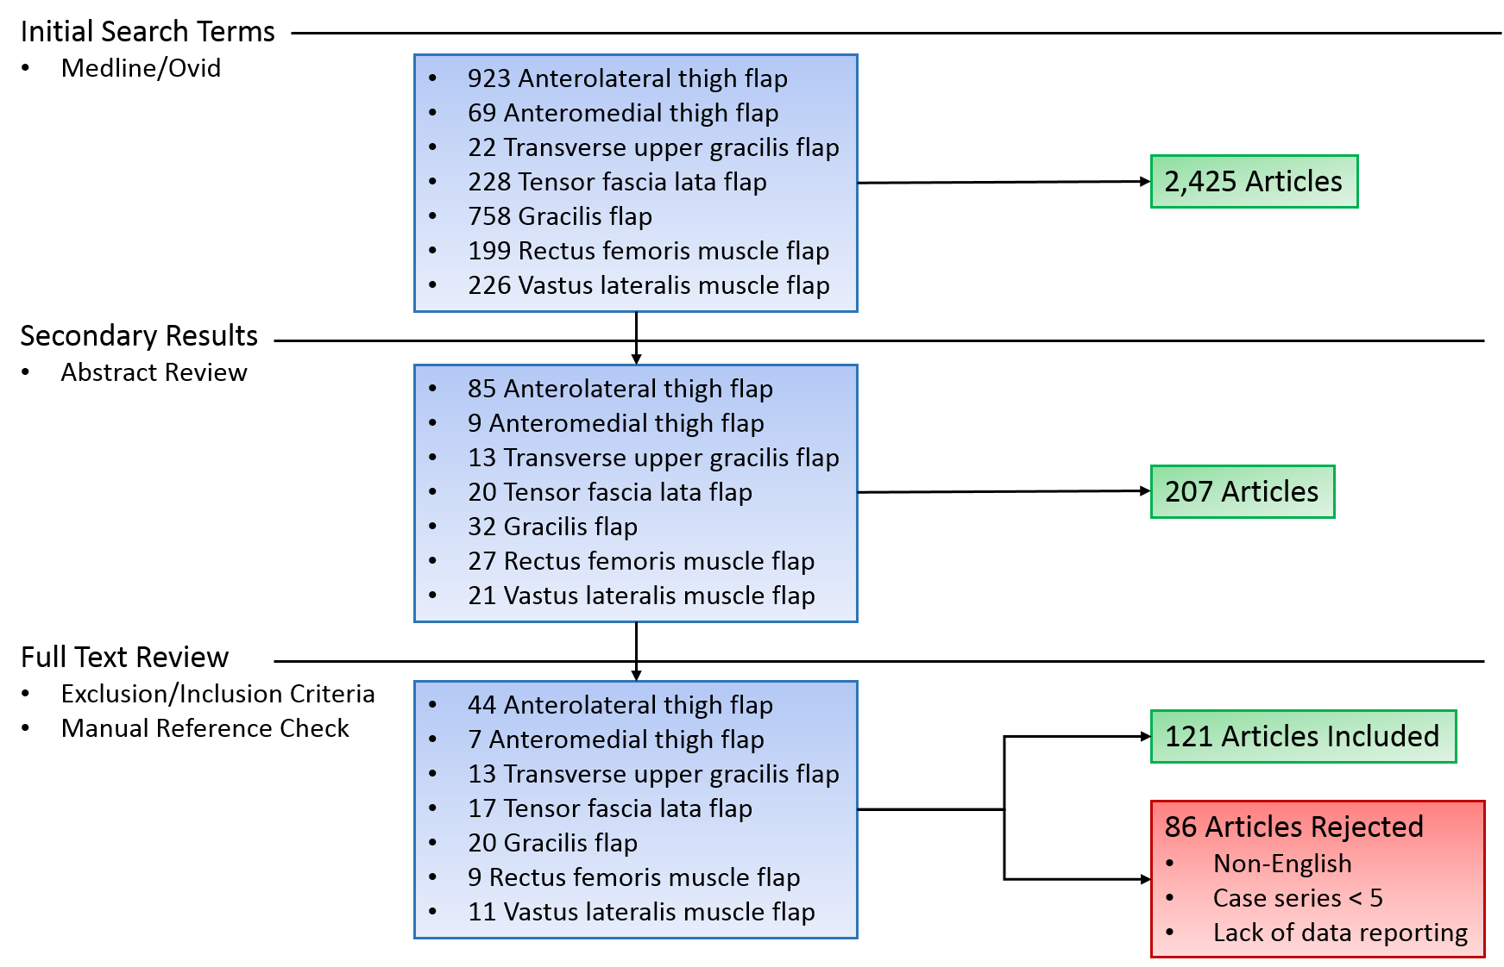
Table 1. Donor-Site Morbidity for Given Flap Type
Flap Type | Flap Number | Need for Skin Graft | Paresthesia | Musculoskeletal Dysfunction | Pain | Wound breakdown | Infection | Hematoma | Seroma | Contour Deformity
Anterolateral thigh flap | 2727 | 10.5% | 14.2% | 2.1% | 0.7% | 3.3% | 1.6% | 0.6% | 0.8% | 0.8%
Anteromedial thigh flap | 102 | 22.5% | 19.6% | 3.9% | 4.9% | 1.0% | 2.0% | 0.0% | 1.0% | 0.0%
Transverse upper gracilis flap | 436 | 0.0% | 13.3% | 0.0% | 0.0% | 8.0% | 0.2% | 1.4% | 1.4% | 0.0%
Tensor fascia lata flap | 193 | 12.4% | 0.0% | 0.0% | 3.6% | 3.6% | 0.5% | 0.0% | 0.5% | 0.0%
Gracilis flap | 527 | 0.0% | 1.7% | 0.4% | 1.7% | 0.9% | 3.4% | 1.3% | 0.8% | 3.2%
Rectus femoris muscle flap | 164 | 0.0% | 4.9% | 2.4% | 4.3% | 1.2% | 0.0% | 1.2% | 0.6% | 0.0%
Vastus lateralis muscle flap | 127 | 1.6% | 11.0% | 0.8% | 0.8% | 3.1% | 0.0% | 0.8% | 0.0% | 6.3%
Total | 4276 | 13.8% | 20.5% | 2.8% | 1.9% | 5.9% | 2.7% | 1.4% | 1.4% | 1.9%

Disclosures/Financial Support
The authors have no financial conflicts of interest to disclose
.

