Intravenous Extravasation: A comprehensive management algorithm
Tamara B. Dawli, MD; Abhishek Chatterjee MD, MBA; Emily B. Ridgway, MD; Mitchell A. Stotland, MD

Abstract
Purpose: Plastic surgeons are often requested to play a role in the management of intravenous extravasation injuries. However, we were unable to identify in the literature a comprehensive treatment protocol for these clinical problems. Given this deficiency, our goal was to evaluate published recommendations and to construct a comprehensive algorithm for the management of common extravasation injuries.

Methods: A thorough literature search of IV extravasation and management was completed. Relevant articles from the English literature (search criteria: “Intravenous extravasation injury and treatment or management”) identified from Pubmed included 1042 publications with 129 reviewed. We evaluated information pertaining to the most common categories of extravasated material managed at our institution (parenteral nutrition, radiologic contrast, vasoactive drugs, basic electrolyte solutions, antibiotics, and chemotherapeutic agents). A treatment algorithm was developed integrating information culled from articles reviewed independently by two of the co-authors.

Results:
One hundred and twenty nine publications were reviewed for content related to the management of extravasation injury. From this assembled information we constructed a comprehensive algorithm for the management of extravasation injury.
Initial management includes discontinuing the administration of the agent, withdrawing as much infiltrate as possible, and removal of the IV. Further active intervention for the injured site begins only after identifying and documenting (include photographing) the location, the type of infiltrate, the duration/dose/volume/concentration, and stage of the injury (as per INS guidelines). For stage I injuries, the affected area should be elevated immediately and warm compresses applied. For stage II injuries (and worse) subcutaneous hyaluronidase injection should be undertaken promptly. Exceptions apply to vasoactive agents (for which hyaluronidase injections are not indicated), and chemotherapeutic drugs (for which treatment varies widely depending on offending agent, see below). Following the initial steps of management, we suggest strict adherence to our algorithm which varies with respect to the extravasant in question.
For extravasation of parenteral nutrition, extravasated contrast material, basic electrolyte solution, or antibiotics, surgical consultation should be requested within 24 hours for injuries identified as INS stage III or IV. These injuries should be treated by surgical drainage (via multiple stab and/or subcutaneous suction method) and the saline flush-out technique (Gault) prior to the development of tissue necrosis. Close post-operative monitoring should continue along with elevation of the affected extremity until the injury process has abated.
In regards to vasoactive substance extravasation (e.g., dopamine and neosynephrine), plastic surgery should be consulted immediately because these injuries can become more limb threatening. Treatment begins with injection of subcutaneous phentolamine and application of topical nitroglycerin. The decision for further surgical intervention depends both on the initial examination as well as injury evolution over the following 6 hours. A decision to perform surgical flush-out and/or subcutaneous suction is based on physical exam findings such as neurologic or vascular compromise, and should precede the development of bullae or necrosis. The management of chemotherapeutic extravasation is more complex in that there are dozens of agents within several drug categories which behave differently, necessitating a more customized treatment approach. Lower risk is associated with the following drug categories: cytoloytic monoclonal antibodies, glycoprotein antibiotics, anti-metabolites, and asparagine-specific enzymes. Agents associated with a higher risk for tissue destruction include topoisomerase inhibitors and anti-mitotic drugs. Alkylating agents vary from mildly neutral to strongly vesicant, so careful verification of the particular drug in question should be made and consultation with the algorithm (or other reference source) undertaken in order to guide treatment.

Figure 1. Algorithm for management of acute extravasation injuries.

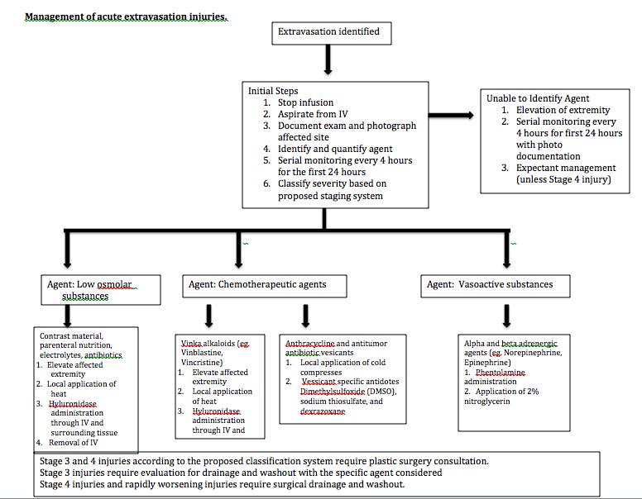

Conclusion:
We present a comprehensive algorithm for the management of common extravasation injuries in an attempt to promote patient safety, reduce patient morbidity, and decrease financial risk. When prevention fails, prompt and thoughtful action is necessary to prevent potentially serious complications.

References
Gault, D.T. Extravasation injuries. British Journal of Plastic Surgery. 1993: 46: 91, 1993.
Langstein H, Duman H, Seelig D, Butler C, Evans G. Retrospective Study of the Management of Chemotherapeutic Extravasation Injury. Annals of Plastic Surgery: 49; 369-374.
Sbitany H, Koltz P, Mays C, Girotto J, Langstein H. CT Contrast extravasation in the upper extremity: Strategies for management. Intenational Journal of Surgery. 2010: 8; 384-6.
Scuderi N, Onesti MG. Antitumor Agents: Extravasation, Managmeent, and Surgical Treatment. Annals of Plastic Surgery, 1993: 32; 39-43
Upton J, Mulliken JB, Murray JE. Major intravenous extravasation injuries. American Journal of Surgery 137: 497-506
Vandeweyer E, Heymans O, Deraemaecker R. Extravasation Injuries and Emergency suction as Treatment. Plastic and Reconstructive Surgery, 2000; 105: 109-10

