The Relationship Between Geographic Access to Plastic Surgeons and Immediate Breast Reconstruction Rates Among Women Undergoing Mastectomy for Cancer
Justin P. Fox, MD, MHS., Andrew R. Bauder, BA, Cary P. Gross, MD, Brigid Killelea, MD, Paris D. Butler, MD, MPH, Stephen J. Kovach, MD
Disclosure/Financial Support: None of the authors have any relevant financial disclosures.
INTRODUCTION: Breast reconstruction is an important component of breast cancer treatment. Despite healthcare policy requiring payers to cover and referring physicians to discuss such procedures, reconstruction rates remain low, particularly among minority populations¹. We conducted this study to determine if geographic access to a plastic surgeon contributes to the likelihood of receiving breast reconstruction; the type of reconstruction received; or when reconstruction is performed. Additionally, we explored the relationship between plastic surgeon distribution and healthcare disparities in breast reconstruction.
MATERIALS AND METHODS: Using inpatient and ambulatory surgery data from Arkansas, Arizona, California, Florida, Maryland, Nebraska, Nevada, New York, Utah, and Washington², we identified adult women who underwent mastectomy for breast cancer in 2010. This data was aggregated to the National Cancer Institute’s health service area (HSA) where mastectomy was performed and augmented with plastic surgeon workforce information from the Area Health Resource File³. We then calculated HSA’s risk standardized, immediate breast reconstruction rates using hierarchical generalized linear models. For states with ambulatory data (CA, FL, NE, NY), we also calculated delayed breast reconstruction rates. Finally, we quantified the relationship between plastic surgeon density and outcomes using volume weighted correlation coefficients.
RESULTS: The final cohort included 22,997 patients from 134 HSAs who underwent mastectomy for breast cancer. At the patient level, 44.7% had immediate breast reconstruction. At the HSA-level, risk standardized, breast reconstruction rates (median=43.0% [25th percentile=29.9%-75th percentile=62.8%]) and plastic surgeon density (median=1.4 [0.0-2.6] surgeons per 100,000 population) varied widely. Higher plastic surgeon density was associated with higher risk standardized breast reconstruction rates (correlation coefficient=0.66, p<0.001; Figure 1). Further, higher plastic surgeon density was directly correlated with a higher percentage of autologous tissue reconstructions (correlation coefficient=0.26, p=0.04) and inversely related to the number of days elapsed between mastectomy and reconstruction (correlation coefficient=-0.18, p<0.001). Despite geographic access to plastic surgeons, women with public forms of insurance were least likely to undergo breast reconstruction (Figure 2).
CONCLUSION: For some women, the lack of geographic access to a plastic surgeon serves as a barrier to receiving breast reconstruction, the type of reconstruction available, and the amount of time waiting for reconstruction. National efforts focused on women’s access to breast reconstruction should aim to improve public payer coverage and address the plastic surgeon workforce.
REFERENCES:
1. Labor USDo. Women's Health and Cancer Rights Act. 1998; Women's Health and Cancer Rights Act. Accessed 20 Jan, 2015.
2. Agency for Healthcare Research and Quality. Overview of HCUP. Available at: http://www.hcup-us.ahrq.gov/overview.jsp. Accessed December 20, 2013.
3. US Department of Health and Human Services HRaSA, Bureau of Health Workforce, Rockville, MD. Area Health Resources Files (AHRF). 2013-2014; http://ahrf.hrsa.gov/overview.htm.
FIGURE LEGENDS:
Figure 1. Scatter plot depicting the relationship between plastic surgeon density (x-axis) and risk-standardized, immediate breast reconstruction (y-axis) rates at the HSA level (correlation coefficient=0.66, p <0.001).
Figure 2. Risk-standardized, immediate breast reconstruction rates (lines) across different patient race and insurance status sub-groups by increasing plastic surgeon density (x-axis).

Figure 1

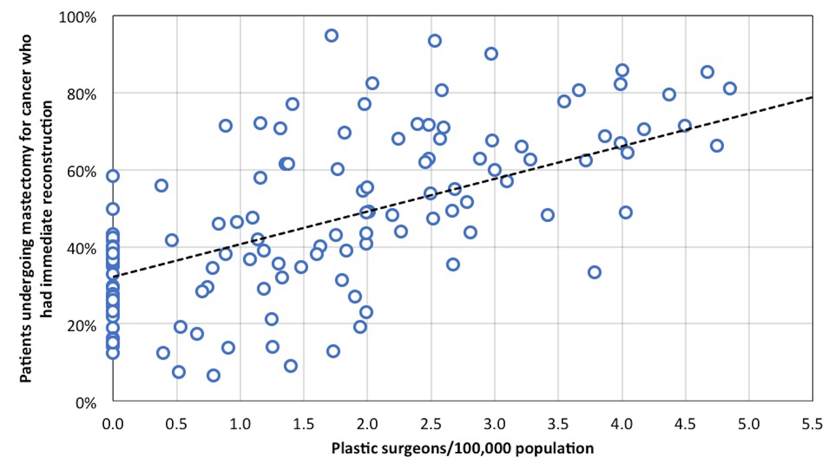

Figure 2
