Geographic Variation in Access to Plastic Surgeons
Andrew R. Bauder, BA, Jonathan R. Sarik, MD, Paris D. Butler, MD, MPH, R. Barrett Noone, MD, John P. Fischer, MD, Joseph M. Serletti, MD, Suhail K. Kanchwala, MD, Stephen J. Kovach, MD, Justin P. Fox, MD, MHS
Disclosure/Financial Support: None of the authors have any relevant financial disclosures.
INTRODUCTION: While recent studies project a future shortage of plastic surgeons, there may currently exist areas within the United States with few plastic surgeons. We conducted this study to describe the geographic distribution of the plastic surgery workforce across the United States.
MATERIALS AND METHODS: Using the 2013-2014 Area Health Resource File, we estimated the number of plastic surgeons at the Health Service Area (HSA) level in 2010 and 2012¹. The density of plastic surgeons was calculated as a ratio per 100,000 population. HSAs were grouped by plastic surgeon density and population characteristics were compared across subgroups. Characteristics of HSAs with increases and decreases in plastic surgeon density were also compared.
RESULTS: The final sample included 949 HSAs with a total population of 313,989,954 people. As of 2012, there were an estimated 7,600 plastic surgeons, or 2.42 plastic surgeons/100,000 population, in the U.S. However, nearly half of the HSAs studied (N=468, 49.3%) were without any plastic surgeons, leaving over 25 million people without access to the specialty. Conversely, 106 million people living in 82 HSAs (8.6%) had more than 3.0 plastic surgeons per 100,000 population (Figure 1). Plastic surgeons were more likely to be distributed in HSAs where a higher percentage of the population was younger, female, and residing in urban areas with greater healthcare resources (all p-values ≤ 0.001). Between 2010 and 2012, 11 HSAs without a plastic surgeon increased density while 15 HSAs lost all plastic surgeons (Figure 2).
CONCLUSION: Plastic surgeons are asymmetrically distributed across the United States, leaving over 25 million people without geographic access to the specialty. This distribution tends to adversely impact rural populations. Further research is needed to understand how this impacts patient care and outcomes, with future workforce policy directed at retaining plastic surgeons in areas suffering from plastic surgeon shortages.
REFERENCES:
- US Department of Health and Human Services HRaSA, Bureau of Health Workforce, Rockville, MD. Area Health Resources Files (AHRF). 2013-2014; http://ahrf.hrsa.gov/overview.htm.
FIGURE LEGENDS:
Figure 1. Choropleth map depicting plastic surgeons density across health service areas as of 2012.*
Figure 2. Choropleth map depicting health service areas that saw an increase or decrease in plastic surgeon density between 2010 and 2012.*
* Alaska and Hawaii included in statistical analysis but not visual representation.

Figure 1
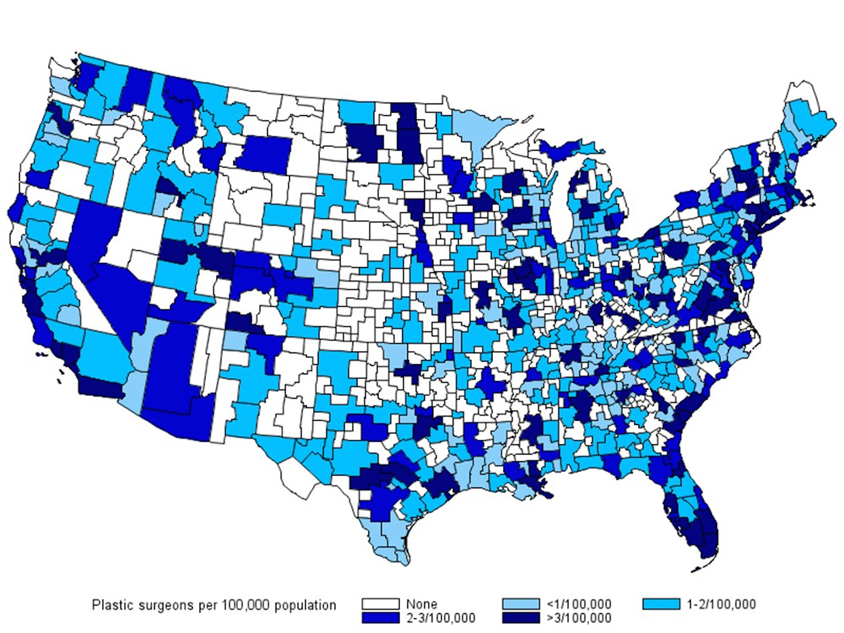

Figure 2
