Breast Augmentation: Patient Satisfaction with 3D Simulation of Surgical Outcomes

Norma I. Cruz, MD

Disclosure/Financial Support: The author has no financial interest in any product mentioned in this manuscript.

Introduction: Currently three-dimensional (3D) image simulation is used as a tool to help patients visualize the results of breast augmentation. The image simulations are supposed to provide an example of how implants can impact the body, however, actual results may vary.¹⁻² The aim of this study was to evaluate whether, after having had their surgery, patients were satisfied with the information provided by the 3D simulation.

Method: A prospective, randomized study compared patient satisfaction with information provided during preoperative consultation for breast augmentation. In the control group (n=40) photographs of average results of breast augmentation were used, and in the study group (n=36) 3D simulations (Crisalix) of surgical outcome were used. Patients were informed that the results might vary from the image produced by the simulation. Three months following surgery a self-administered questionnaire was used to evaluate patient satisfaction with the information provided during the preoperative consultation and to collect basic demographic information (age, weight, height and implant size).

Results: The study and control groups were not significantly different in mean age (30±7 vs.31±6), body mass index (21±3 vs. 21±2) or mean implant size (350±41cc vs. 355±50cc). Our results indicated that dissatisfaction with the accuracy of the information provided during the pre-operative consultation occurred in 25% of the study group compared to 5% of the control group (p<0.05). The 3D simulations tend to show perfect round breasts (Figure 1), while the actual results (Figure 2) may have more ptosis and less fullness because of the elasticity of the tissues.

Conclusion: After having had their surgery, patients reported a higher percentage of dissatisfaction (25%) with the information provided by 3D simulation. The accuracy of the information is low and often misleading, since tissues respond in different ways to placement of implants.

References
1. Tzou CH, Artner NM, Pona I, et al. Comparison of three-dimensional surface-imaging systems. J Plast Reconstr Aesthet Surg. 67(4):489-497, 2014.
2. de Heras Ciechomski P, Constantinescu M, Garcia J, et al. Development and implementation of a web-enabled 3D consultation tool for breast augmentation surgery based on 3D-image reconstruction of 2D pictures. J Med Internet Res 14 (1):e21, 2012.

Legends
Figure 1. Simulation (3D) of surgical outcome.
Figure 2. Actual result of breast augmentation in the same patient.

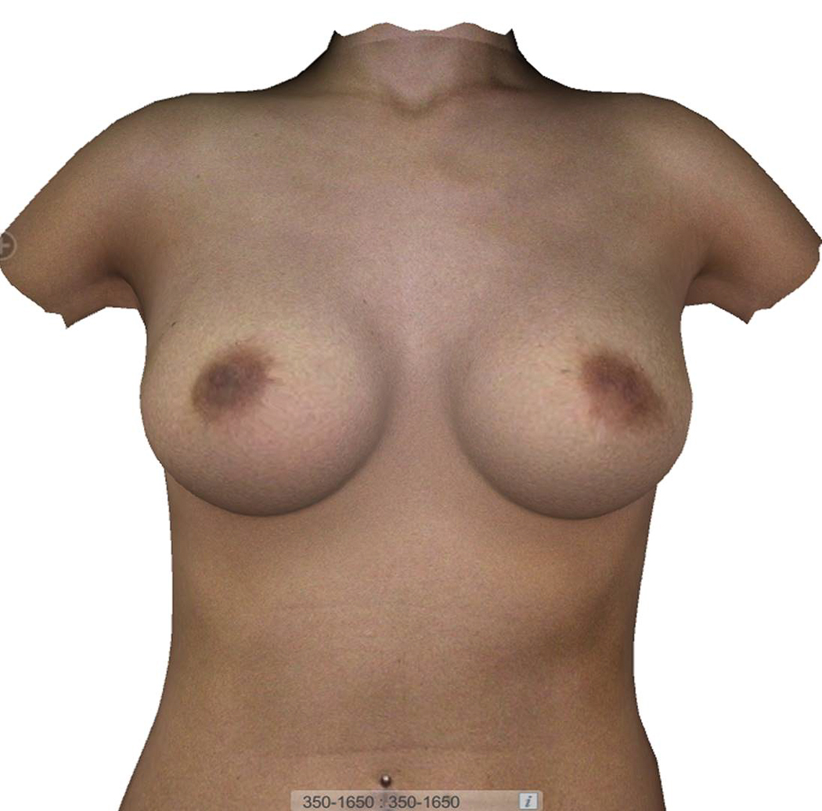
Figure 1.

Figure 2.
