Resident Participation: Impact on Plastic Surgical Outcomes
Benjamin B. Massenburg, BA; Paymon Sanati-Mehrizy, BA; Eric M. Jablonka, MD; Peter J. Taub, MD
Introduction: Ensuring maximum patient safety as well as a complete surgical experience is of utmost importance in training for plastic surgery. As plastic surgical training relies on resident participation in various procedures, we must guarantee adequate hands-on operative time while maintaining the best possible outcomes for the patient. The effect of resident involvement on the outcomes of plastic surgery procedures remains largely unknown. We assess the impact of resident participation on surgical outcomes using a prospective, validated, national database.
Methods: This study retrospectively reviewed the American College of Surgeons National Surgical Quality Improvement Program (ACS-NSQIP) database and identified all procedures performed by plastic surgeons between 2007 and 2012. Multivariate regression models were constructed to assess the impact of resident involvement when compared to attendings alone on 30-day general complications, wound complications, and reoperation rates.
Results: A total of 25,676 patients were identified, with 15,774 patients operated on by an attending only and 9,902 with residents participating. The general complications, wound complications, and reoperation rates are consistently elevated with resident participation. With multivariate analysis by year, the rate of general complications, wound complications, and reoperations in plastic surgery procedures with resident involvement are trending down and fail to be statistically different in 2012.
Conclusions: Though resident involvement has historically been associated with increased surgical morbidity, recent years have no longer shown a significant difference in total adverse outcomes between procedures with residents and those with attendings only. This suggests that plastic surgical residency training is successfully improving in both outcomes and safety.
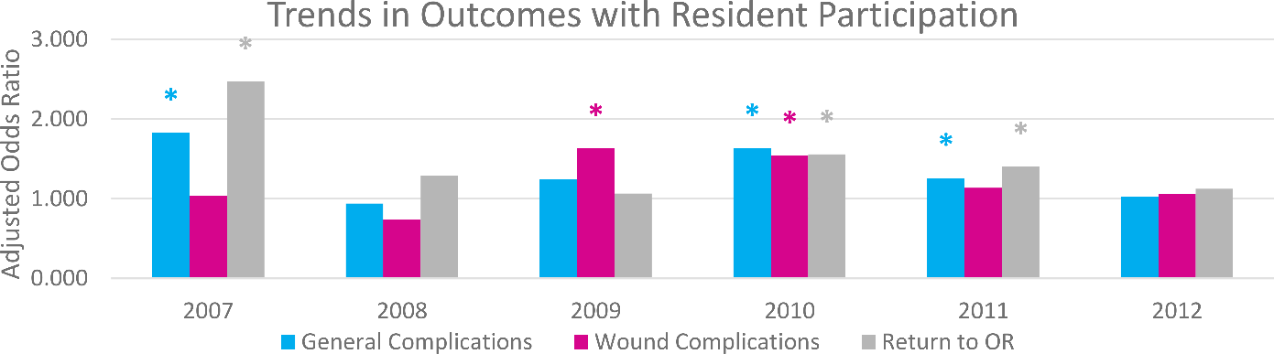
Figure 1. Annual trends of the multivariate adjusted odds ratio of general complications, wound complications, and reoperation in plastic surgery procedures performed with resident participation compared to procedures performed by an attending alone.
Variables | Attending Only (n=15774) | Resident Participation (n=9902) | p Value
Total Work RVUs, mean (SD) | 21.3 (17.7) | 24.6 (19.6) | 0.000
Age, mean (SD) | 48.8 (15.4) | 48.9 (15.4) | 0.523
Female, % (n) | 80.6 (12701) | 74.1 (7317) | 0.000
Race, % (n) |  |  | 0.363
White | 84.9 (10174) | 83.3 (6426)
Black | 11.2 (1337) | 13.9 (1072)
Hispanic | 1.5 (184) | 0.3 (21)
Asian | 1.8 (214) | 2.0 (152)
Other | 0.6 (71) | 0.6 (47)
BMI, mean (SD) | 27.9 (7.2) | 28.2 (7.2) | 0.950
Obese, % (n) | 32.1 (4989) | 33.7 (3290) | 0.006
ASA ≥3, % (n) | 21.8 (3403) | 27.6 (2721) | 0.000
Smoking, % (n) | 16.3 (2573) | 17.5 (1732) | 0.014
Pre-Operative Comorbidities, % (n)
Cardiac Comorbidity | 3.8 (598) | 4.0 (398) | 0.375
Pulmonary Comorbidity | 1.8 (291) | 2.1 (203) | 0.254
Diabetes | 8.0 (1259) | 7.9 (781) | 0.786
Hypertension | 26.4 (4159) | 26.8 (2653) | 0.451
Wound/Wound Infection | 8.3 (1313) | 11.5 (1134) | 0.000
Steroid Use | 1.6 (256) | 2.0 (202) | 0.014
Bleeding Disorder | 1.7 (273) | 2.0 (197) | 0.132
Post-Operative Complications, % (n)
Cardiac Complication | 0.1 (22) | 0.2 (24) | 0.058
Pulmonary Complication | 0.5 (84) | 0.7 (71) | 0.063
Venous Thromboembolism | 0.3 (43) | 0.4 (42) | 0.040
Wound Complication | 3.2 (502) | 4.6 (453) | 0.000
General Complications | 7.5 (1185) | 12.3 (1222) | 0.000
Return to OR | 3.4 (538) | 5.8 (571) | 0.000
Mortality | 0.3 (47) | 0.2 (20) | 0.142
Anesthetic Time (minutes), mean (SD) | 164.1 (107.6) | 209.7 (153.8) | 0.000
Operative Time (minutes), mean (SD) | 122.4 (93.9) | 153.5 (137.9) | 0.000
Length of Stay (days), mean (SD) | 1.7 (7.0) | 2.8 (8.7) | 0.000

Table 1. Pre-operative patient characteristics and post-operative complications as a function of resident involvement in plastic surgery procedures.

