Sexuality in aesthetic breast surgery
Paulo Afonso Monteiro Pacheco Guimarães, MD; Vanessa Contato Lopes Resende, MD; Miguel Sabino Neto, PhD; Caroline Lumy Seito, MS; Maria José Azevedo de Brito, PhD; Luiz Eduardo Felipe Abla, PhD; Daniela Francescato Veiga, PhD; Lydia Masako Ferreira, PhD.
Disclosure/Financial Support: None of the authors has a financial interest, and there is no disclosure in this manuscript.
INTRODUTION: The breasts are important for the woman’s psychological well-being, which may be negatively affected by distortions of breast size and shape. Improvements in self-esteem and sexuality are important psychological factors associated with motivation for cosmetic surgery. Mammaplasty is among the most sought-after and performed cosmetic procedures. The aim of this study was to evaluate the impact of aesthetic breast surgery on woman's sexuality.
METHODS: This study was conducted in a plastic surgery clinic of a hospital university in Brazil, between 2009 and 2012. Forty-six patients with hypomastia and 30 patients with breast hypertrophy, who expressed the desire for aesthetic breast surgery, were selected for the study. The patients were assessed preoperatively and 6 months postoperatively using the Sexual Quotient - Female version scale (QS-F). The QS-F is a validated Brazilian questionnaire to assess sexual function. It contains of 10 items covering five domains of female sexual function: desire and interest, foreplay, excitement and harmony, comfort, and orgasm and satisfaction. Higher QS-F scores indicate better sexual functioning.
RESULTS: There was a significant increase in the mean total QS-F score after surgery in both groups (p < 0.001). No significant improvement in desire and comfort was reported by patients who underwent breast augmentation and in comfort by patients who underwent breast reduction. Improvement in sexuality after surgery was observed in both groups, which is consistent with the literature.
CONCLUSION: Aesthetic breast surgery has a positive impact on the sexuality of patients.
- Figueroa-Haas CL (2007) Effect of breast augmentation mammoplasty on self-esteem and sexuality: a quantitative analysis. Plast Surg Nurs 27: 16-36
- Abdo CHN (2006) Development and validation of female sexual quotient - a questionnaire to assess female sexual function. Rev Bras Med 63: 477-482
- Guimarães PAMP, Lage FC, Abla LEF, Veiga DF, Neto MS, Ferreira LM (2013) Female sexual quotient in patients after breast augmentation. Plast Reconstr Surg 132: 160-161
- Resende VCL, Sabino Neto M, Veiga DF, Rocha MJA, Ferreira LM (2013) Sexuality in patients submitted to reduction mammoplasty. J Womens Health (Larchmt) 22: 18-19. DOI: 10.1089/jwh.2013.Ab01, March 12, 2013
- McCarthy CM, Cano SJ, Klassen AF, Scott A, Van Laeken N, Lennox PA, Cordeiro PG, Pusic AL (2012) The magnitude of effect of cosmetic breast augmentation on patient satisfaction and health-related quality of life. Plast Reconstr Surg 130: 218-223

FIGURE LEGEND:
Figure 1. Breast augmentation. (Left) Preoperative photograph in frontal view. (Right) Photograph in frontal view taken 18 months postoperatively. The patient received 280-ml subglandular high-profile implants.

Figure 2. Breast reduction. (Left) Preoperative photograph in frontal view. (Right) Photograph in frontal view taken 6 months postoperatively.

Figure 3. Mean total QS-F scores for the three groups. Asterisks indicate statistical significance: * = p < 0.001 (Friedman’s test).

Figure 4. Mean QS-F domain scores for patients who underwent augmentation mammaplasty. Asterisks indicate statistical significance: * = p < 0.001; ** = p < 0.05 (Friedman’s test).

Figure 5. Mean QS-F domain scores for patients who underwent reduction mammaplasty. Asterisks indicate statistical significance: * = p < 0.001 (Friedman’s test).

Fig. 1
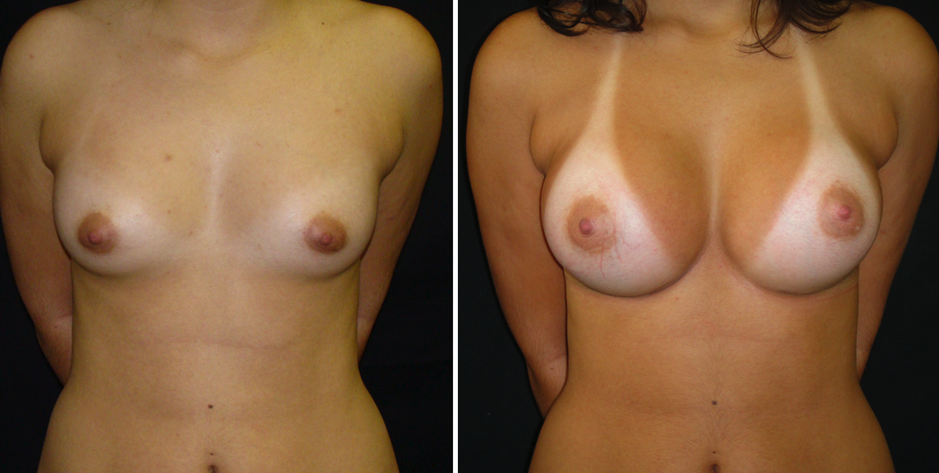

Fig. 2
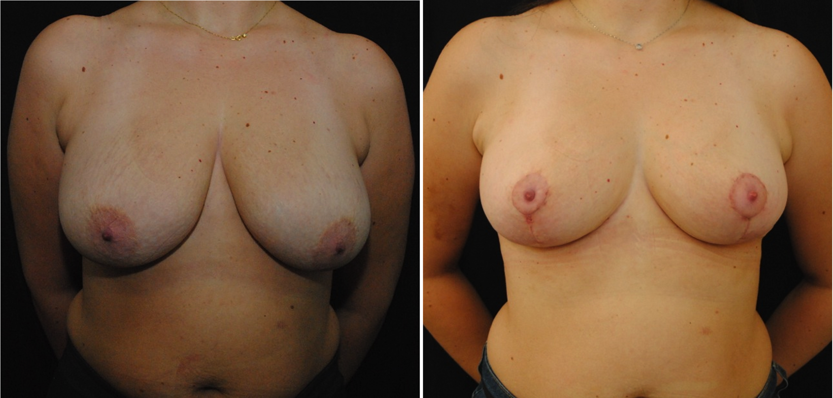

Fig. 3
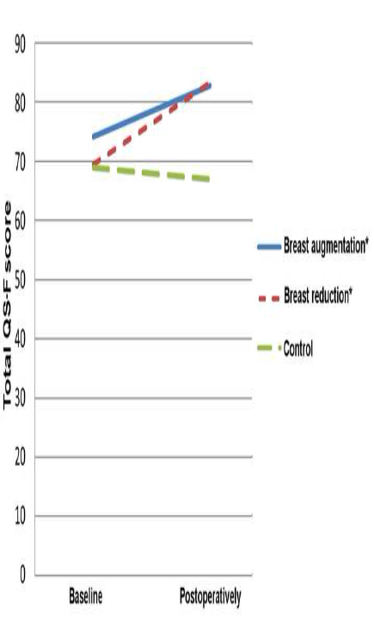

Fig. 4
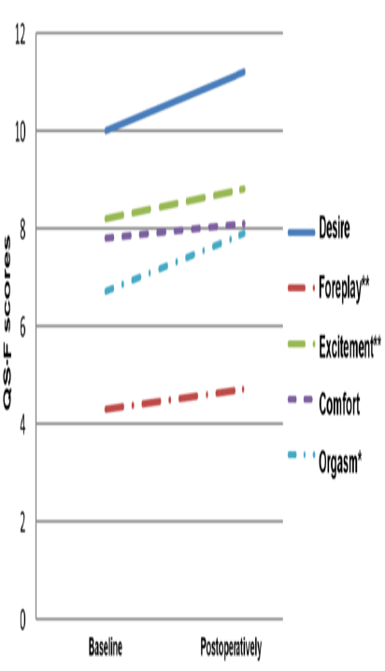

Fig. 5
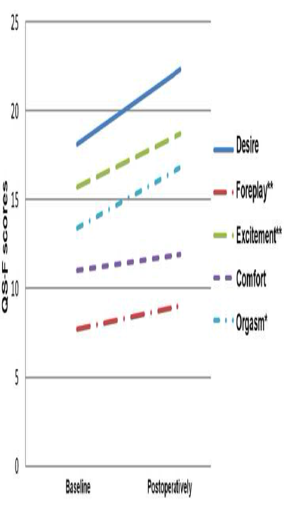

Table 1. Characteristics of participants
Variables | Augmentation Mammaplasty | Reduction Mammaplasty | Controls
Mean age (years) | 25.9 | 33.24 | 31.83
Mean weight (kg) | 57.4 | 65.55 | 66.19
Mean height (m) | 1.63 | 1.61 | 1.61
Mean BMI (kg/m²) | 21.4 | 25.42 | 25.45
Mean years of education (years) | 12.1 | 10.72 | 11.13
BMI, body mean index

