Proteome analysis the differences of the mesenchymal stem cells and extracorporeal shock wave therapy enhancing diabetic wound healing

¹Yur-Ren Kuo ,MD, PhD; ¹Yu-Ting Huang, MS; ¹Chun-Ting Wang, BS, ²Ching-Jen Wang, MD
Department of Plastic and Reconstructive Surgery¹,Orthopaedics²
Kaohsiung Chang Gung Memorial Hospital and Chang Gung University College of Medicine, Kaohsiung, Taiwan

Purpose: Non-healing foot ulcers in patients with diabetes are the leading cause of complications. Our studies have demonstrated topical application of bone marrow-derived mesenchymal stem cells (MSCs) and extracorporeal shock wave therapy (ESWT) both could enhance the diabetic wound healing in a rodent STZ-induced diabetes model.^{1,2} However, the details mechanisms how MSCs and ESWT increased the wound healing is still unclear. Therefore, this study investigated the topical wounding margin tissue between the MSC group and ESWT group and diabetic controls by using 2D proteome study.

Materials and methods: A dorsal skin defect (area, 6×5cm) in a streptozotocin-induced diabetes Wistar rats as a rodent model was used. Group I consisted of diabetic control receiving no MSC; group II, rats received 2 sessions of MSC treatment on day 7 and 10 post-wounding. Group III, rats received 2 sessions of ESWT treatment on day 3 and 7 post-wounding. Each group were assessed at least three wounding-edge skin tissue samples. The proteomic study of skin tissue after different treatment was analyzed. The spots of interest were subjected to in-gel trypsin digestion and MALDI-TOF mass spectrometry in order to elucidate the peptide mass fingerprints.

Results: Representative two-dimensional gel electrophoretograms of skin tissue protein in diabetic wound control, post-MSC and post-ESWT treatments. The proteomic study of wounding–edge skin tissue in MSC group had significantly higher abundance of the alpha-2-HS-glycoprotein and vitamin D-binding protein as compared to that in controls. MSC group had significantly lower levels of the Serine protease inhibitor A3N, Serpin B5, tropomyosinα-1 chain, Haptoglobin, as compared to the diabetic controls. In ESWT group had significantly higher abundance of the hemopexin, alpha-2-HS-glycoprotein and vitamin D-binding protein as compared to that in controls. ESWT group had significantly lower levels of the Serine protease inhibitor A3N, Leukocyte elastase inhibitor A, Haptoglobin, Structural maintenance of chromosomes protein 3 and Catechol O-methyltransferase as compared to the diabetic controls without ESWT.

Conclusion: This proteomic study demonstrated there were some protein indeed up-regulation (alpha-2-HS-glycoprotein and vitamin D-binding protein) or down-regulation (Serine protease inhibitor A3N, Haptoglobin) between MSCs treatment group and ESWT group. Further studies are needed to elucidate whether modulate these proteins could increase diabetic wound healing.

Reference
- Kuo YR, Wang CT, Wang FS, Chiang YC, Wang CJ. Extracorporeal shock-wave therapy enhanced wound healing via increasing topical blood perfusion and tissue regeneration in a rat model of STZ-induced diabetes. Wound Repair Regen. 2009; 17(4):522-530.
- Kuo YR, Wang CT, Cheng JT, Wang FS, Chiang YC, Wang CJ. Bone marrow-derived mesenchymal stem cells enhanced diabetic wound healing through recruitment of tissue regeneration in a rat model of streptozotocin-induced diabetes. Plast Reconstr Surg. 2011; 128(4):872-880.\

Figure Legend
Figure 1. Mass spectrometric characteristics of the positive identified proteins in the peri-wounding skin tissue at day 3 post-mesenchymal stem cells treatment
Figure 2. Mass spectrometric characteristics of the positive identified proteins in the peri-wounding skin tissue post- extracorporeal shock wave therapy

Fig. 1

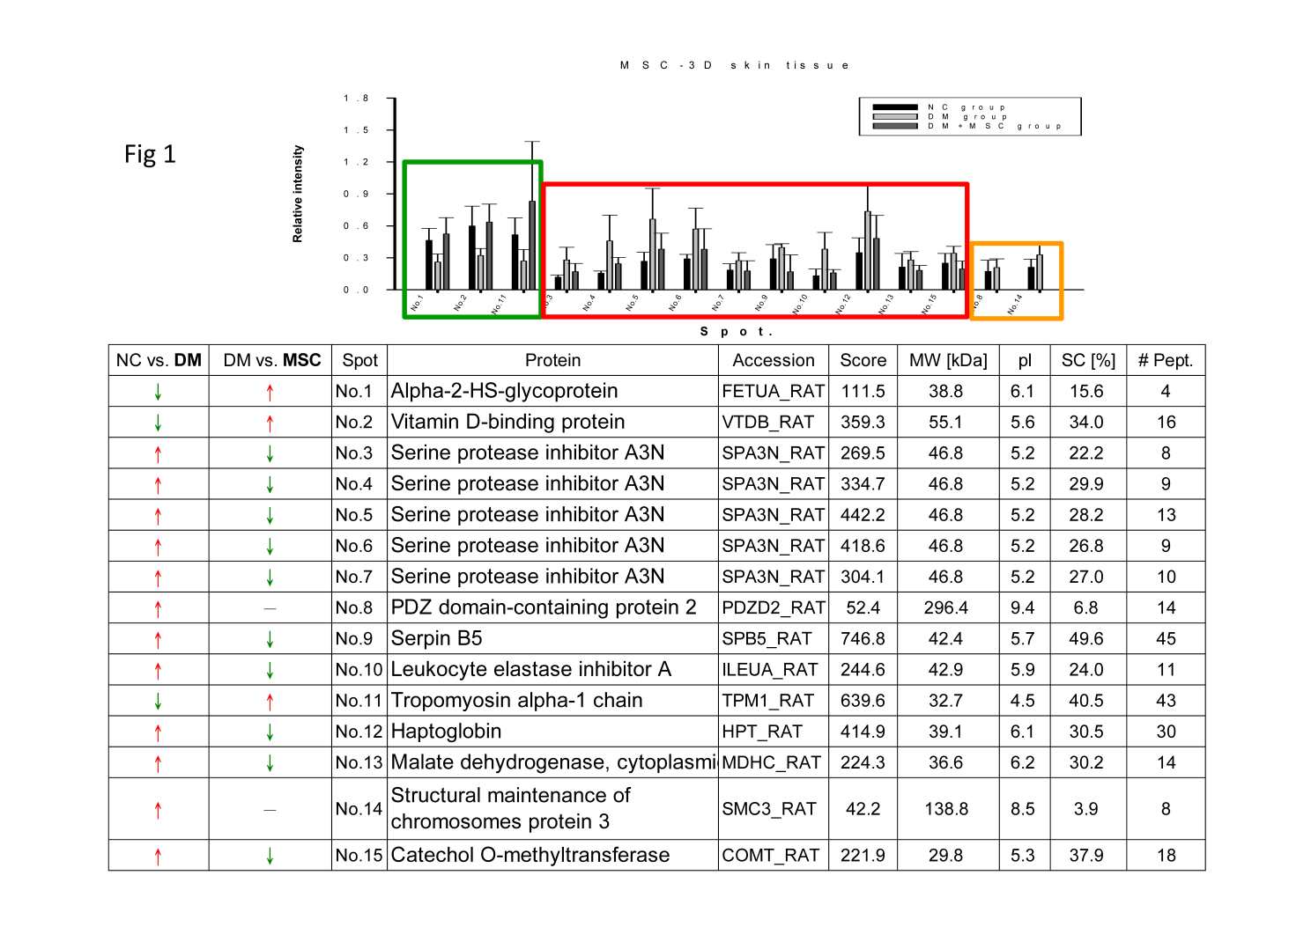

Fig. 2

