Micro Fat Grafting for Post Lumpectomy and Breast Reconstruction Deformities: Pearls for Success.

Boris E. Goldman MD, FACS

Disclosure/Financial Support: None

Background: Micro fat grafting is increasingly being used as an adjunct to standard breast reconstruction techniques; including expander/implant and autogenous reconstruction. It is now possible to correct previously difficult to treat post lumpectomy and post mastectomy reconstruction deformities.

Purpose: To present a simple, inexpensive and effective method of micro fat graft breast reconstruction; including details of patient selection, fat harvest, fat processing and fat grafting.

Results: The author has been performing micro fat graft breast reconstruction as an adjunct to standard breast reconstruction techniques and for post lumpectomy/radiation deformities for the last 3 years. To date a total of 43 cases have been performed. The procedure has been extremely well tolerated, with minimal to no morbidity; 2 patients required local excision of fat oil cysts.

Conclusion: Utilizing a simple technique for fat harvest and preparation, micro fat grafting was performed for patients with post lumpectomy/radiation deformities and in post mastectomy breast reconstruction deformities. The author presents technical pearls for the procedure as well as photos documenting before and after results. Figure 1: Post-op left latissimus flap and implant before fat grafting. Figure 2: Post-op left latissimus flap and implant, with post-op fat grafting (multiple sessions) and nipple reconstruction.

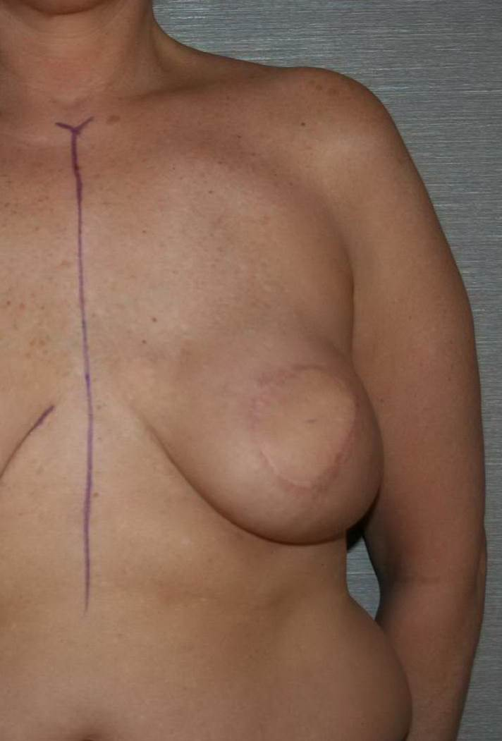
Figure 1

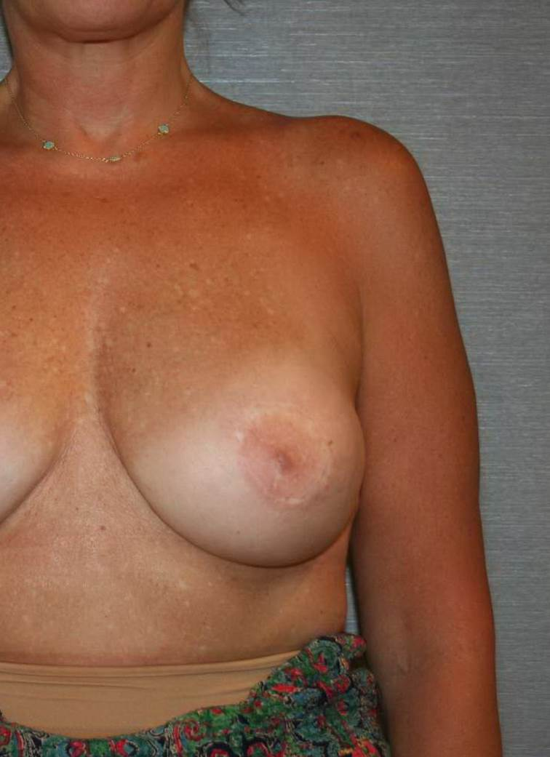

Figure 2

