Long-term growth of costochondral rib grafts in mandibular reconstruction for craniofacial microsomia
Andrew R. Bauder BA, Brianne T. Mitchell MD, Jordan Swanson MD, Jesse A. Taylor MD, Scott P. Bartlett MD
Disclosure/Financial Support: None of the authors have any relevant financial disclosures.
INTRODUCTION: Costochondral rib grafting is the most common surgical technique for reconstructing the Pruzansky-Kaban 2b/3a mandibular deformity in craniofacial microsomia (CFM). However, graft growth is thought to be unpredictable, with possible over- or undergrowth with time¹⁻³. Secondary procedures, including mandibular distraction osteogenesis (DO), may be utilized to augment graft growth. We seek to understand the intrinsic growth properties of costochondral grafts in CFM and the role of mandibular distraction to refine symmetry of the grafted mandible.
MATERIALS AND METHODS: We identified children with Pruzansky-Kaban 2b/3a CFM who underwent mandibular reconstruction with costochondral rib grafting between 2005 and 2012, with minimum follow-up of two years. Three-dimensional volumetric analysis was used to calculate changes in graft length and volume. Graft growth was compared within the individual, using the contralateral side as a control, and between distracted and non-distracted patients. The Wilcoxon matched pairs sign rank test was used for comparisons within individuals, and Wilcoxon rank sum for comparisons between groups.
RESULTS: A total of 11 children (6M, 5F) underwent 12 mandibular rib graft reconstructions for CFM. The average age at intervention was 6.58+/-1.36 years, and all grafts achieved stable graft integration with the native mandible, at a mean follow up of 5.71+/-2.74 years. Eight grafts (67%) did not require DO and achieved growth in length [6.86+/-8.15mm (16.1+/-19.6%)] and volume [287.0613+/-2404.98mm³ (14.3+/-55.3%)] that was not significantly different from the contralateral side (L: p=0.796; V: p=0.519). Four grafts (33%) went on to require DO and achieved long-term length increases [15.34+/-2.51mm (46.8+/-9.7%)], accompanied by volume decreases [-1570.05+/-1079.70mm³ (-39.3+/-24.5%)], both of which were significantly different from that of the contralateral side (L: p=0.043; V: p=0.021). When compared to non-distracted grafts, DO resulted in greater increases in mandibular length (p=0.017).
CONCLUSION: Costochondral grafts grow in length and volume commensurately with the unaffected side in the majority of patients with CFM. Distraction osteogenesis achieves consistent graft lengthening, but is associated with graft remodeling.

REFERENCES:
- Guyuron B, Lasa CI Jr.. Unpredictable growth pattern of costochondral graft. Plast Reconstr Surg. 1992;90:880–886; discussion 887.

- Perrott DH, Umeda H, Kaban LB. Costochondral graft construction/reconstruction of the ramus/condyle unit: Long-term follow-up. Int J Oral Maxillofac Surg. 1994;23:321–328.

- Munro IR, Phillips JH, Griffin G. Growth after construction of the temporomandibular joint in children with hemifacial microsomia. Cleft Palate J. 1989;26:303–311.
FIGURE LEGENDS:
Figure 1. 3D-reconstruction immediately postoperative after rib graft.
Figure 2. 3D-reconstruction at long-term follow up after DO, demonstrating lengthening and closer approximation to skull base.
Blue: native mandible and graft; Purple: contralateral mandible; Dashed white lines recapitulate plane used to transect each hemi-mandible

Figure 1

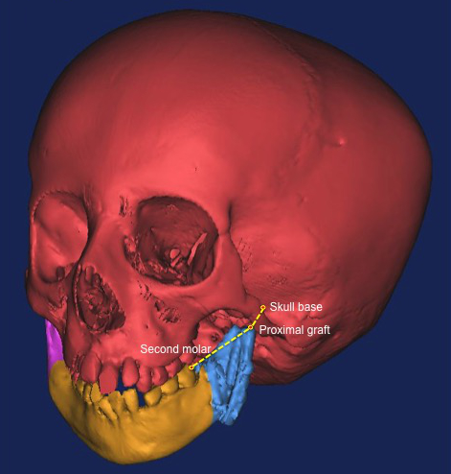

Figure 2
