Electrical Stimulation Differentiates Adipose Derived Stem Cells (ADSC) To A Neurological Phenotype

Shomari D. L. Zack-Williams, MBChB MSc; Michelle Griffin, MBChB, MRes, MSc; Peter Butler MD; Brian G. Cousins PhD

Disclosure/Financial Support: Nil supporting grants

Introduction
Adipose derived stem cells (ADSCs) are multipotent mesenchymal stem cells found within adipose tissue⁽¹⁾. They form unique colonies within the adipose niche and are characterised by expressing specific cells surface proteins⁽²⁾. Historically, they were exposed to a cocktail of glial growth factors to obtain neural phenotypes⁽³⁾. Our aim was to determine if electrical stimulation alone could provide the electromechanical stimulation for neural differentiation.

Materials and Methods
ADSCs were obtained from patients undergoing routine abdominoplasty and liposuction with ethical approval from the Royal Free Hospital, London ethics committee. ADSCs were isolated and cultured within tissue culture plastic flasks before being seeded at 75,000 cells per millilitre onto 8 channel gold microelectrode arrays prior to low voltage electrical stimulation (1-11mv). The system used was the Electrical Cell Impedance Spectroscopy (ECIS) (Ibidi Biosytems, Germany) which cycled through multiple frequencies over a 5 day period. We observed the effects of electrical stimulation on cell metabolism, proliferation and differentiation studies using immunohistochemistry of mouse anti beta-III tubulin to identify the neural phenotype. A fluorescent signal was obtained using a rhodamine rat anti-mouse secondary antibody.

Results
Electrical stimulation of ADSCs increased rates of growth, proliferation resulting in higher impedance values. After stimulation, ADSCs formed distinctive sub-populations of cells staining negative with oil red o and altered phenotype (figure 1). The cells appeared more spread with spindle fibroblastic morphology at higher cell numbers. Immunohistrochemistry confirmed the change in phenotype on the gold microelectrodes with small populations of cells staining positive for β-III tubulin representing the neural phenotype (figure 2).

Conclusion
We demonstrate that electrical stimulation can enhance cell growth, proliferation and differentiation of ADSCs into neural phenotypes at low voltages and without the exogenous growth factors. This growth factor free method represents a major step in the translation of ADSC therapies for nerve disorders. One day this technology could be used to maintain transplanted stem cells and maintain their ability to regenerate damaged neurons in peripheral nerve disorders.
Figure Legend

Figure1: Oil Red O Stain of unstimulated adipose stem cells (left) and stimulated cells (right)
Figure2: Co-localisation of anti beta-III tubulin antibody on the gold electrode showing the presence of β-III tubulin antibody

1. Cheng K-H, Kuo T-L, Kuo K-K, Hsiao C-C. Human adipose-derived stem cells: Isolation, characterization and current application in regeneration medicine. Genomic Medicine, Biomarkers, and Health Sciences. 2011;3(2):53-62.
2. Lv F-J, Tuan R, Cheung KMC, Leung VYL. Concise review: the surface markers and identity of human mesenchymal stem cells. Stem cells. 2014;32(6):1408-19.
3. Zack-Williams SD, Butler PE, Kalaskar DM. Current progress in use of adipose derived stem cells in peripheral nerve regeneration. World J Stem Cells. 2015;7(1):51-64.

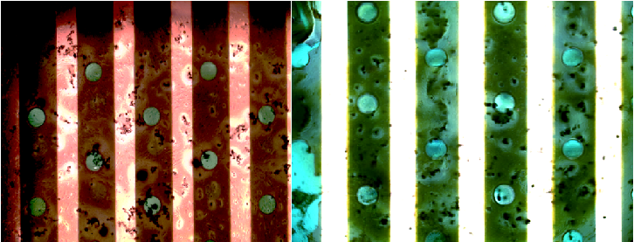

Figure 1

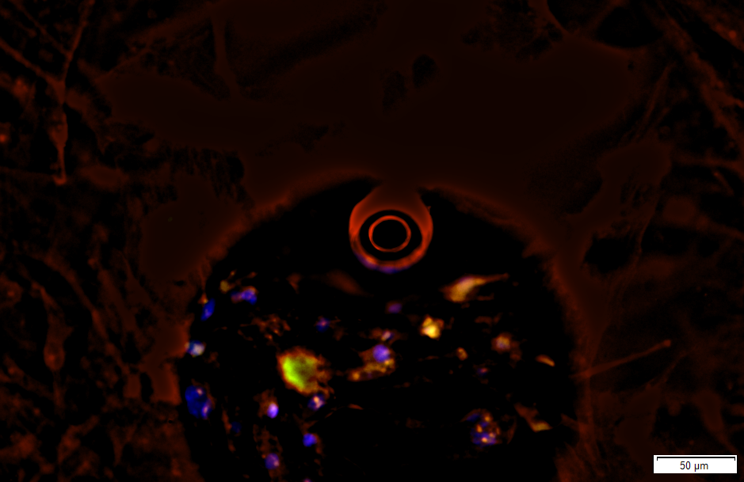

Figure 2

