Blood Supply and Skeletal Muscle Infarction
Ya-Wei Lai, MD; Kao-Ping Chang, MD, PhD; Su-Shin Lee, MD; Sin-Daw Lin, MD; Austin Deng Chen, MD; Hui-Min David Wang, PhD; Shu-Hung Huang, MD, PhD; Chung Sheng Lai MD, PhD

Disclosure/Financial Support: NIL
BACKGROUND: Muscle infarction is a rare complication of spontaneous ischemic necrosis occurring in skeletal muscle. It is particularly common in patients with diabetes who have impaired sugar regulation. However, muscle infarction is frequently misdiagnosed due to varied clinical manifestations.
METHODS:
We presented 3 cases of muscle infarction reported during April 2009 to April 2014. After a comprehensive literature review, we selected 147 muscle infarction cases from the literature, first investigating the relationships between type of muscle blood supply and infarcted muscle.
RESULTS:
The result indicated that muscle infarction 25.85 % belonged to type I vascular supply and 61.21% belonged to type II vascular supply, according to the definition by Mathes and Nahai.
CONCLUSIONS:
Poor glucose regulation, intense exercise without adequate hydration, vascular disease, and type I and II muscular blood supply were critical predisposing factors. For preventing muscle infarction, we recommend strict glucose regulation and a gradual increase in exercise with adequate hydration.

FIGURE LEGEND:
Figure 1
Upper : Axial view of MRI with hyper intense signal
Lower:: Coronal view with infarcted gastrocnemius and subcutaneous edematous change.
Table 1
muscle infarction 25.85 % belonged to type I vascular supply and 61.21% belonged to type II vascular supply, according to the definition by Mathes and Nahai.

Figure 1

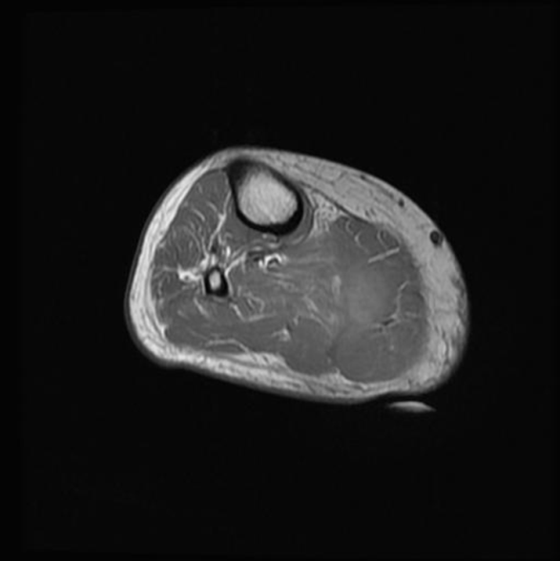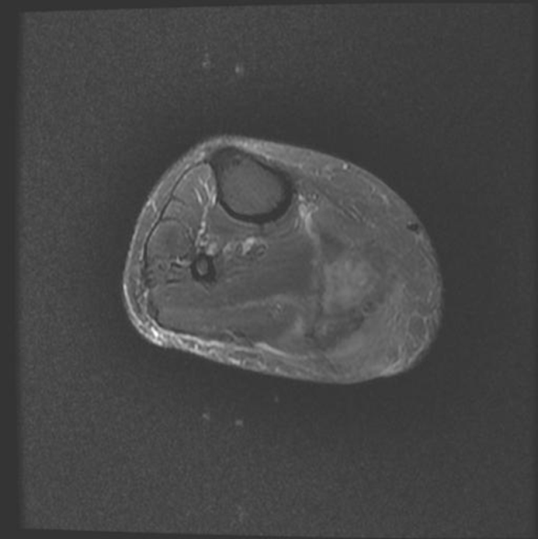
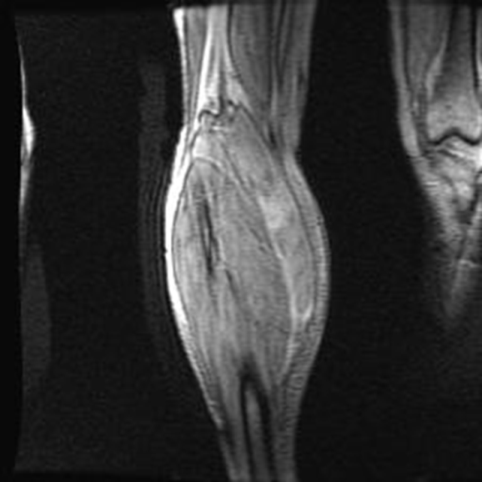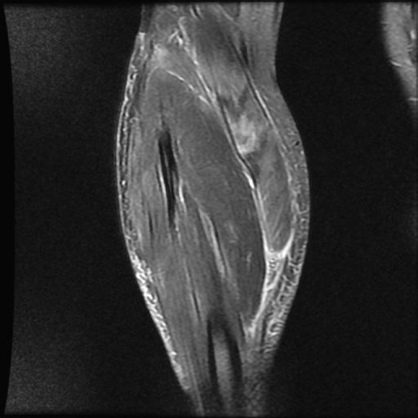

Table 1Vascular type of infarcted muscles

Muscle  involvement | Classification | Jelinek  1999 | Huang  2010 | Litvnov  2012 | Arroyave  2013 | Lai  2014 | Total  Nr.(%)
VM | II | 26 | 0 | 0 | 1 | 0 | 27  18.37%
VL | I | 26 | 0 | 0 | 1 | 0 | 27  18.37%
VI | II | 20 | 0 | 0 | 0 | 0 | 20  13.6%
RF | II | 14 | 0 | 0 | 0 | 0 | 14  9.52%
Gastrocnemius | I | 7 | 1 | 1 | 0 | 2 | 11  7.48%
BF | II | 10 | 0 | 0 | 0 | 0 | 10  6.80%
Sartorious | IV | 10 | 0 | 0 | 0 | 0 | 10  6.80%
Adductor | Not classified | 9 | 0 | 0 | 0 | 0 | 9  6.12%
Soleus | II | 6 | 1 | 0 | 0 | 0 | 7  4.76%
Gracilis | II | 6 | 0 | 0 | 0 | 0 | 6  4.08%
Peroneus | II | 5 | 0 | 0 | 0 | 0 | 5  3.40%
Triceps | II | 0 | 0 | 0 | 0 | 1 | 1  0.68%
Total: 147, type I: 25.85%, type II: 61.21%, type III: 0, type IV: 6.8%
Note:
Classification by Mathes and Nahai⁵
VI: Vastus intermedius , VM: Vastus medialis , VL:Vastus lateralis , RF: Rectus femoris BF: Biceps femoris

