Evaluation of a Patient with Metopic Synostosis Treated using Cranial Orthosis
Kamlesh B. Patel, MD, Dennis C. Nguyen, MD, Gary B. Skolnick BS, Sybill D. Naidoo PhD RN, Matthew D. Smyth MD,
Purpose: Outcomes in patients with metopic synostosis are focused on improvements in head shape due to surgical intervention.^{1,2} Most patients with true pathological trigonocephaly are managed surgically, therefore literature is lacking on frontal morphology in untreated patients.³ We present and analyze the early result with orthotic therapy alone for a patient with metopic synostosis.
Case Presentation:
A 6-month-old twin boy born at 30-weeks via a surrogate presented to the clinic with chief complaint of abnormal head shape. Patient's history was significant for VACTERL and had undergone repair of tracheoesophageal fistula at 2 days of life. He also required prolonged respiratory support due to primary pulmonary hypertension. On physical exam the head circumference was in the 26th percentile with both occipital brachycephaly and trigonocephaly with frontal width of 62mm. Intercanthal distance was 27mm. Computed tomography scan showed 7 of 8 characteristic findings consistent with metopic synostosis as described by Birgfeld and colleagues (metopic ridge, pulled anterior fontanelle, posteriorly displaced lateral frontal bone, tangent drawn along lateral frontal bone intersects mid-orbit, upsloping lateral orbital rim, interorbital narrowing and narrowing of upper orbit).⁴
Management and Outcome:
In view of the patient having continued respiratory difficulty due to primary pulmonary hypertension, operative intervention was deferred. The patient was placed in a cranial orthotic, till 12-months of age, to treat deformational brachycephaly. However, initial helmet design was similar to a postoperative helmet after strip craniectomy to allow for frontal expansion.
The patient was seen regularly and noted to have improvement in frontal appearance with resolution of trigonocephaly at 20-months of age (Fig. 1). The frontal width improved to 95mm and intercanthal distance was 33mm. Repeat computed tomography scan showed a metopic ridge, but all prior characteristics of metopic synostosis were no longer present. The pre and post-orthotic therapy interfrontal angle were 94° and 98° (normal range 125-160°), respectively.⁵ Based on clinical findings, surgery was not recommended.
Conclusion:
We present a patient with metopic synostosis that was managed with orthotic therapy alone, producing an improvement in frontal morphology to not warrant surgical intervention. Further evaluations are needed to identify clinical characteristics that allow for nonsurgical treatment using a cranial orthosis.

Figure 1. (Left) 6-month-old with metopic synostosis. (Right) At 20-months of age, after helmet molding therapy.
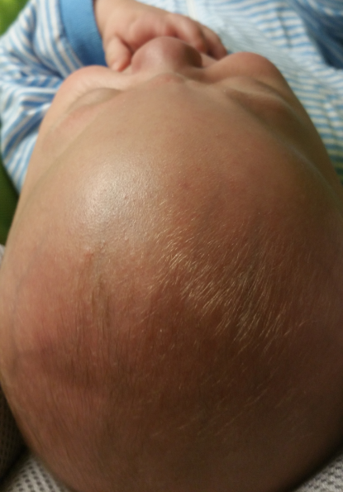
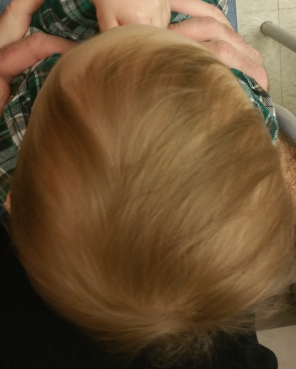

Disclosure/Financial Support:
Dr. Patel is a consultant for Stryker CMF. The other authors have no conflicts of interest to report.
References:
1. Wes AM, Paliga JT, Goldstein JA, Whitaker LA, Bartlett SP, Taylor JA. An evaluation of complications, revisions, and long-term aesthetic outcomes in nonsyndromic metopic craniosynostosis. Plastic and reconstructive surgery 2014;133:1453-64.
2. Nguyen DC, Patel KB, Skolnick GB, et al. Are endoscopic and open treatments of metopic synostosis equivalent in treating trigonocephaly and hypotelorism? The Journal of craniofacial surgery 2015;26:129-34.
3. Dominguez R, Oh KS, Bender T, Girdany BR. Uncomplicated trigonocephaly. A radiographic affirmation of conservative therapy. Radiology 1981;140:681-8.
4. Birgfeld CB, Saltzman BS, Hing AV, et al. Making the diagnosis: metopic ridge versus metopic craniosynostosis. The Journal of craniofacial surgery 2013;24:178-85.
5. Kellogg R, Allori AC, Rogers GF, Marcus JR. Interfrontal angle for characterization of trigonocephaly: part 1: development and validation of a tool for diagnosis of metopic synostosis. The Journal of craniofacial surgery 2012;23:799-804.

