PSEF 2005 Research Fellowship - Lyndon Peer: Mechanisms of Radiation Injury and Cytoprotection in Osteoblasts
Artur Gevorgyan, MD, Balram Sukhu, Peter C. Neligan, MD, Cho Y. Pang, PhD, Benjamin A. Alman, MD, Robert G. Bristow, MD, PhD, Christopher R. Forrest, MD, MSc
Introduction: Therapeutic radiation for the management of paediatric head and neck cancer may result in inhibition of craniofacial bone growth with development of severe deformities¹. Previously, the infant rabbit orbito-zygomatic complex (OZC) was established as an animal model². Significant improvement of craniofacial bone growth was achieved following administration of Amifostine (Ethyol®, WR-2721), a broad-range cytoprotective agent, before single or fractionated dose radiation^{3, 4}. In addition, histological studies revealed diminished active bone cell populations. Subsequently, a primary osteogenic cell culture was established from the OZC periosteum, and significantly higher numbers of osteogenic cells were obtained from rabbits pre-treated with Amifostine compared to those who underwent radiation only. This study was designed to assess post-radiation osteoblast survival and function with and without radioprotection in a model of in vitro osteogenesis.
Methods: MC3T3-E1 newborn mouse calvarial osteoblasts underwent γ-radiation (0-10 Gy) in the presence or absence of WR-1065 (10⁻³-10⁻⁷ M), the active metabolite of Amifostine, in a pre-treatment schedule 30 minutes before ionizing radiation (IR). To assess the immediate effects, analysis of clonogenic survival, viability (MTT) and alkaline phosphatase activity (p-nitrophenyl phosphate based assay) was carried out up to day 10 post-IR. To assess osteogenic function in later stages following IR, the expression of several osteogenesis-related genes (alkaline phosphatase, collagen type I, osteocalcin and osteopontin) was analyzed by semi-quantitative RT-PCR at days 14 and 21. Formation of mineralized bone nodules was assessed by Alizarin Red S staining at day 31 post-IR.
Results: Following IR, significant (p<0.05), dose-dependent inhibition of clonogenic survival, viability and alkaline phosphatase activity was observed (Fig. 1 A-C). The expression of 3 genes – alkaline phosphatase, collagen type I and osteocalcin – which are important in the process of osteogenic differentiation, bone extracellular matrix formation and mineralization, was significantly suppressed even after 14 and 21 days post-IR (Fig. 2). Pre-IR treatment with WR-1065 had highest significantly radioprotective effect at the concentration of 10⁻⁴ M, which correlates with its peak plasma levels in patients who were administered Amifostine (Fig. 3 A). Pre-treatment with this concentration at several IR doses resulted in a significant radioprotection at 2, 6 and 8 Gy (Fig. 3 B). Importantly, significant radioprotection (surviving fraction of 0.74 vs. 0.53 in radioprotection vs. IR only cultures, respectively; p<0.05, Mann-Whitney U test) was observed at the clinically relevant 2 Gy dose (SF₂) (Fig. 3 C). However, colonies of osteogenic cells that have survived IR formed bone nodules with positive mineralization staining (not shown).
Conclusions: We show that pre-treatment with WR-1065, the active metabolite of Amifostine, results in a significant improvement of osteogenic cell survival following IR at clinically relevant drug concentrations and IR doses. If similar improvement of survival occurred with each IR fraction in head and neck area osteogenic cells, this effect would translate into over 3,000-fold improved survival over the course of regular head and neck cancer radiotherapy in children (2 Gy x 25 fractions = 50 Gy total) (Fig. 3 D). This study corroborates previous findings from the primary periosteal osteogenic cell culture and the rabbit OZC model, and supports the premise that radioprotection can be a viable means for preventing radiation-induced craniofacial bone growth inhibition and ensuing deformities.
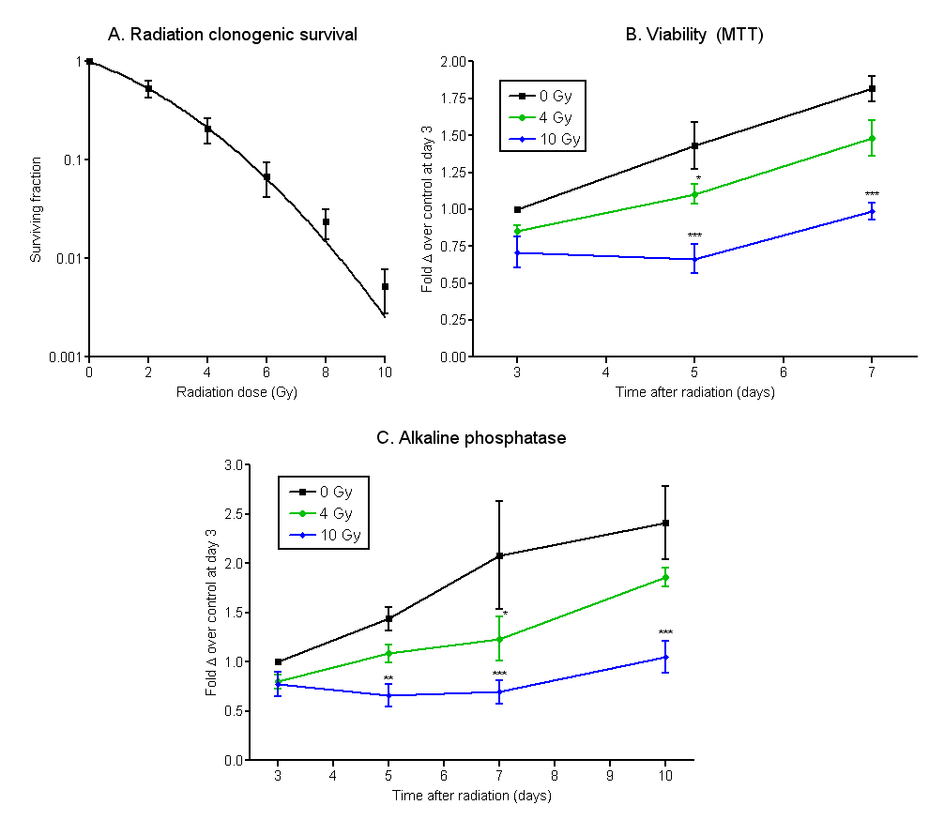
Figure 1. Exposure to ionizing radiation (IR) results in a dose-dependent inhibition of clonogenic survival (A), viability (B) and alkaline phosphatase activity (C). All values are mean ± SEM of at least triplicate experiments. In B and C, values are expressed as fold change compared with the control at day 3. Repeated measures ANOVA with Tukey’s HSD post-hoc test was used to test for differences (* = p<0.05, ** = p<0.01, *** = p<0.001).
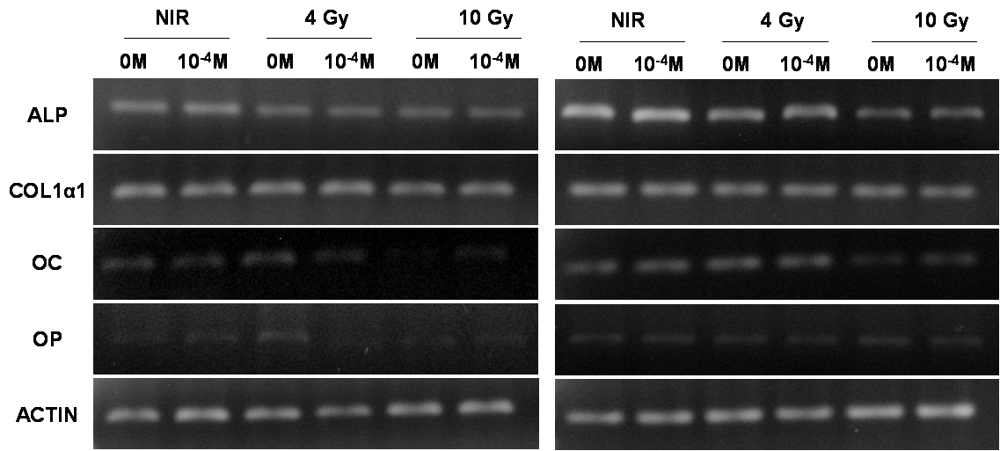
Figure 2. Radiation inhibits the expression of ALP, COL1α1 and OC genes at days 14 (left) and 21 (right) post-IR, and does not affect the expression of OP gene.
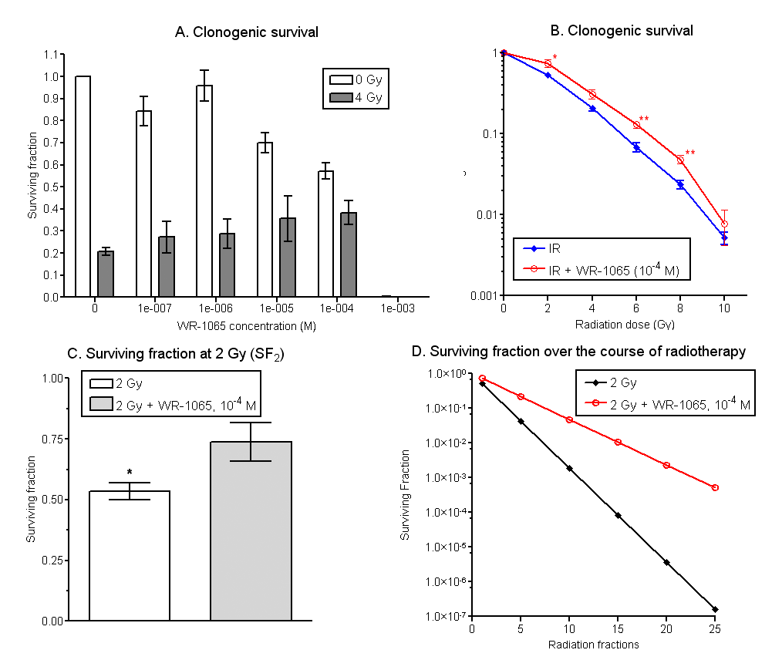
Figure 2. WR-1065, the active metabolite of Amifostine, has a significantly radioprotective effect in a concentration-dependent manner. (A) Radiation clonogenic survival with 4 Gy or sham radiation and 0, 10⁻³-10⁻⁷ M WR-1065. (B) Radiation clonogenic survival with 0 or 10⁻⁴ M WR-1065 and 0-10 Gy radiation. (C) Surviving fraction at 2 Gy (SF₂) with 10⁻⁴ M WR-1065. (D) The surviving fraction over the course of radiotherapy assuming SF₂ difference of 0.74 vs. 0.53 with and without radiotherapy, and 25 fractions of 2 Gy (50 Gy total). All values are mean ± SEM of at least 4 experiments. In B and C, Mann-Whitney U test at each IR dose was used to test for differences (* = p<0.05, ** = p<0.01).
References:

1. Larson, D.L., et al., Long-term effects of radiotherapy in childhood and adolescence. Am J Surg, 1990. 160(4): p. 348-51.
2. O'Donovan, D.A., et al., Radiation-induced craniofacial bone growth inhibition: development of an animal model. J Craniofac Surg, 2001. 12(6): p. 533-43.
3. Forrest, C.R., et al., Efficacy of radioprotection in the prevention of radiation-induced craniofacial bone growth inhibition. Plast Reconstr Surg, 2002. 109(4): p. 1311-23; discussion 1324.
4. La Scala, G.C., et al., Radiation-induced craniofacial bone growth inhibition: efficacy of cytoprotection following a fractionated dose regimen. Plast Reconstr Surg, 2005. 115(7): p. 1973-85.

